**Week 14 Attachments.**

Attachment 1: Core Reader 4 “Up, Up and Away!”

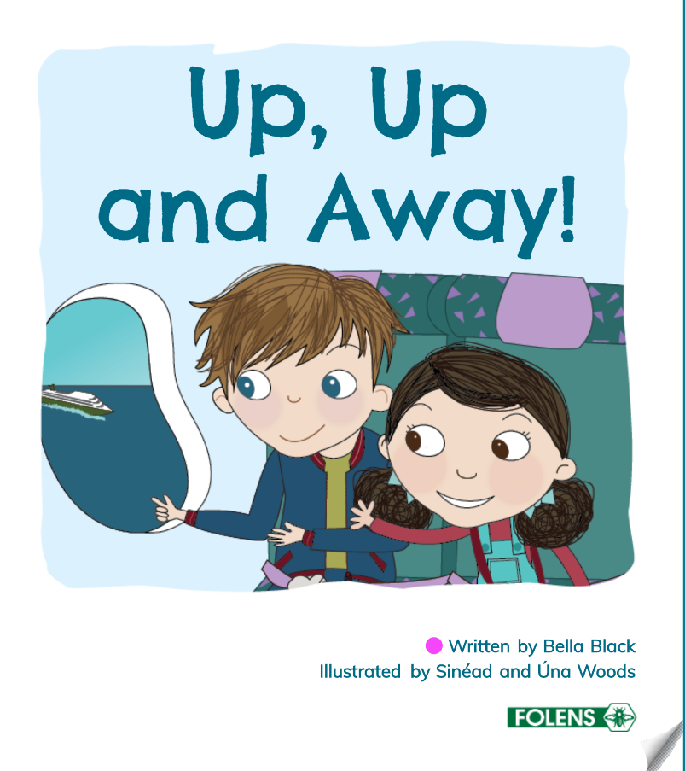

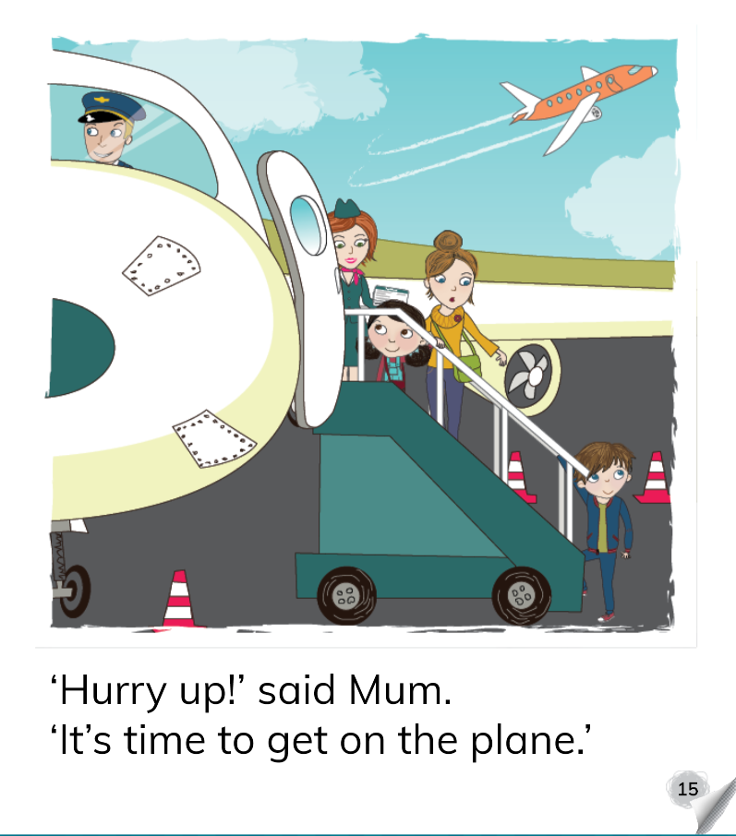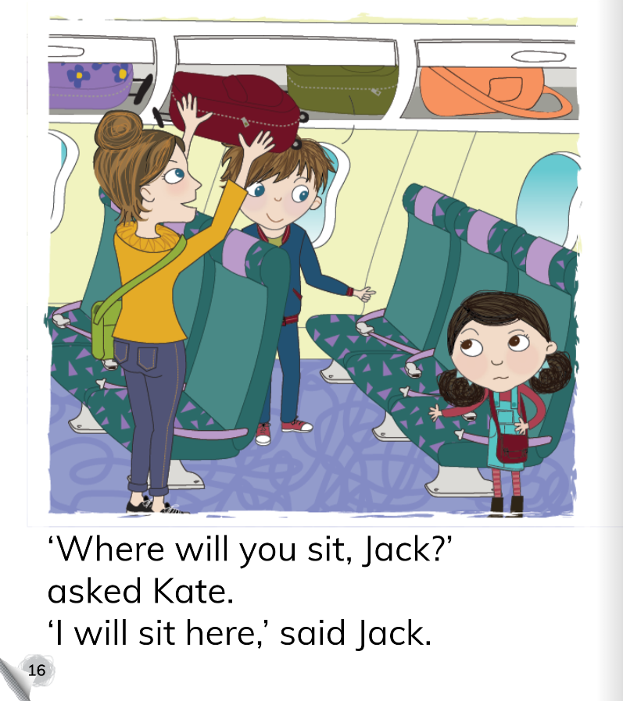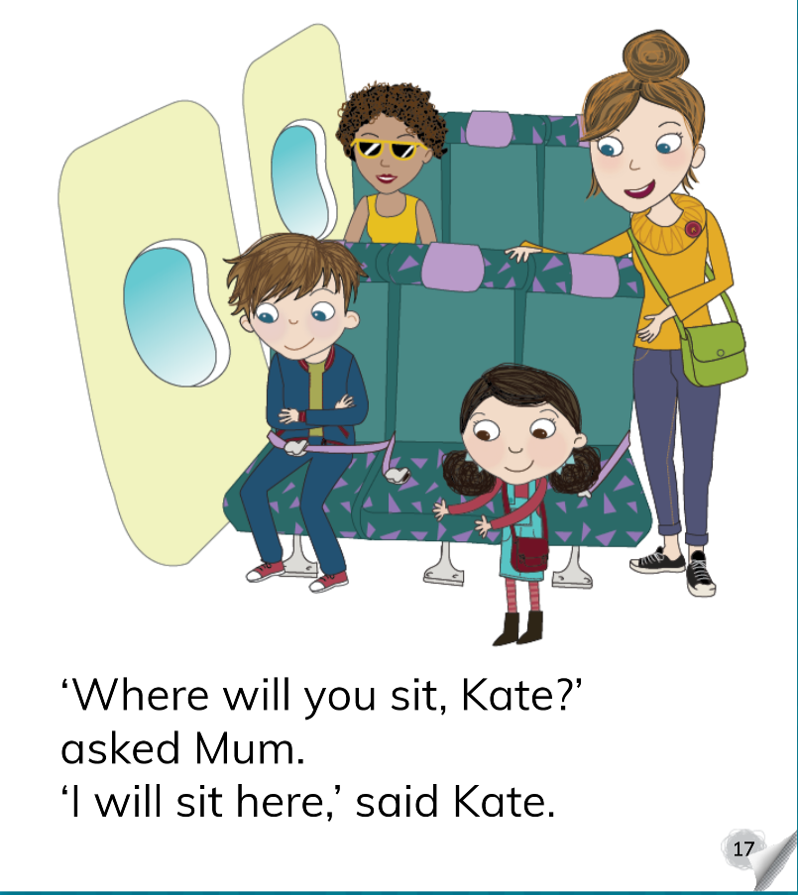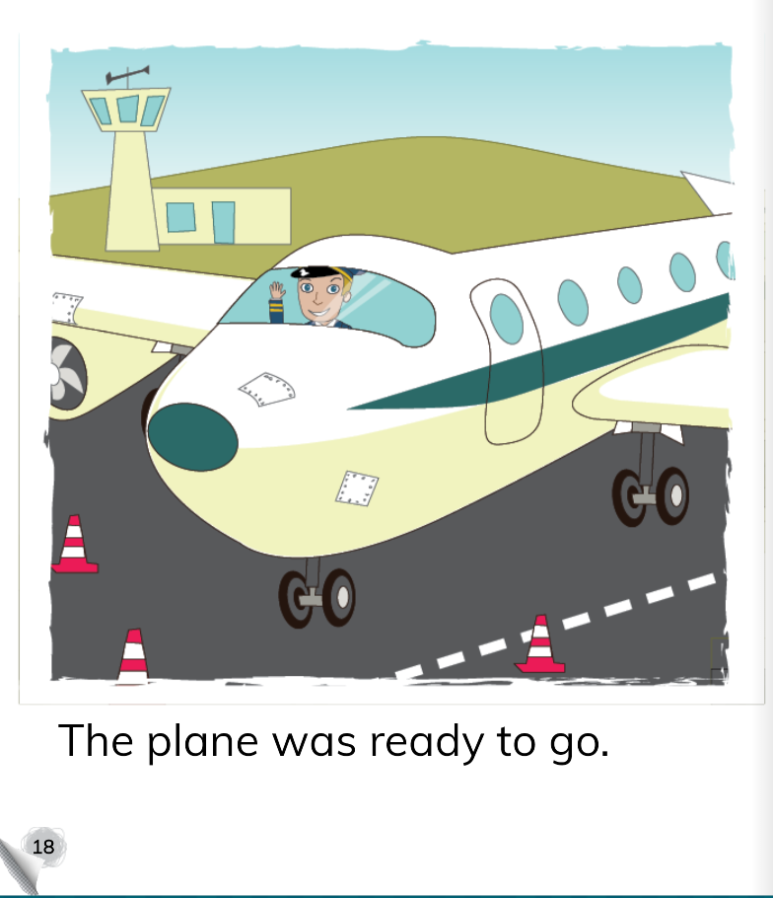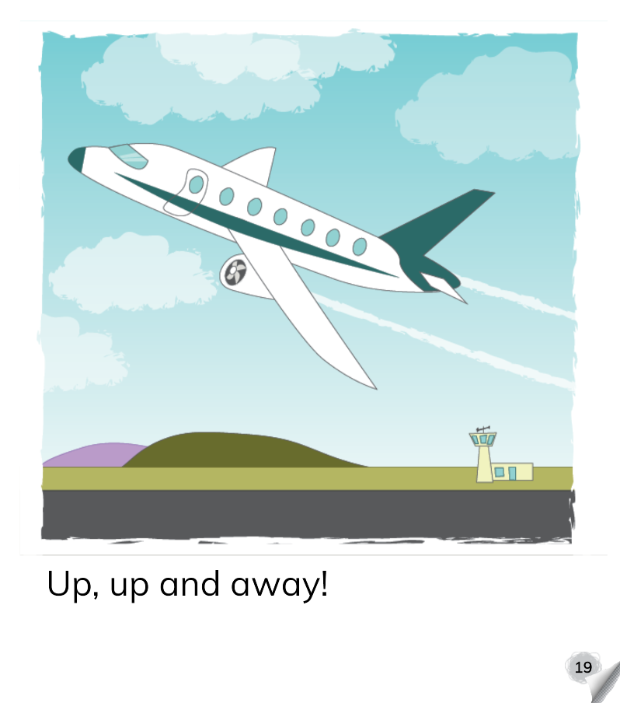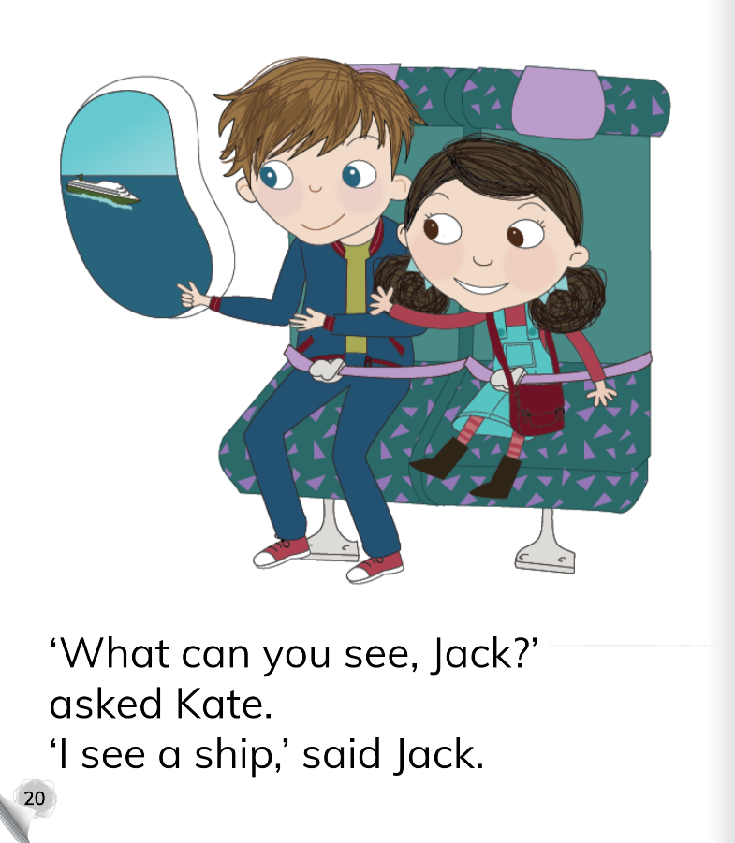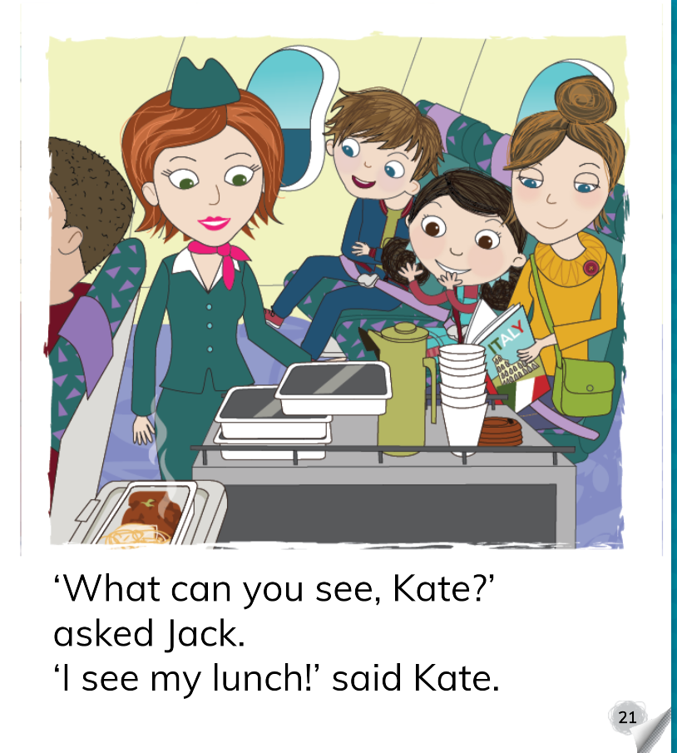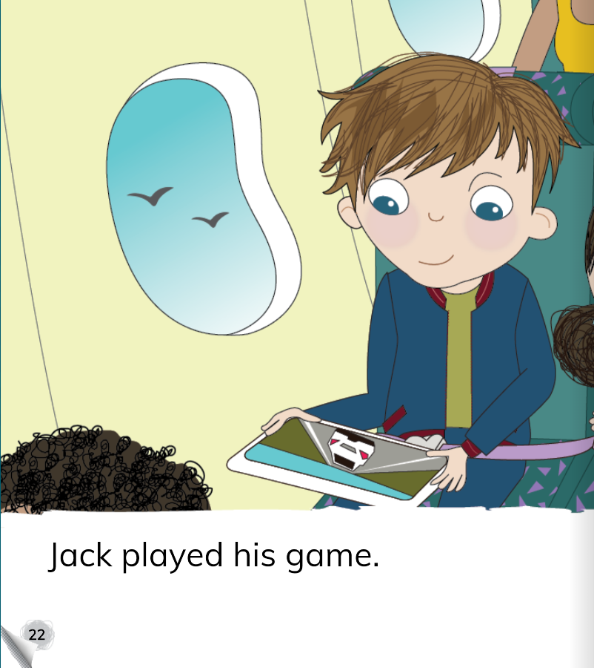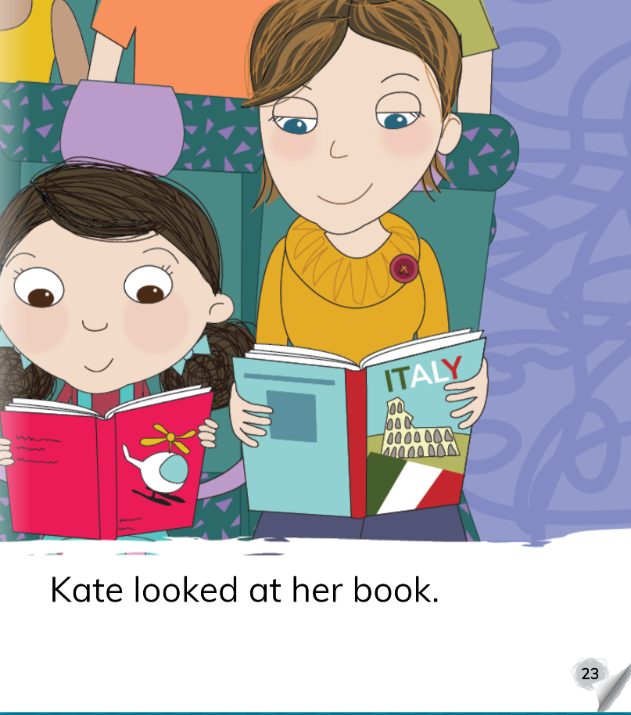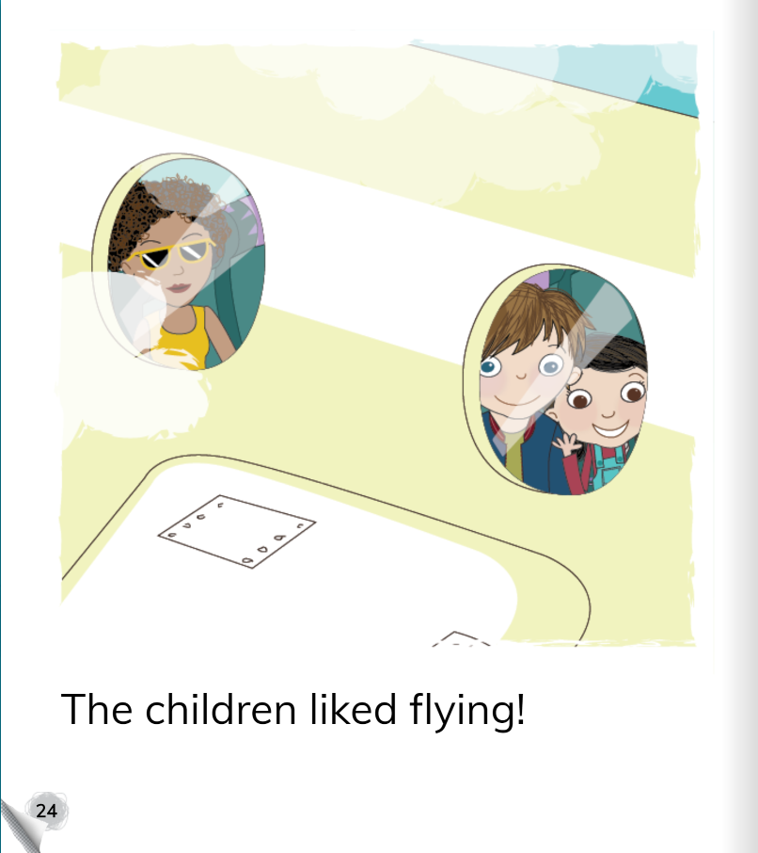

Attachment 2: Skills Book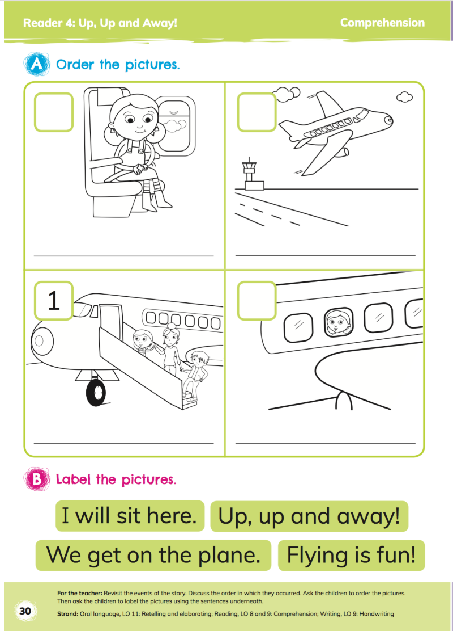

Attachment 3: Tricky Word Revision (Set 1-3)

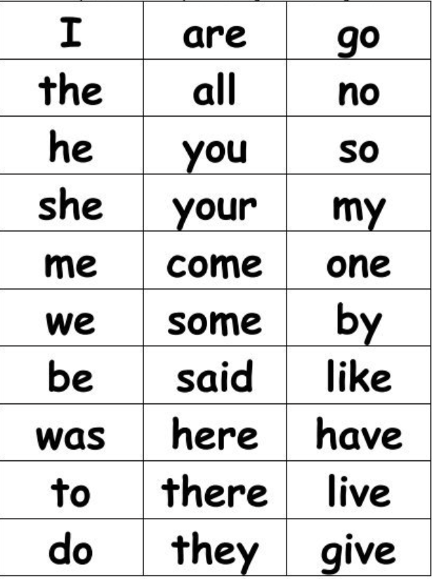

Attachment 4:

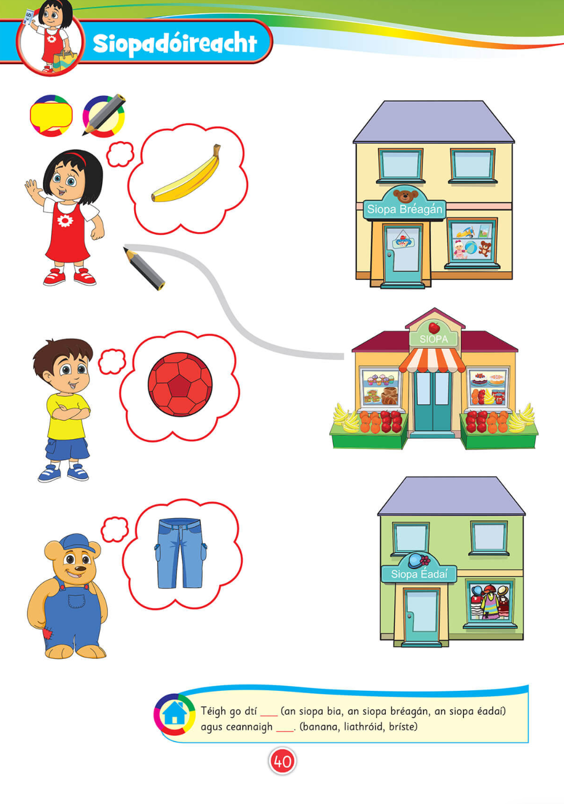

Attachment 5: 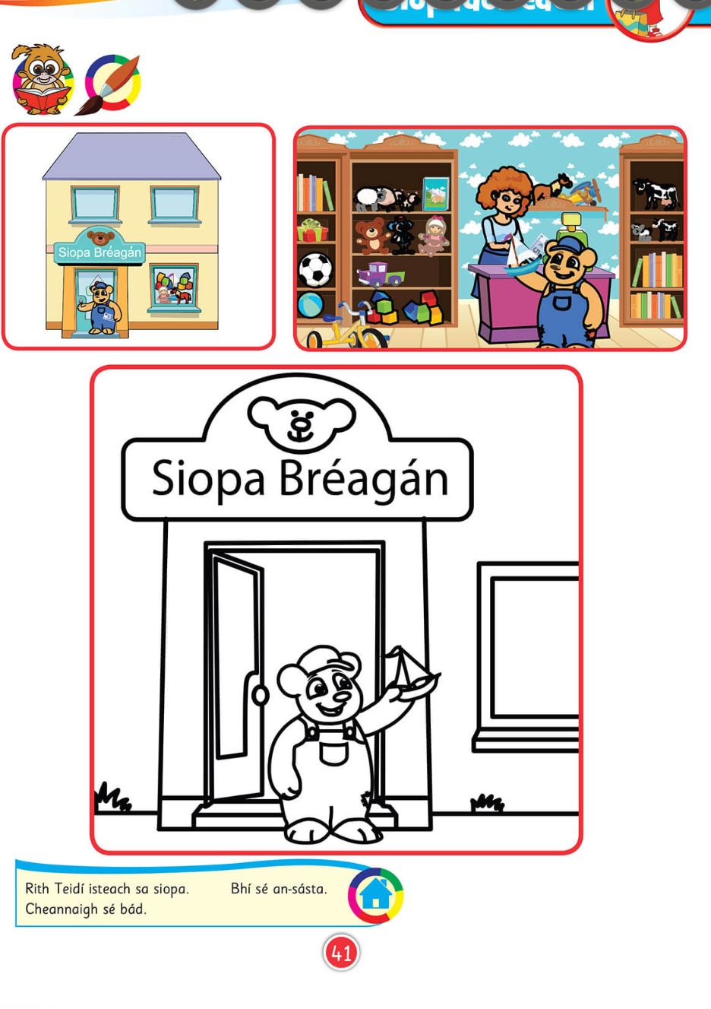

Attachment 6: Mars Bar Squares

Prep Time

10 minutes

Cook Time

5 minutes

Total Time

15 minutes

Course

Dessert

Cuisine

American

Servings

16

Calories

194

Author

**Ingredients**

*  4 Mars Bars
*  1/2 cup butter
*  3 cups Rice Krispies
*  Topping:
*  1 cup chocolate chips, semi-sweet
*  1/4 cup butter or margarine

**Instructions**

1. Melt the Mars bars and butter together in a pot, then mix the Rice Krispies in with them, coating the cereal completely.
2. Transfer to a well greased 9×9 or 8x8 pan.
3. Melt the chocolate and butter for the topping, stirring until smooth, then pour it on top.
4. Cool in the fridge then cut into pieces and serve.

<https://www.thekitchenmagpie.com/mars-bars-squares/-> for video guidance