**Week 13 Attachments.**

Attachment 1: “The Airport” Oral Language Poster

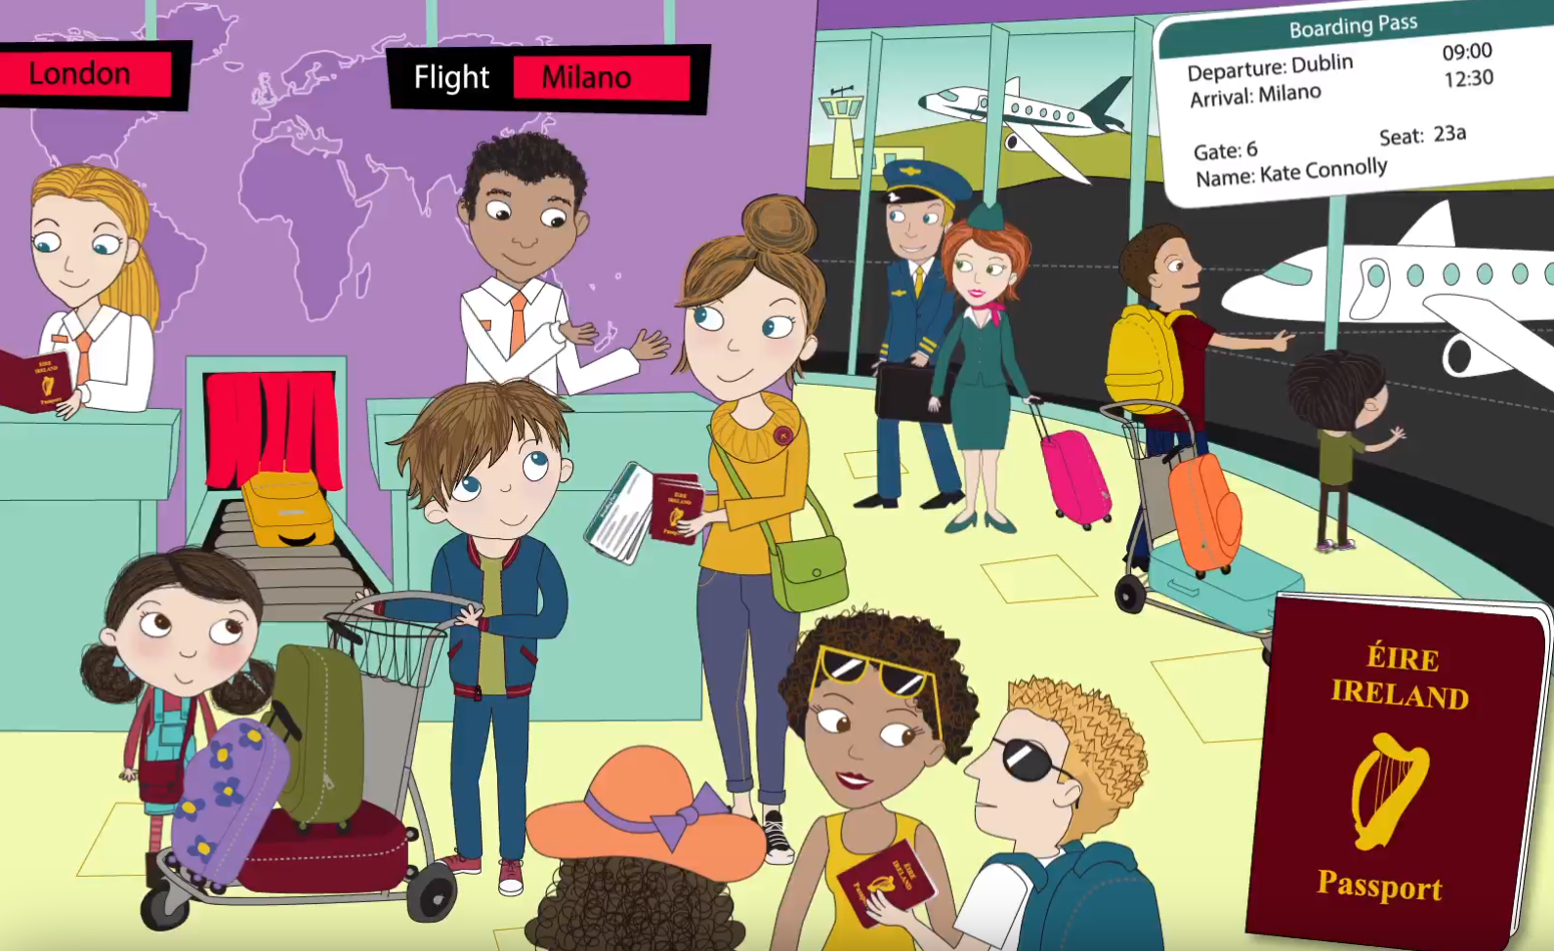

See if you can identify what these signs mean.

Questions to ask.

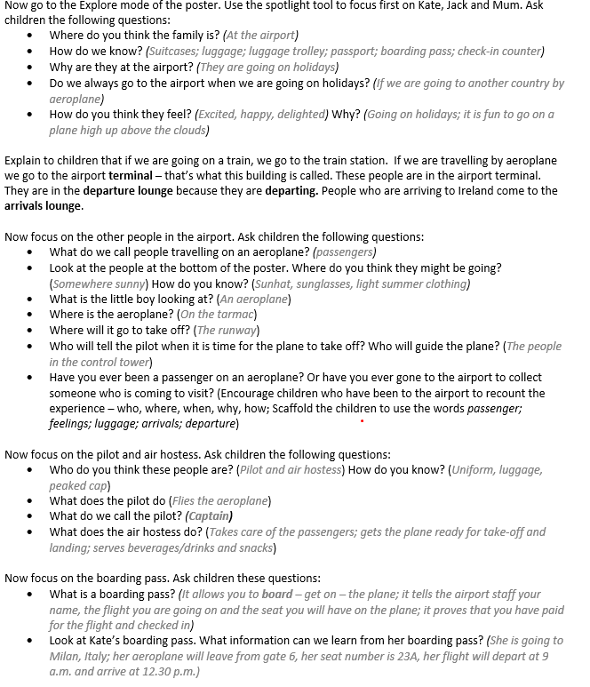

Attachment 2: “Up, Up and Away!” Final Core reader of junior infants!

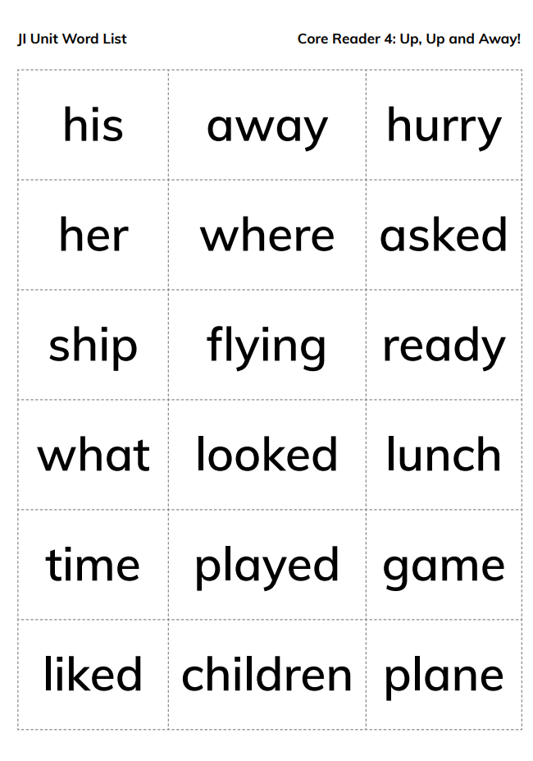

There are some difficult words here so take maybe 3 or 4 each day and begin with the ones known to the children first ( ship, lunch, her, his etc)

Attachment 3: “ar” words

car far bar dark park shark scarf Mark

Attachment 4: Gaeilge Cómhrá

In lesson 3 the children will need someone to carry out a role-play conversation just like in the Bua na Cainte lesson with them.

Person 1 will be the customer while person 2 is the shopkeeper

*************************************************************

Duine 1: Dia duit

Duine 2: Dia’s Muire duit.

Duine 1: Tabhair dom_______( úll, oráiste, ceapaire etc)

Duine 2: Seo duit______. (úll, oráiste, ceapaire etc)

Duine 1: Go raibh maith agat.

Duine 2: Fáilte romhat.

Duine 1: Seo duit an t-airgead.

Duine 2: Slán

*********************************************************************

Try practice this many times at home in a pretend shop with real/pretend food and money. Try make it as fun as possible.

Attachment 5:

Dathaigh an úll glas. Dathaigh an oráiste oráiste. Dathaigh an arán donn. Dathaigh an im buí. Dathaing an bainne gorm. Dathaigh an subh dearg.

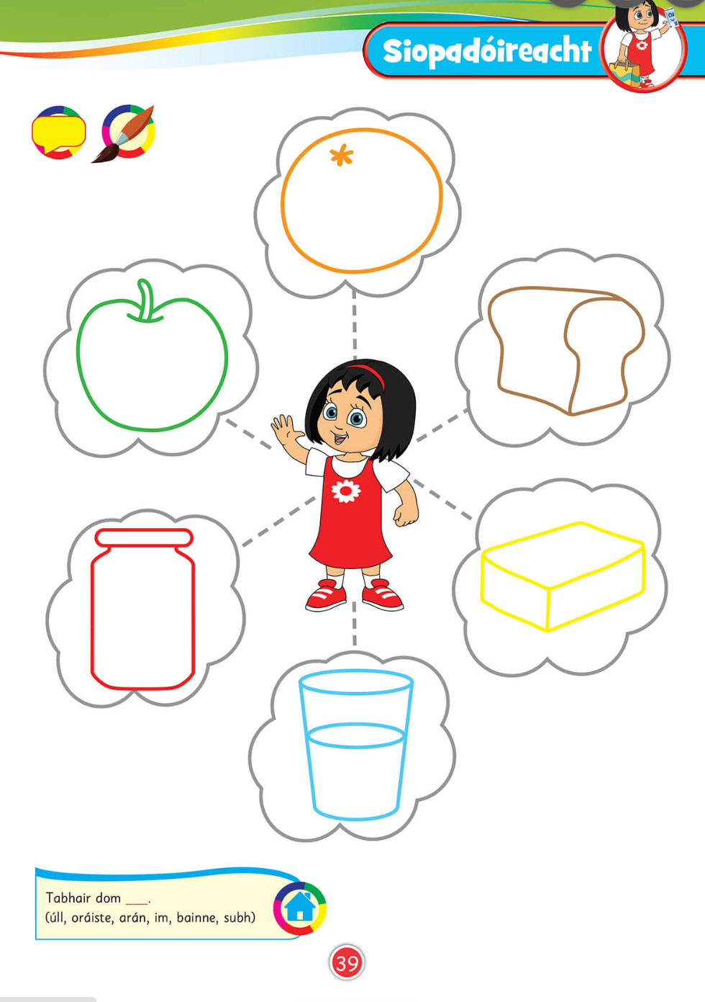

Attachment 6: Cómhrá Ceacht 5

Duine 1: Dia duit

Duine 2: Dia’s Muire duit.

Duine 1: Cóta, más é do thoil é.

Duine 2: Cuir ort an cóta dearg.

Duine 1: Tá sé róbheag.

Duine 2: Bain díot an cóta dearg.

Duine 2: Cuir ort an cóta buí.

Duine 1: Is maith liom an cóta buí.

Duine 2: Tá sé go hálain.

Duine 1: Seo duit an t-airgead.

Duine 2: Seo duit an cóta.

Duine 1: Slán leat agus go raibh maith agat

Attachment 7: Art

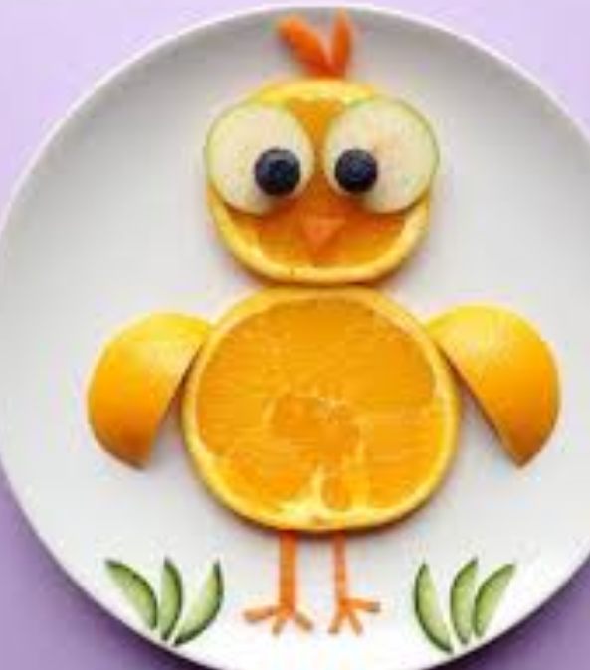 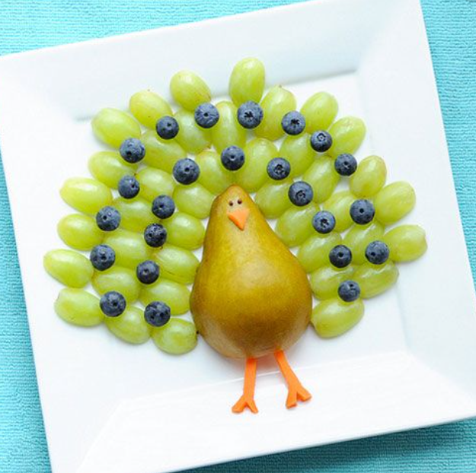

Attachment 8: This week activity challenges have been incresed just like they would have been in school. Some suggestions are outlined below. These activities may need to be altered to suit your equipment and number of family members willing to play. Alter as you see fit. Feel free to create your own PE games also. Have fun.

PE 1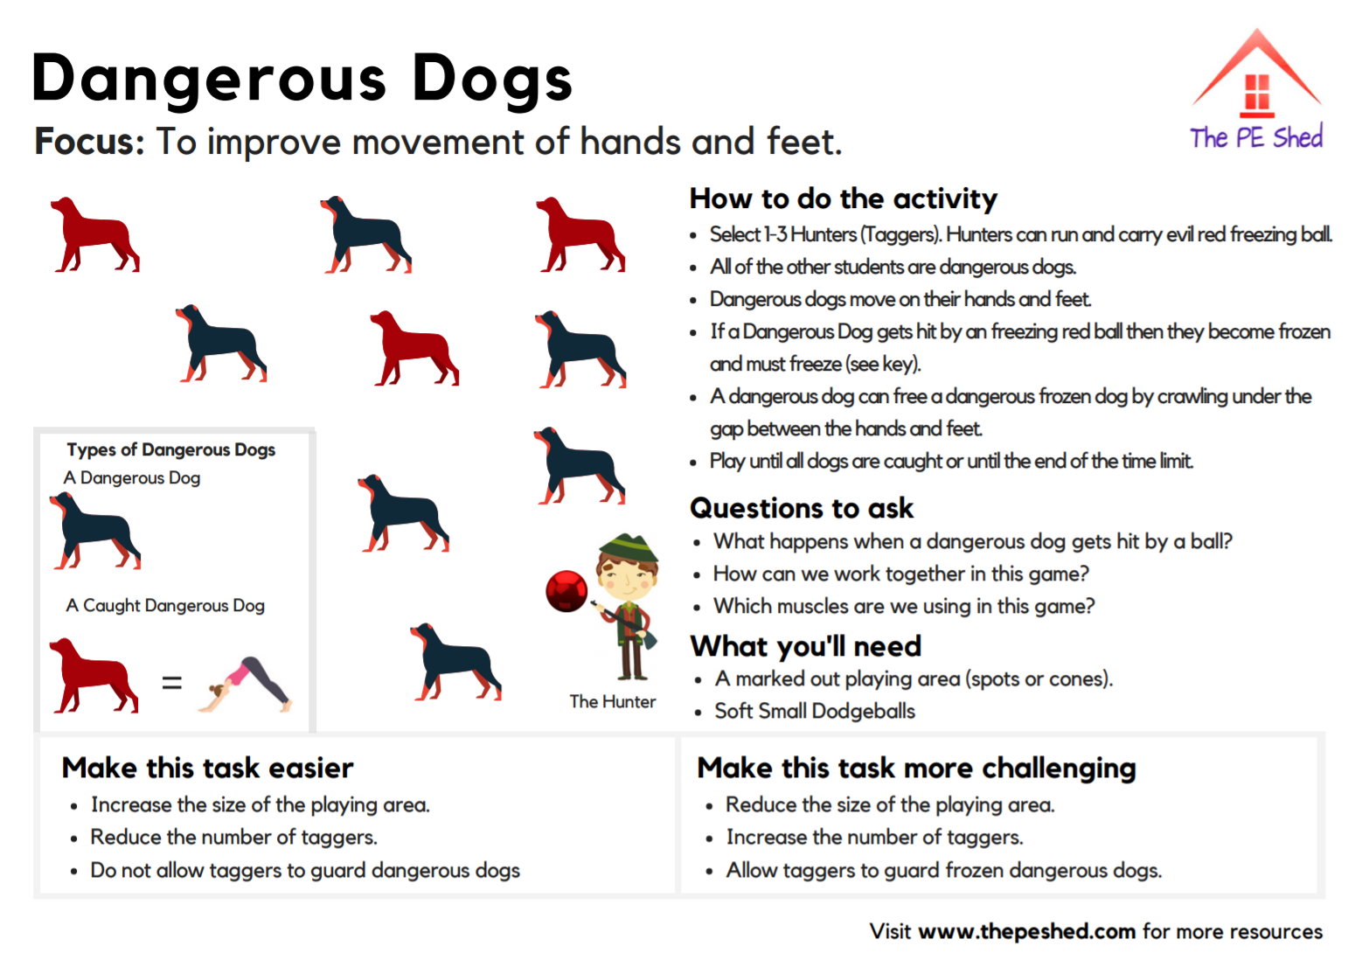

PE 2

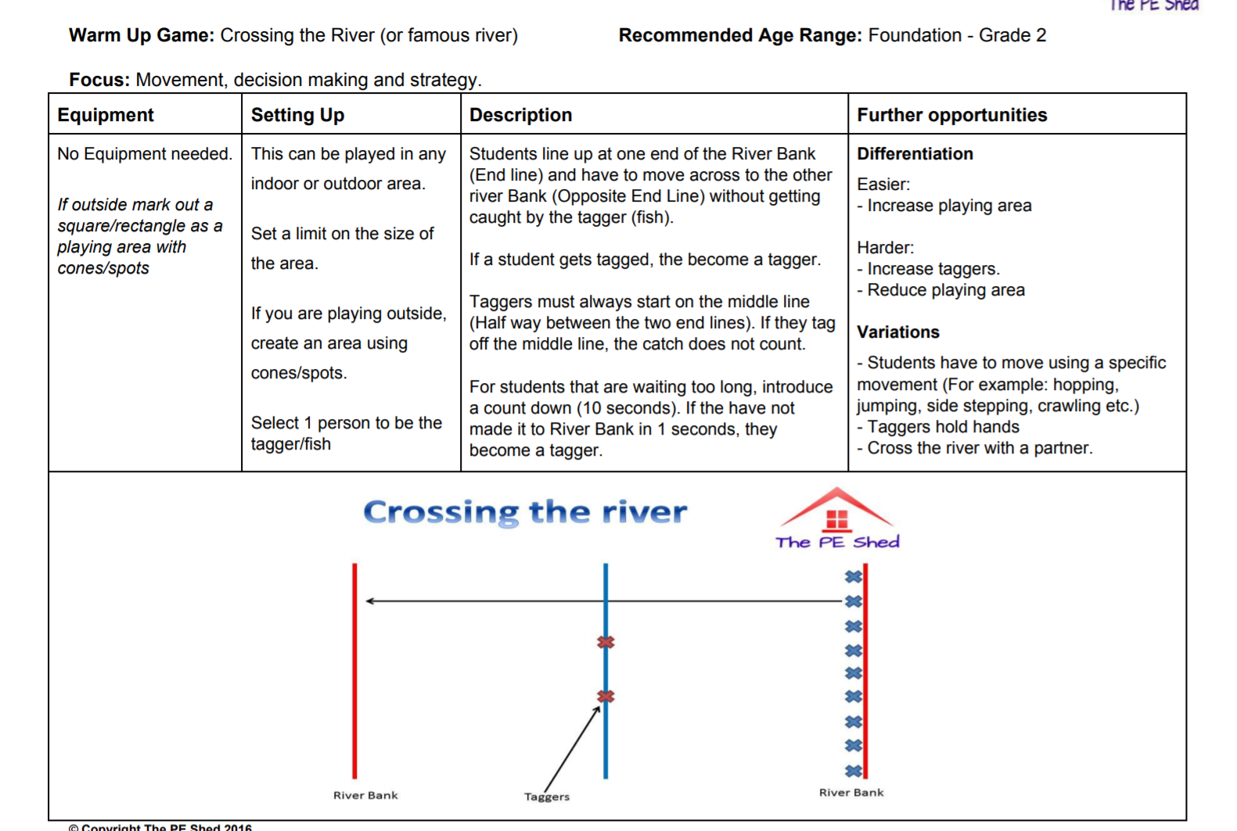

PE 3

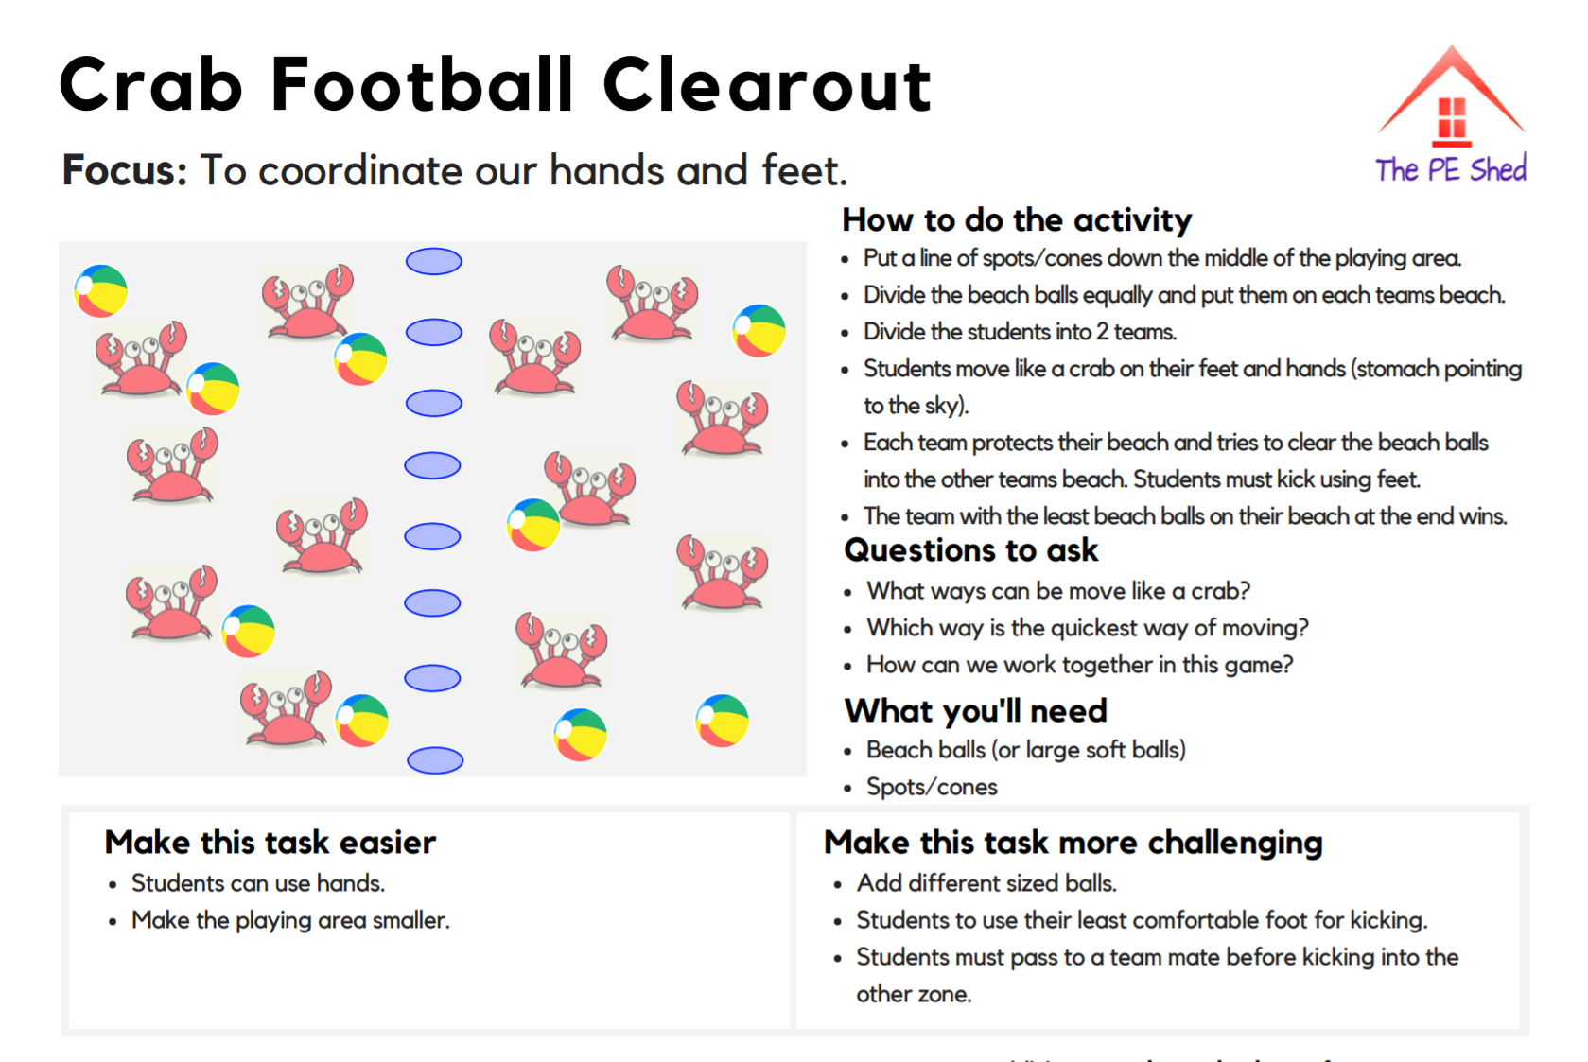

**PE 4**

