Week 11 Attachments.
Attachment 1: “Camping Trip” new wordlist
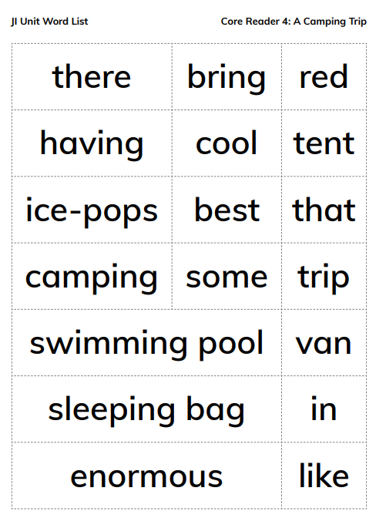
- Red, tent, bring, cool, that, having, best, trip, camping, van, sleeping bag, in, swimming pool ( words that can be sounded out)

- There, ice-pops, some, like, enormous (words that will need to be learned)

Attachment 2: Oral Langauge Poster

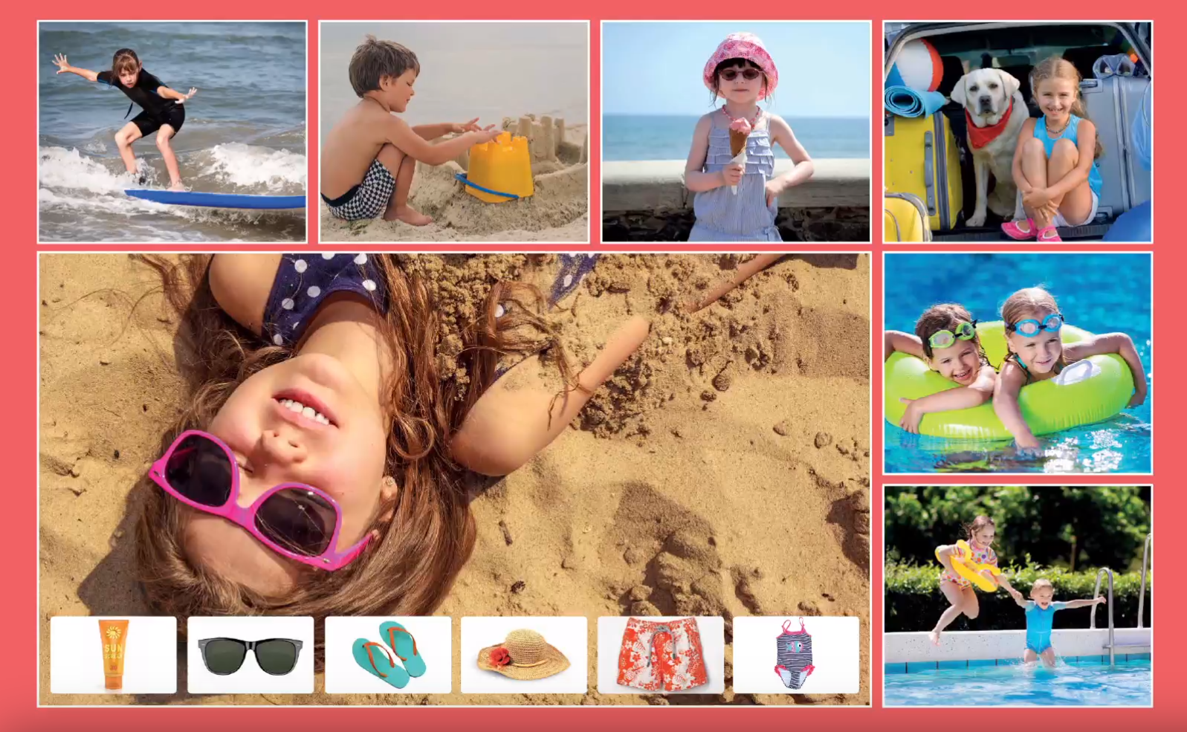
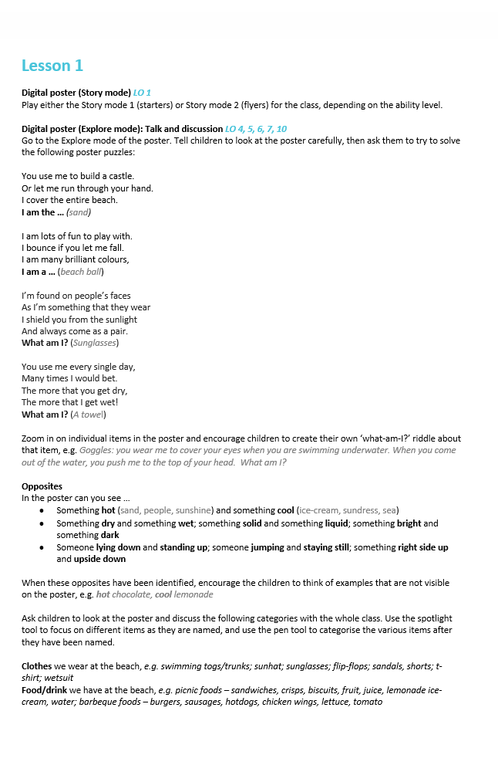

Attachment 3: “ue” words

fuel value argue rescue avenue statue

Attachment 4: A Camping Trip
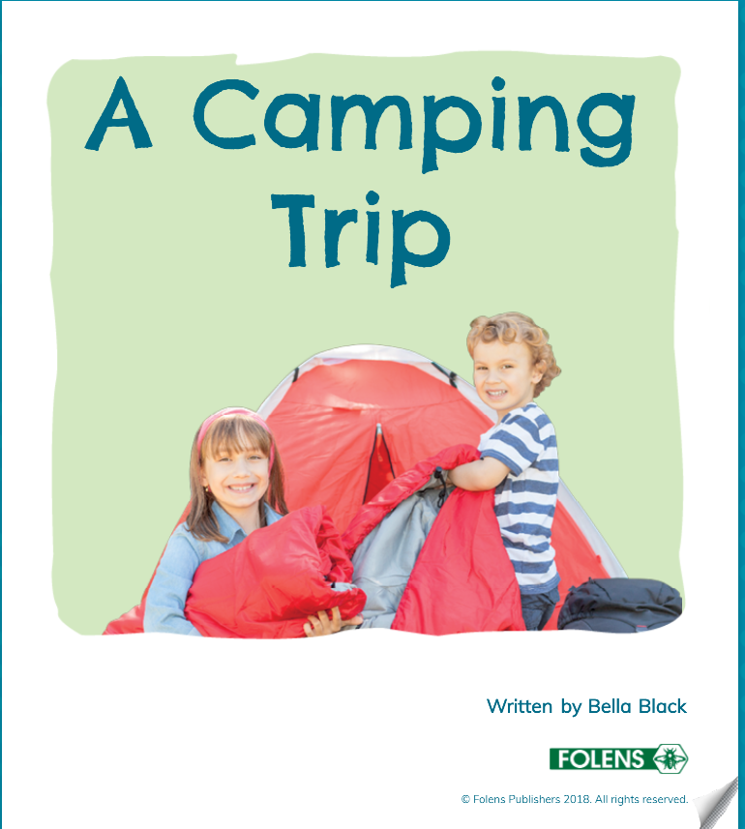

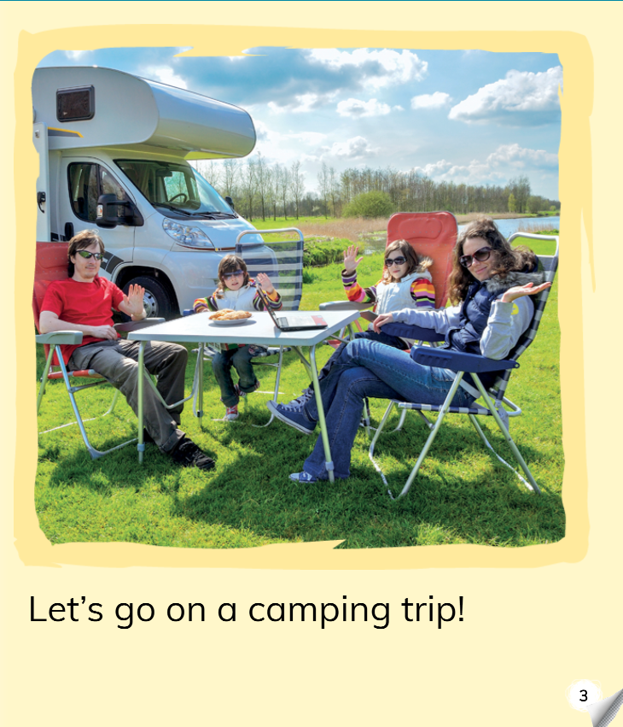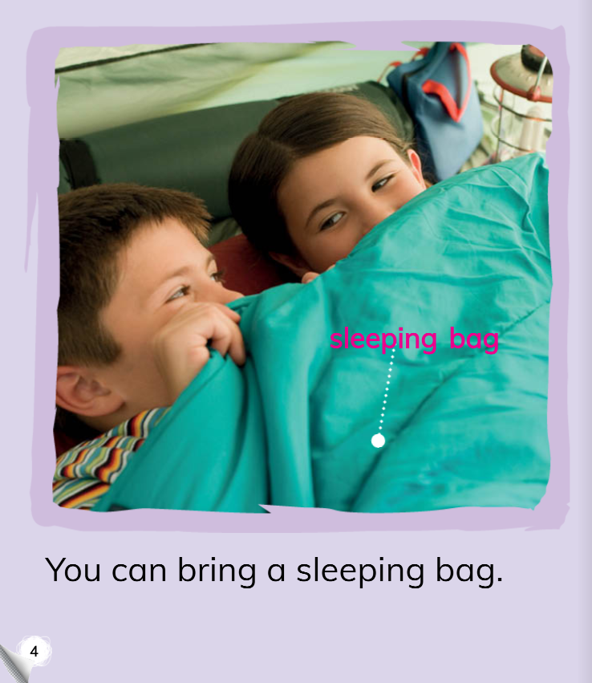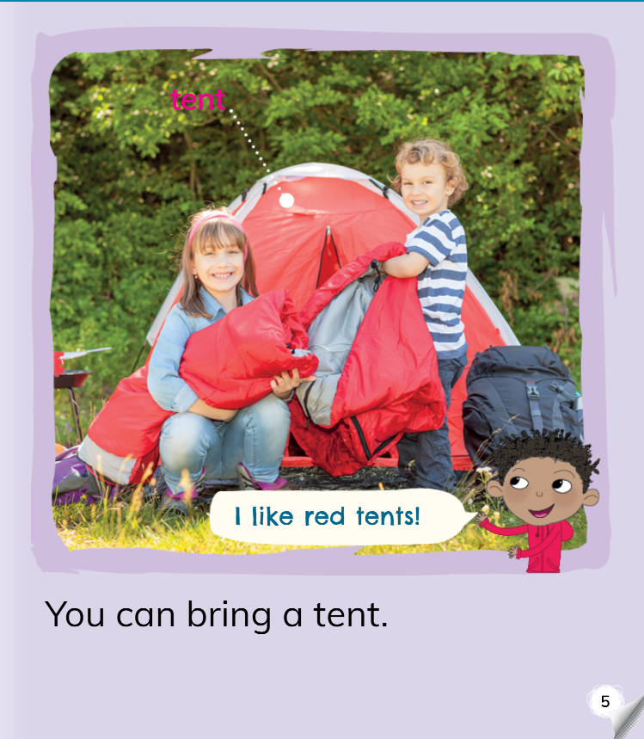

Attachment 5:
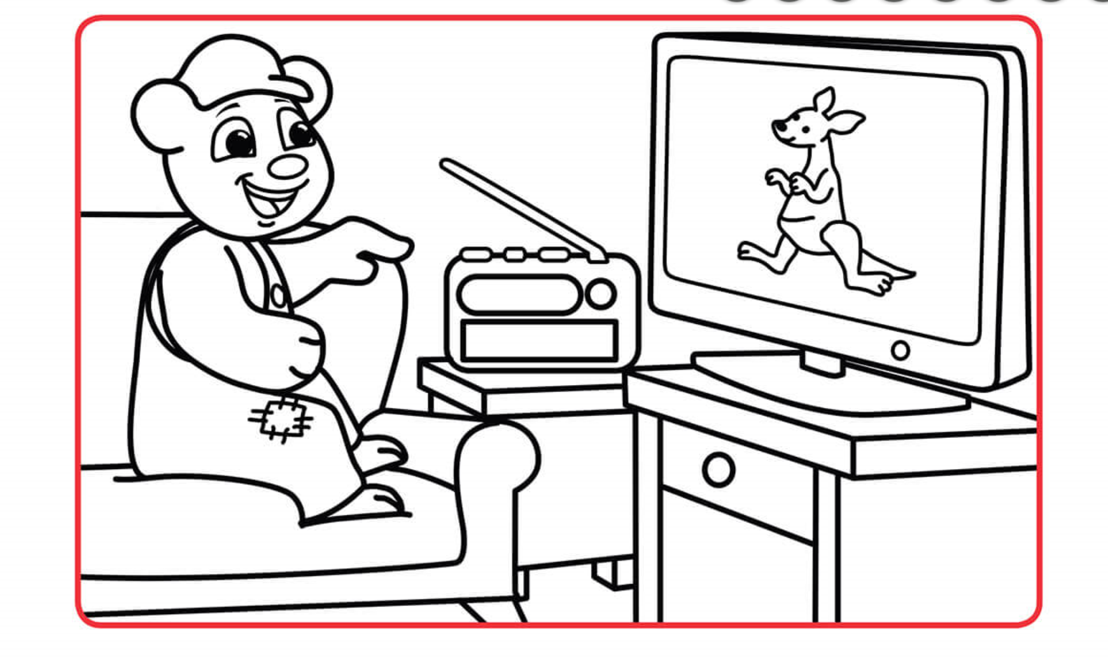
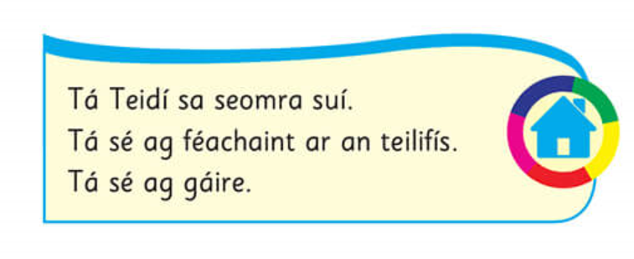

Attachment 6:

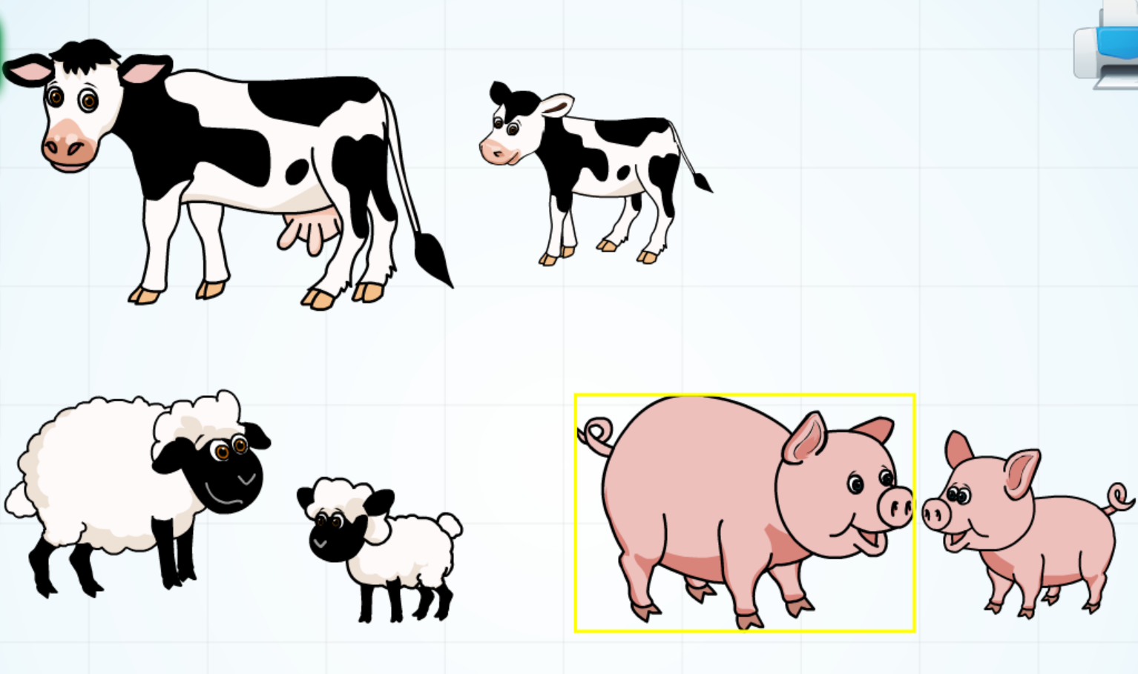

Taispeáin dom___.
Cad é sin? Sin___.

Attachment 8:

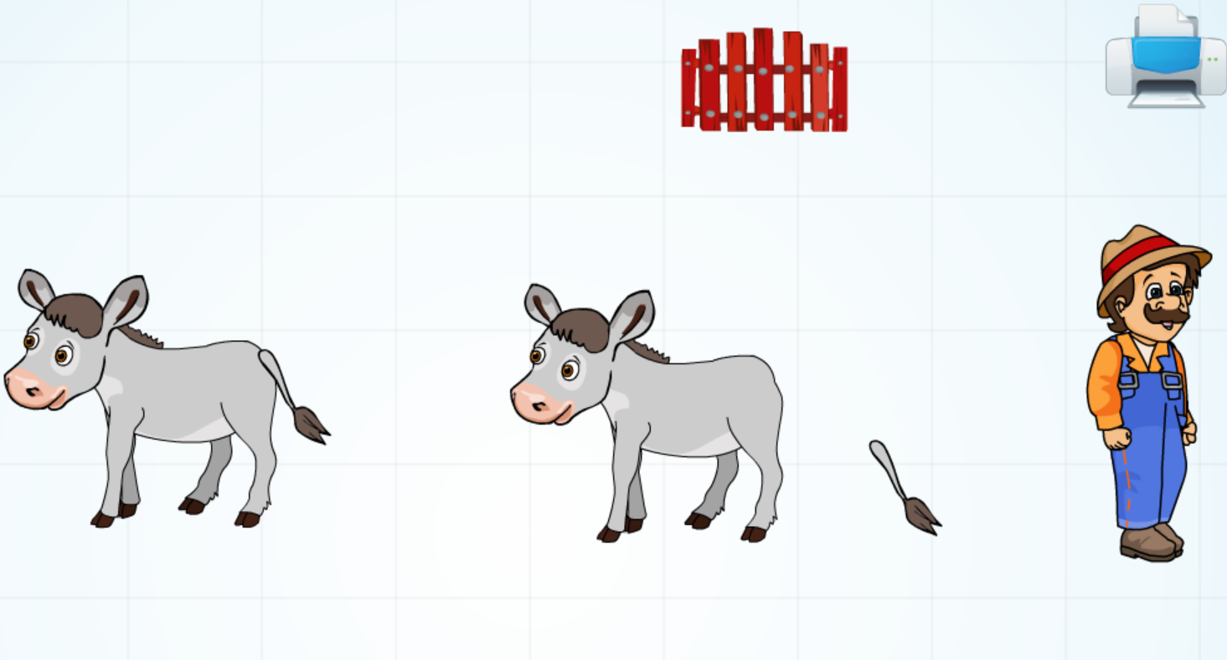

Attachment 9: Maths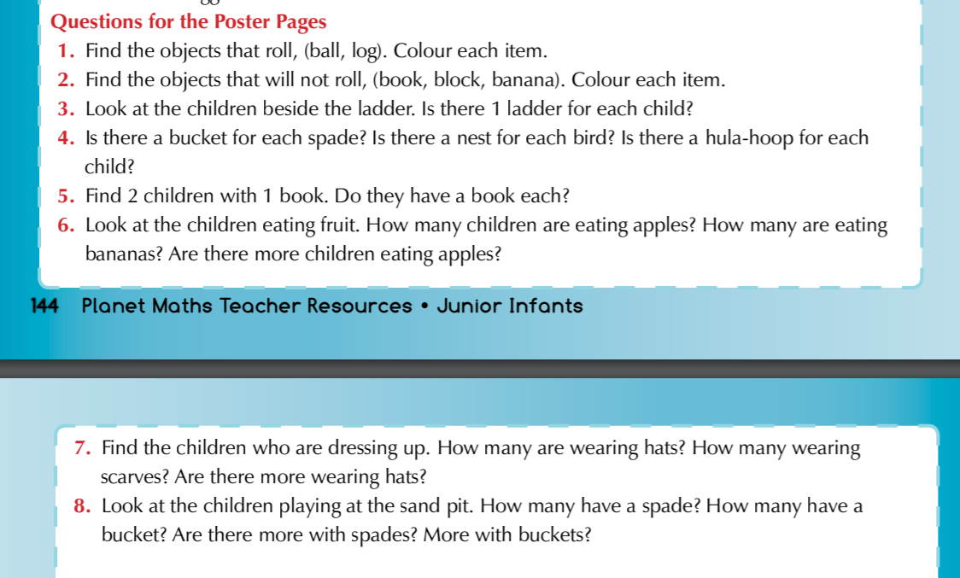

Attachment 10: 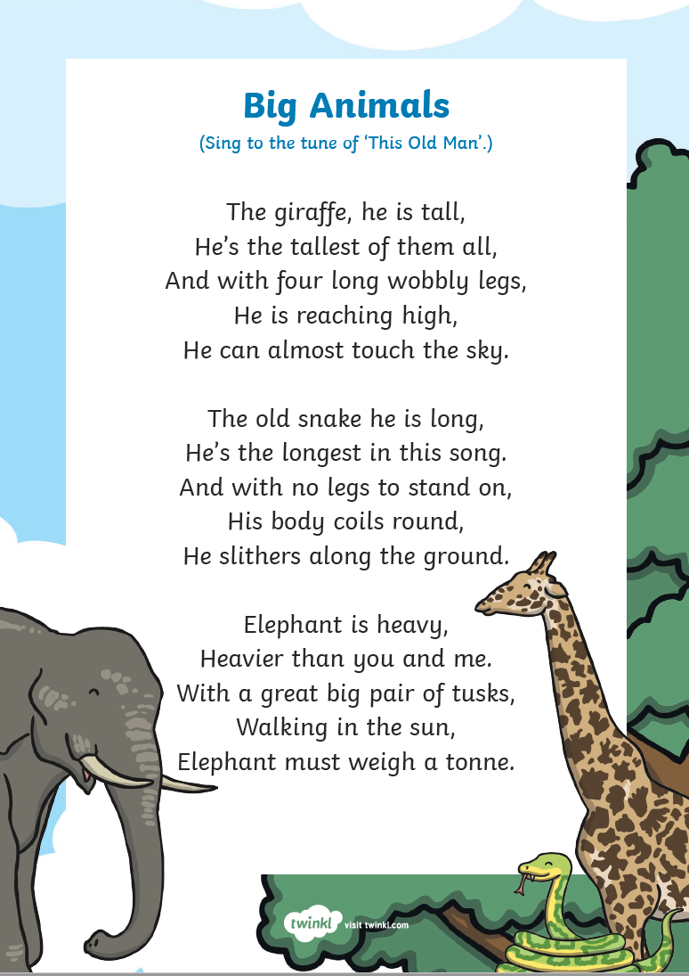

Attachment 11: Sequencing cards
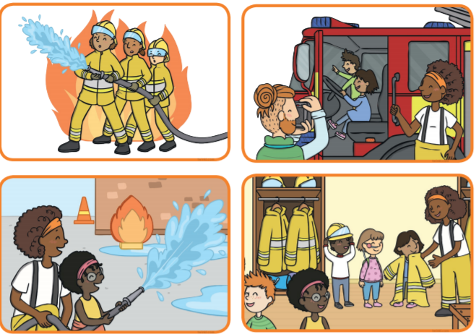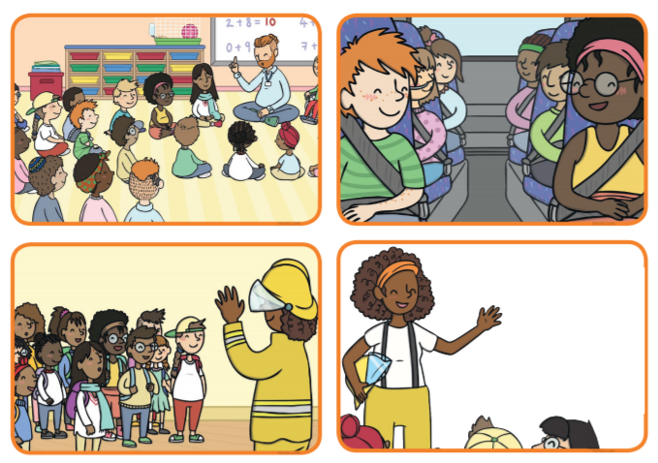
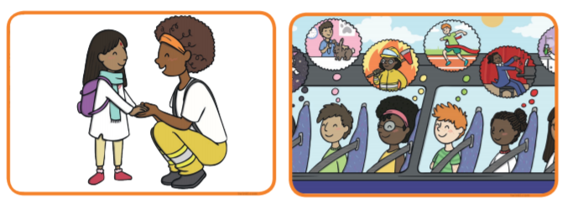

Attachment 12
