Scoil na Croise Naofa
Geashill
Co. Offaly
geashillnsoffice@gmail.com
www.geashillns.ie
Dates for your Diaries:
- Confirmation takes place on Friday 13th March in Ballinagar Church at 2.30pm.
- Friday 13th will also be a non-uniform day. Children can wear something green if they wish. A donation of €2 per family can be made to our Parents’ Council.
- School is closed on Monday 16th and Tuesday 17th March for St. Patrick’s weekend.
- School closes for the Easter holidays at 12.30pm on Friday 3rd April.
- School re-opens after Easter on Monday 20th April.
Coronavirus Information
It is our aim to protect our pupils, their families, our staff and the wider community, where possible, from contracting or transmitting the virus.
In school every day the pupils in all classes are reminded of the importance of regular hand hygiene. As you know, hand washing with soapy water is the best way to prevent the spread of this infection.
We are also reminding pupils to refrain from touching their faces with their hands.
We have also practiced the advised coughing technique. We encourage all parents to reinforce these guidelines with children at home.
We are also regularly cleaning and disinfecting all frequently touched surfaces.
More information can be found on the HSE website at www2.hse.ie. There is a link to this on our own website also. Our website will be updated to reflect the latest advice from the HSE.
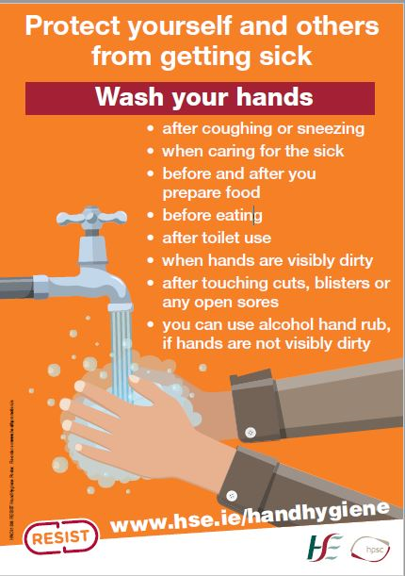

Board of Management:
We held our last board meeting on Monday 27th January. Our 2020 Child Safeguarding Statement was ratified at the meeting. We also carried out our annual review of child safeguarding procedures.
To find out more about issues discussed you can read a report from the meeting on our website.

Website
It has been an extremely busy few weeks since we started the new term in January. We have had great success in quizzes, a photography competition and our Bottlebusters did very well in Limerick. We have been doing a huge amount of activity such as football, hurling, tag rugby and swimming. Our Lunchtime Leaders have been trained and leading the younger children in structured games at lunchtime. To find out more about all of these activities please look at our website on www.geashillns.ie. There is also information on healthy lunches, internet safety, treatment of headlice as well as the upcoming important dates.

Yours Sincerely,

Mícheál Hyland

