**Week 9 Attachments.**

Attachment 1: New Words from “Fish and Chips”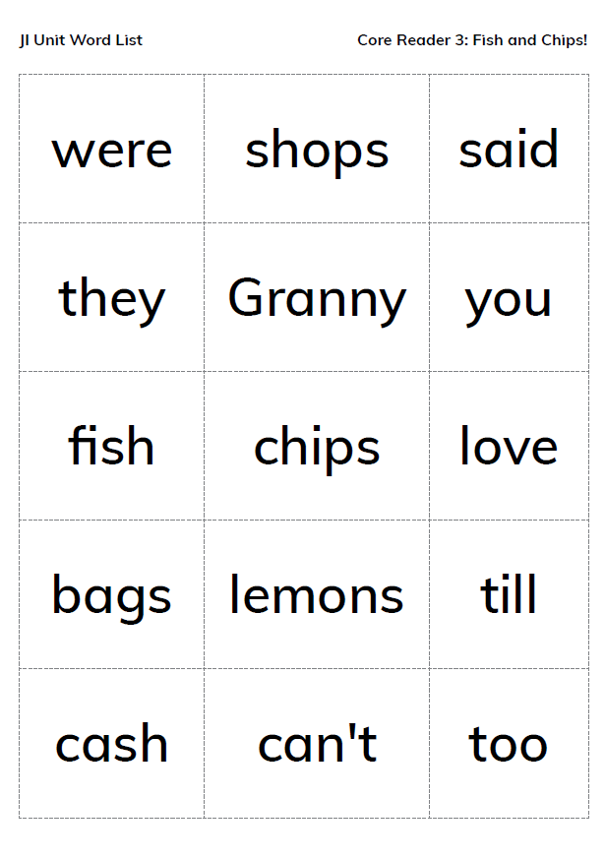

The following words the children will be able to sound out: shops, fish, chips, bags, lemons, till, cash, can’t. The rest are TRICKY words that the children will be required to learn from memory

Attachment 2: Oral Language Poster

**The Supermarket**

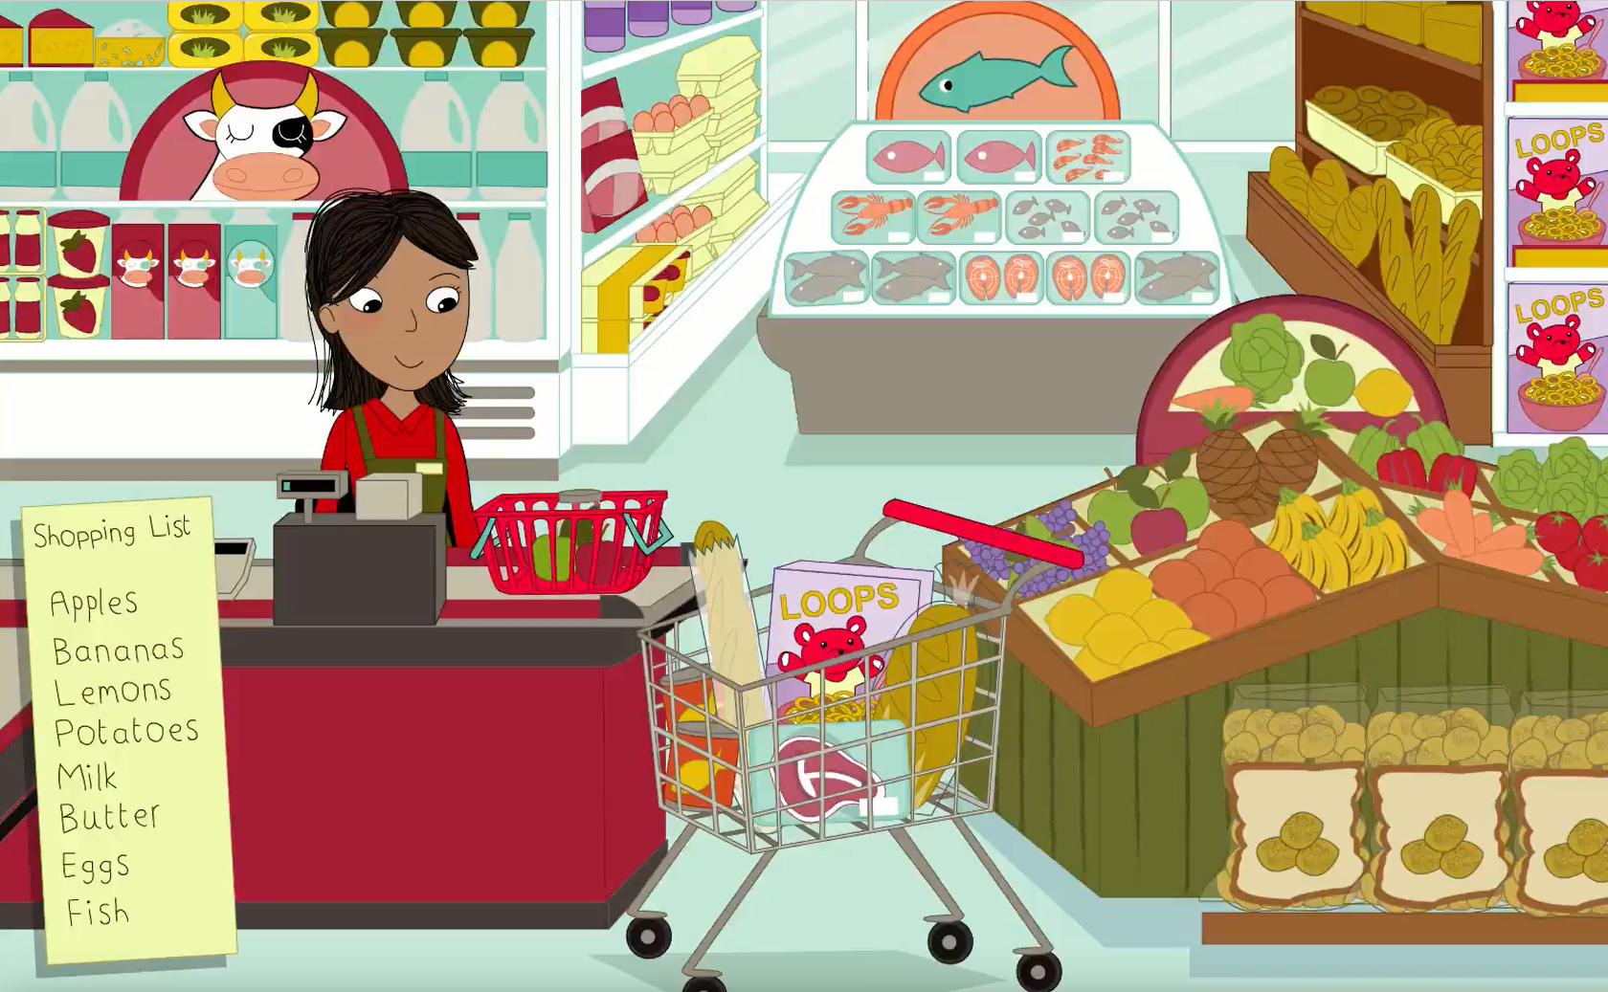

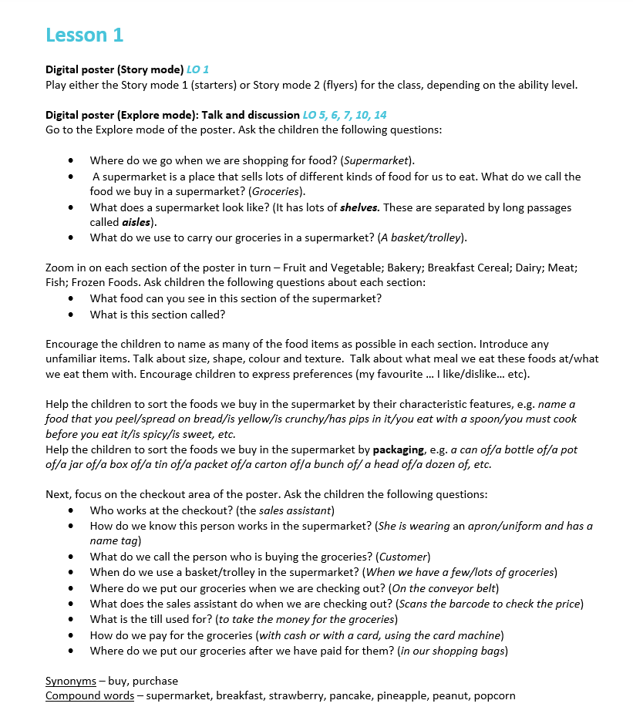

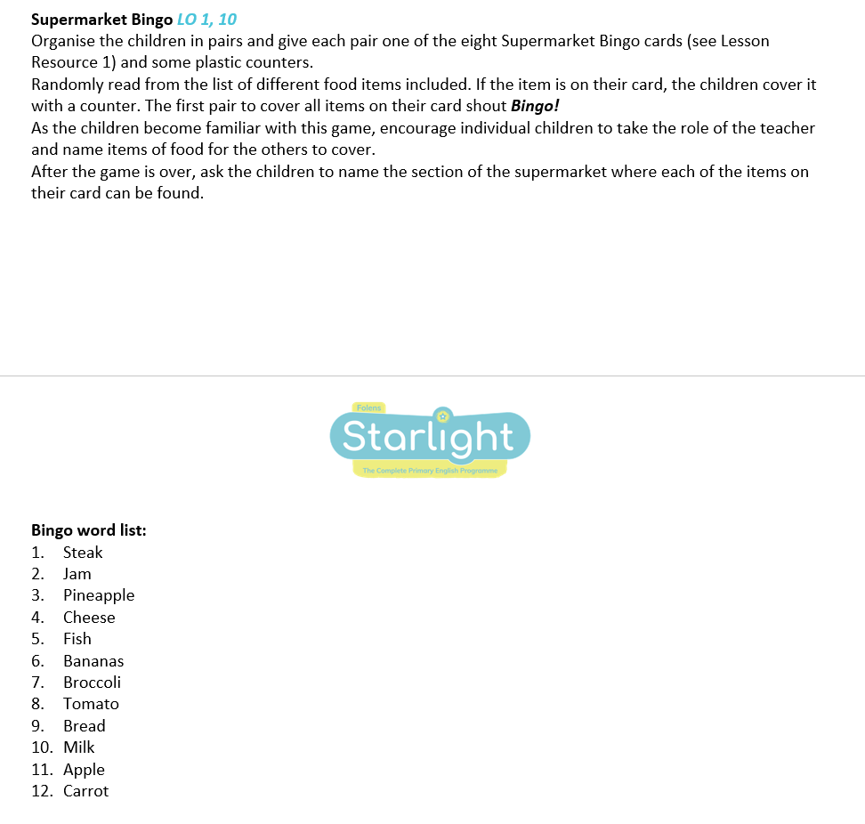 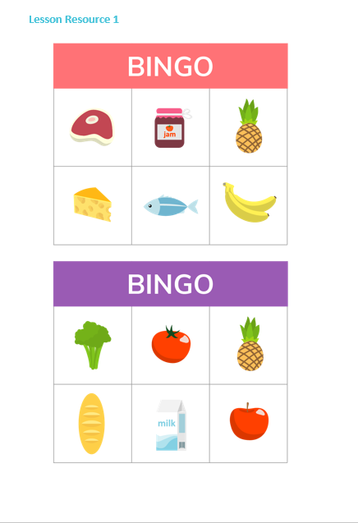

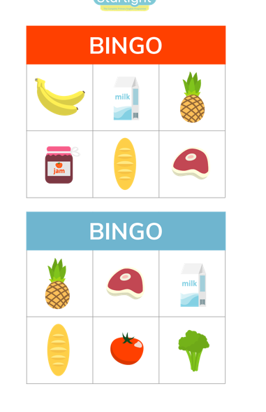Attachment 3 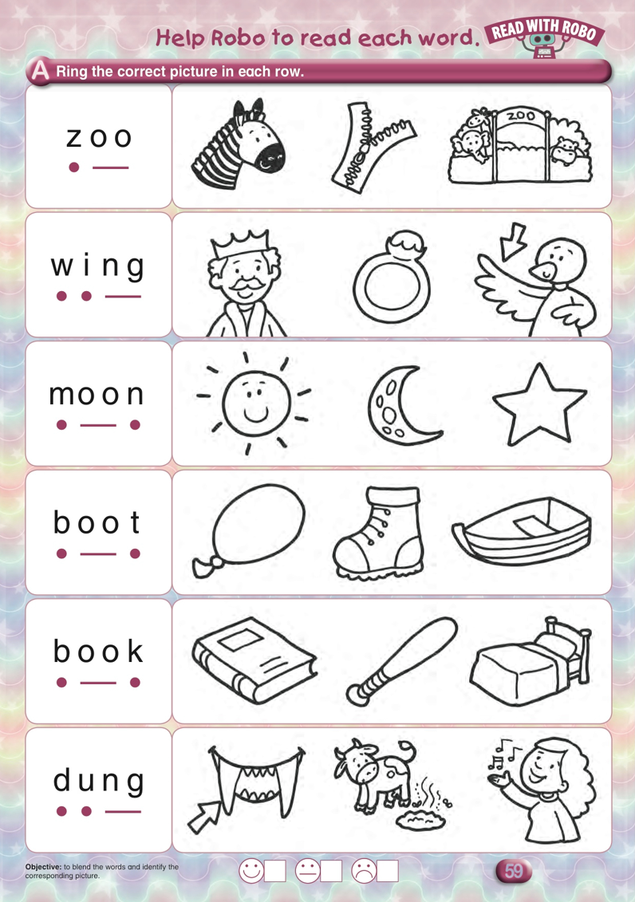

Attachment 4: “ou” Sound

cloud ouch couch loud

mouth round

Attachment 5: Phonics

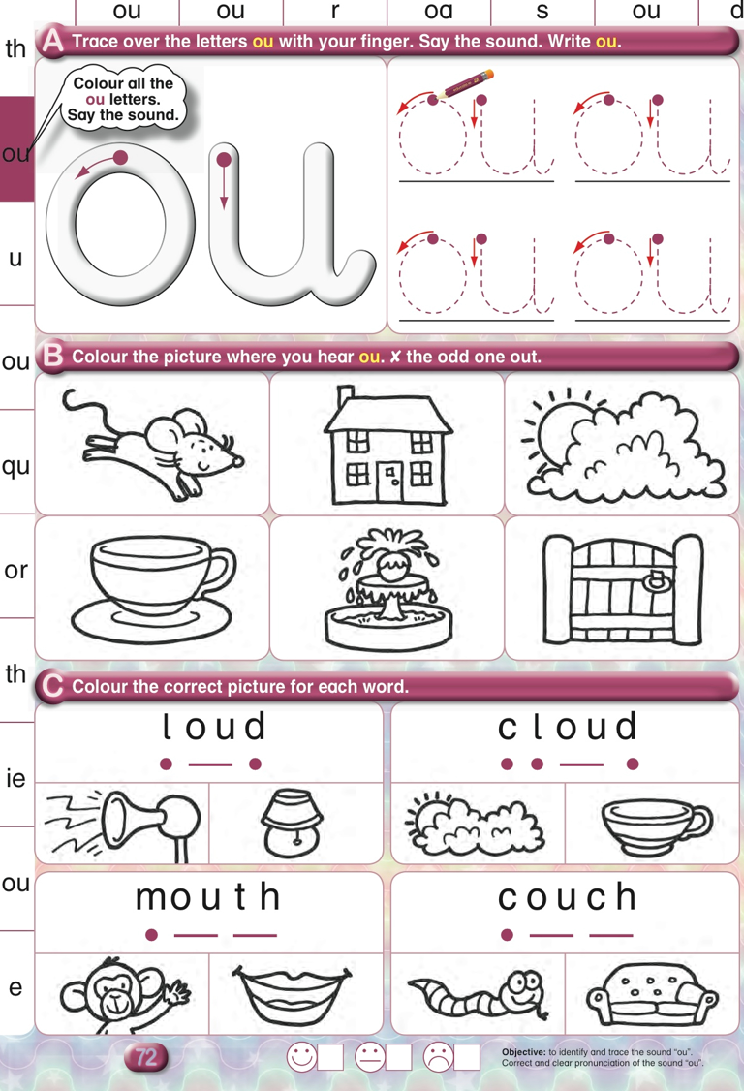

Attachment 6

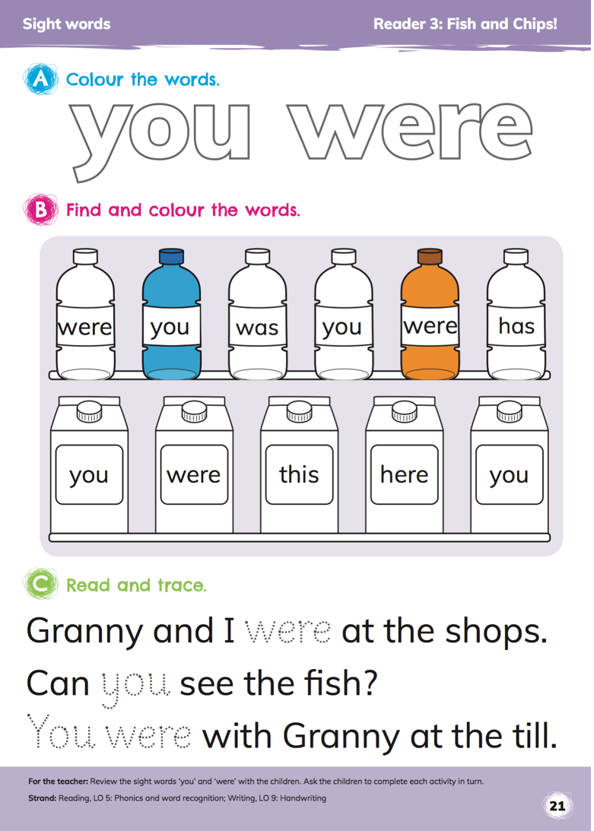

Attachment 5:

Doras 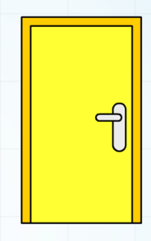 fuinneog 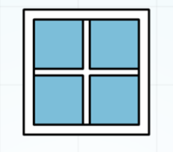 stól 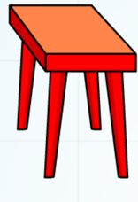

clog 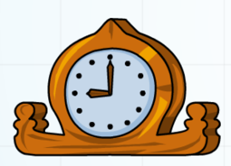 bord 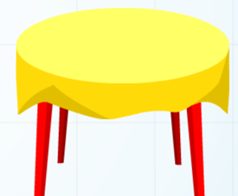 cathaoir 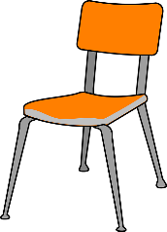

cófra 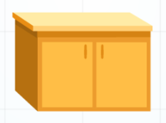 Tá bainne **ar an** mbord (Milk is on the table) Tá subh **ar an** mbord. ( Jam is on the table)

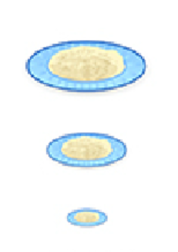

Pláta **an-mhór**

Pláta **mhór**

Pláta **bheag**

Attachment 6: 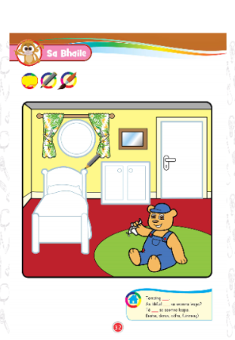

Tarraing leaba, cófra, doras agus fuinneog. Draw the bed, press, door and window.

An bhfuil leaba sa seomra leapa?Tá leaba sa seomra leapa

An bhfuil doras sa seomra leapa? Tá doras sa seomra leapa.

An bhfuil bláthanna sa seomra leapa? Níl bláthanna sa seomra leapa

Attachment 7: Cinnín Óir ( Goldilocks)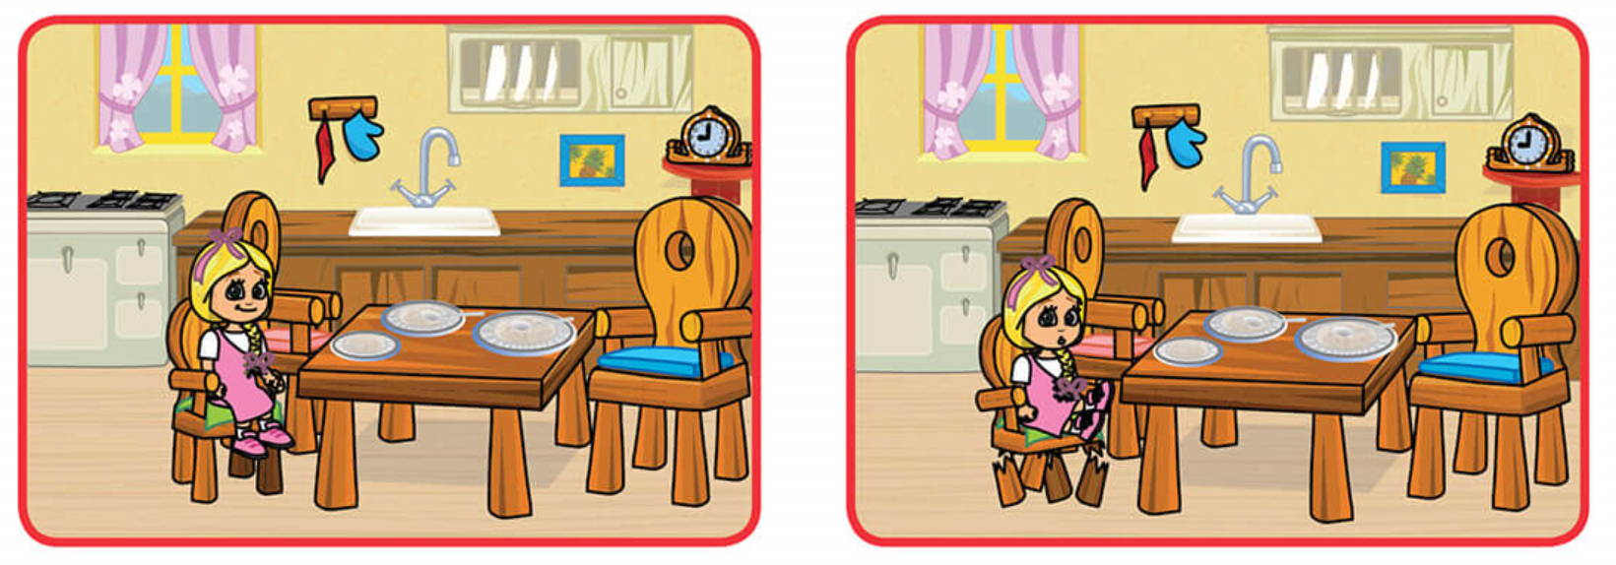

Shuigh Cinnín Óir ar an gcathaoir. Bhris sí an chathaoir

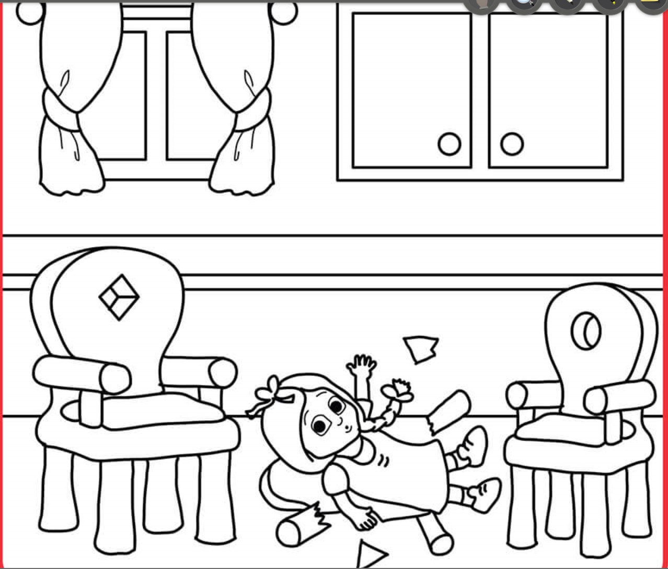

Thit sí ar an talamh

Attachment 8:

**Measúnú - Sa Bhaile**

**Question 1: Cad é sin?  **

|  |  |
| --- | --- |
| **1.** |  |
| **2.** |  |
| **3.** |  |
| **4.** |  |

**Answers: Sin doras, bord, cathaoir, leaba . /4**

**Question 2:** Taispeáin dom: (show me) The children just need to point to the correct picture.

|  |  |
| --- | --- |
| Taispeáin dom cathaoir bheag. |  |
| Taispeáin dom Cinnín Óir. |  |
| Taispeáin dom pláta an-mhór. |  |
| Taispeáin dom simléar. |  |

/4

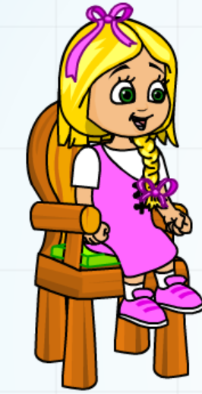 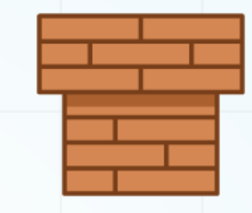 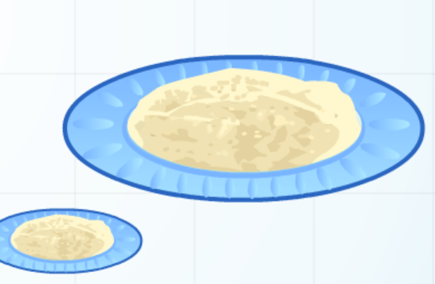

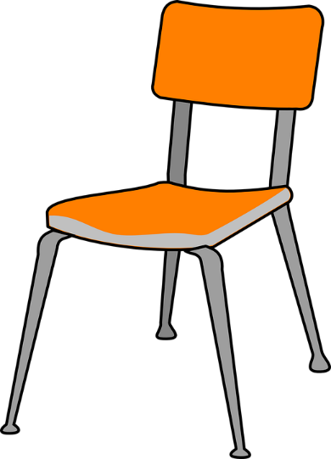 

**Question 3:** Cuir úll agus cáca ar an mbord. Put an apple and cake on the table. (Draw with pencil**) 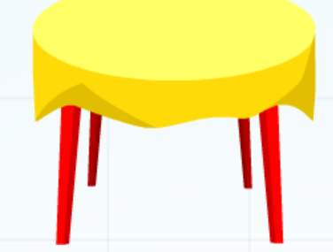 /2**

**Question 4:**

* Dathaigh uimhir a dó glas. (Colour number 2 green)
* Dathaigh uimhir a cúig oráiste.( Colour number 5 orange)
* Dathaigh and banana buí. (Colour the banana yellow)
* Dathaigh and leaba gorm. (Colour the bed blue.) /4

 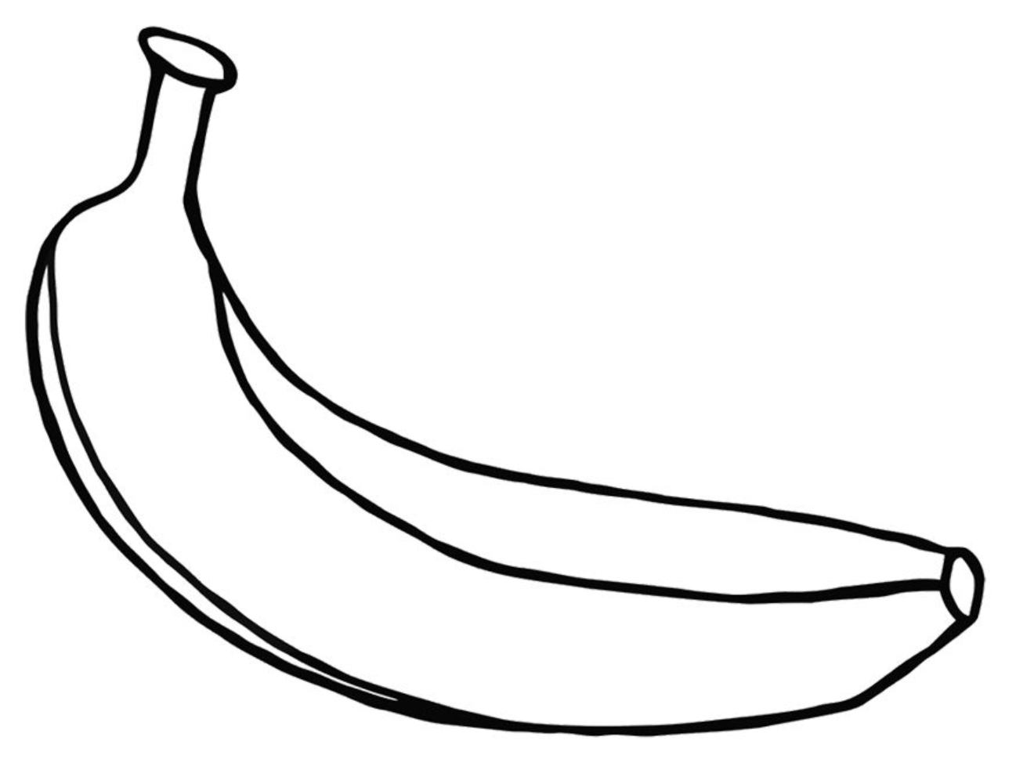

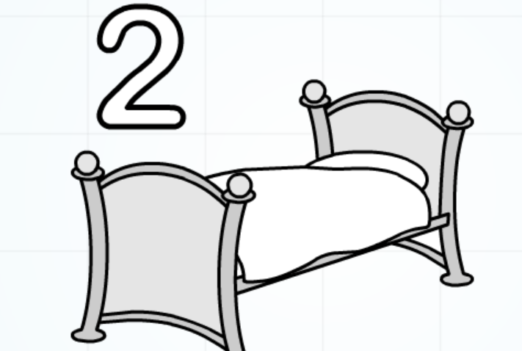

**Question 5:** Tarraing fuinneog. (Draw a window) /1

Total : /15

Attachment 9: Maths

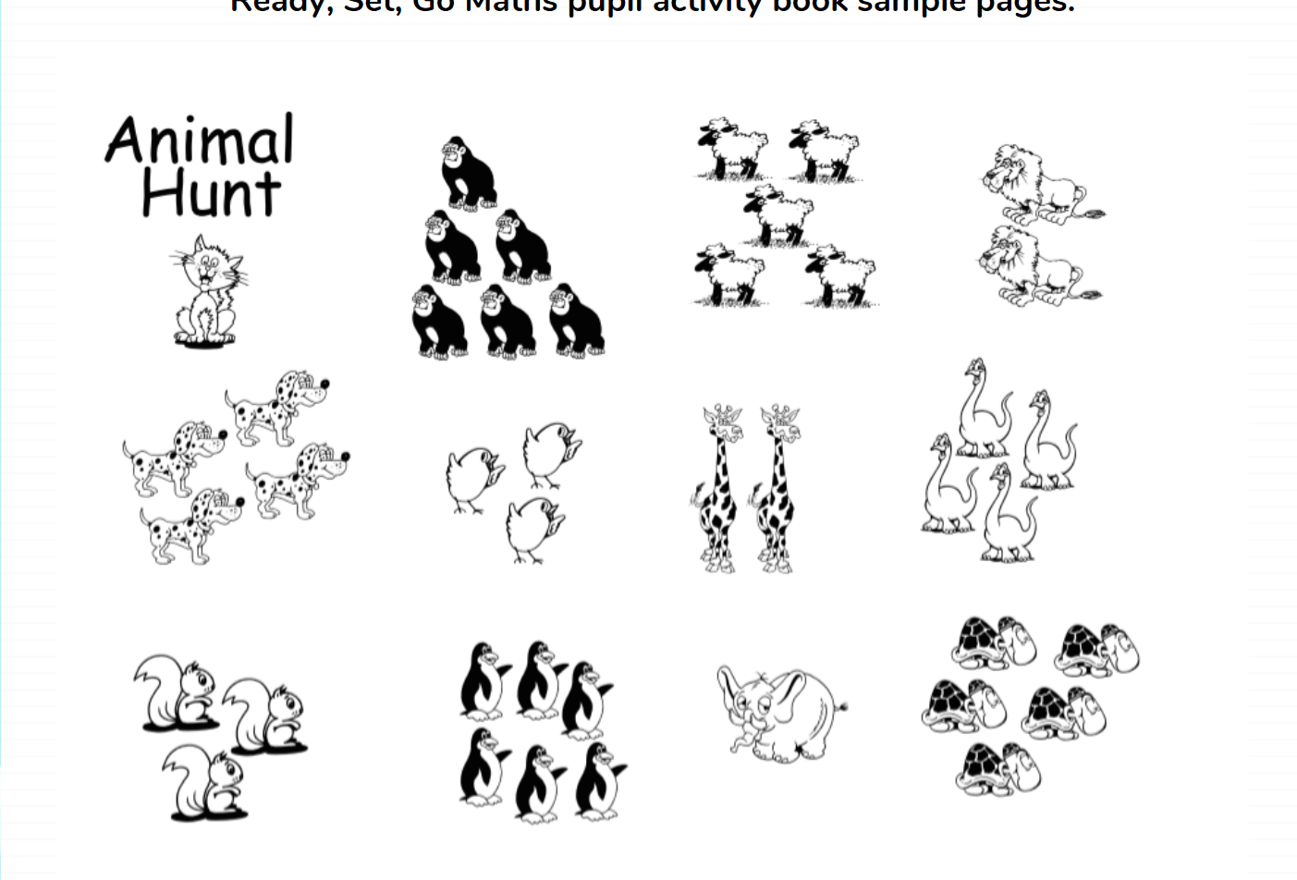

Attachment 10:

1 2 3 4 5 6 7 8 9 10

Attachment 10:

