**Week 8 Attachments.**

Attachment 1: Revision of ch, sh & th

chip shop three

chin shut thorn

chop fish thin

Attachment 2: “Just Phonics”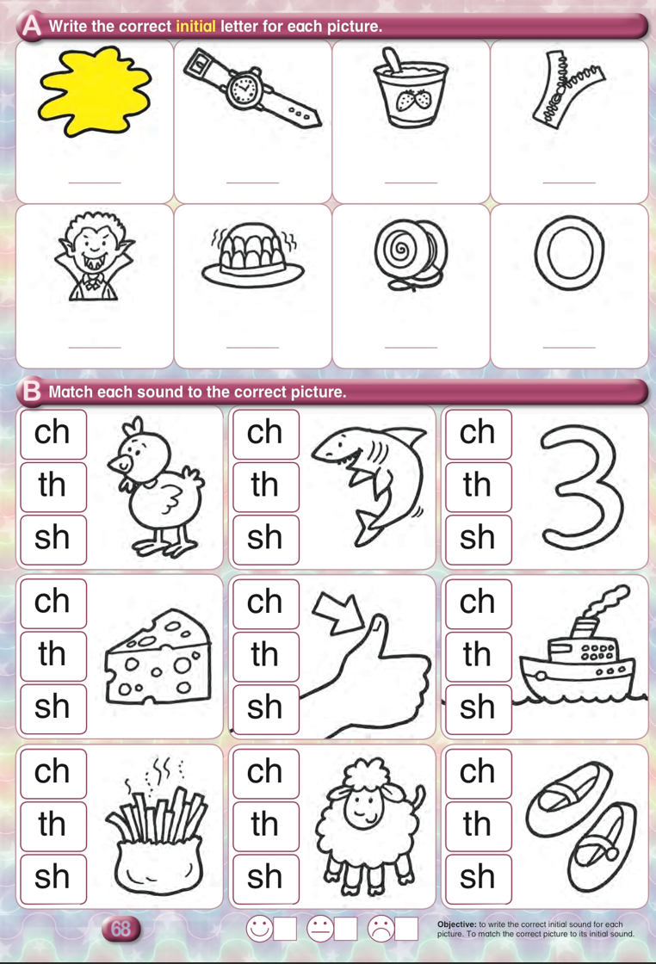

Attachment 3

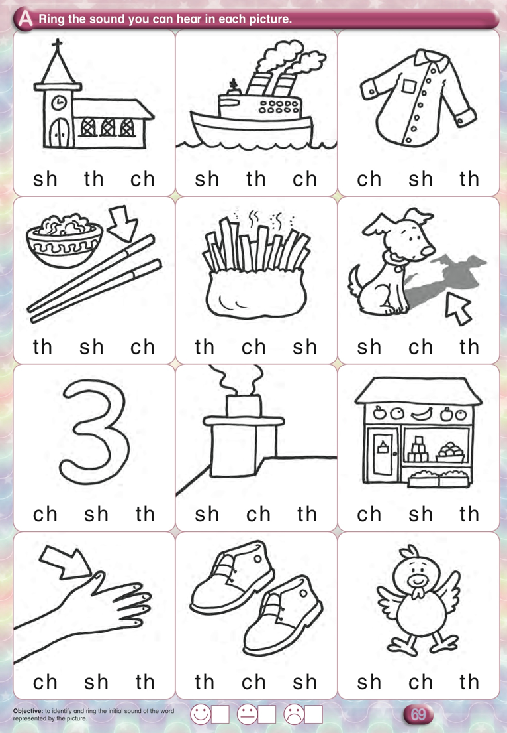

Attachment 4: “Let’s Make Pancakes” Skills Book

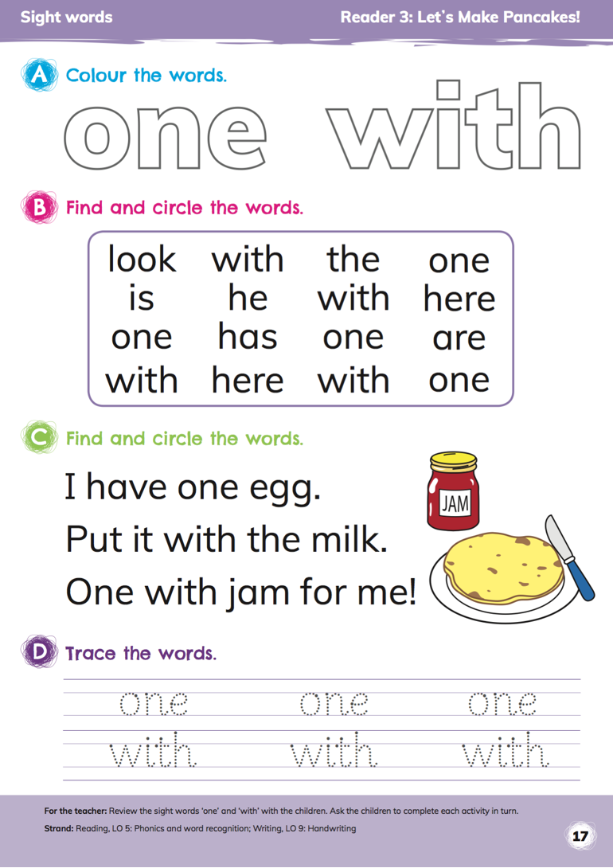

Attachment 5: Assessment

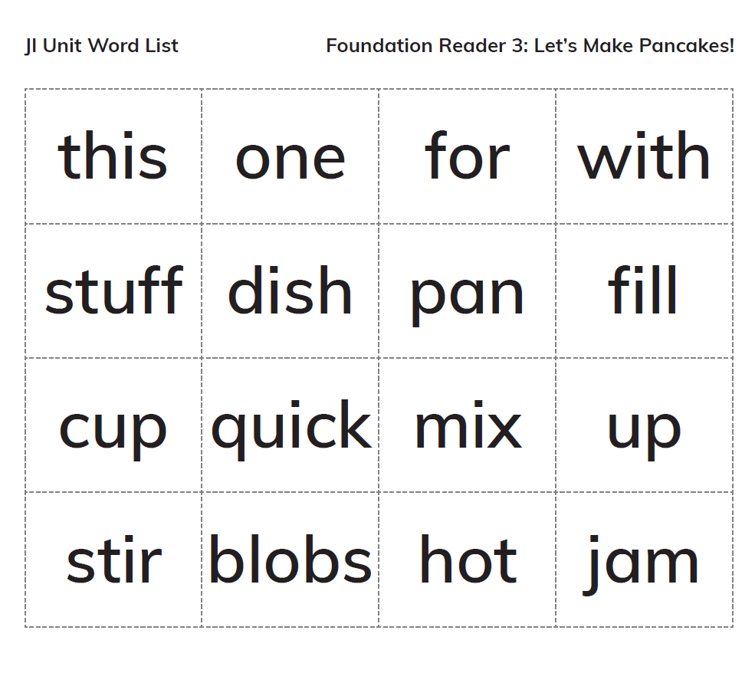

Attachment 6:

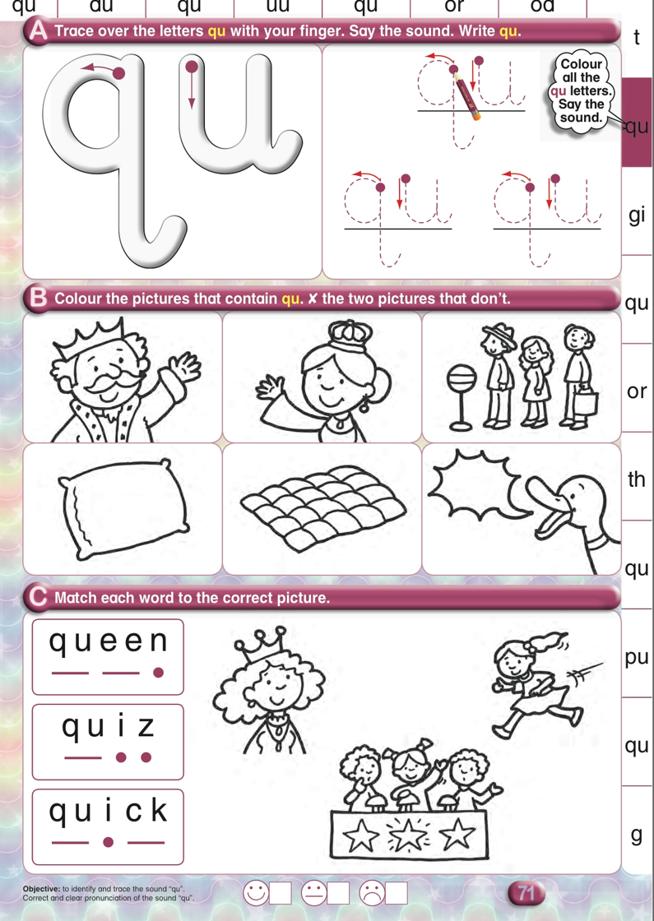

Attachment 7: 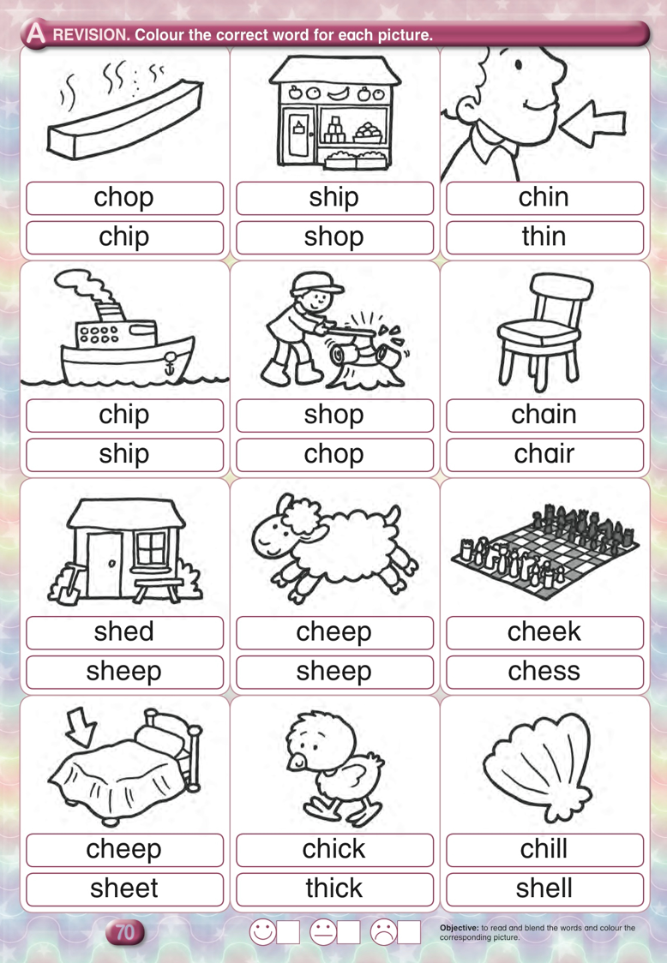

Attachment 8:

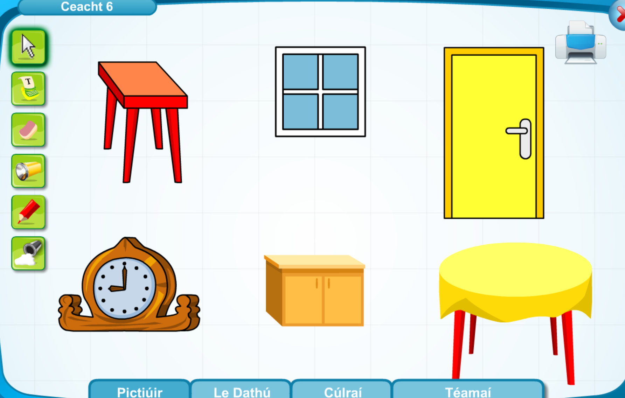

Attachment 9:

Dathaigh an cófra, doras, stól, cathaoir agus bord. Colour the press, door, stool, chair and table.

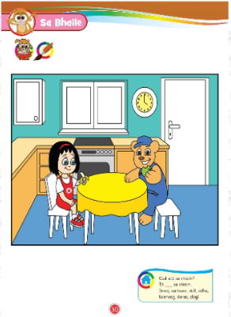

Attachment 10:

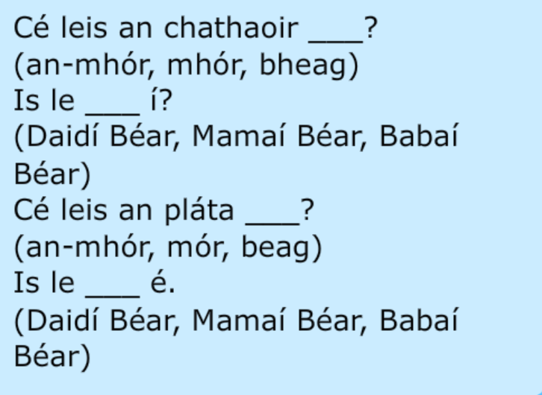

**Attachment 11:** 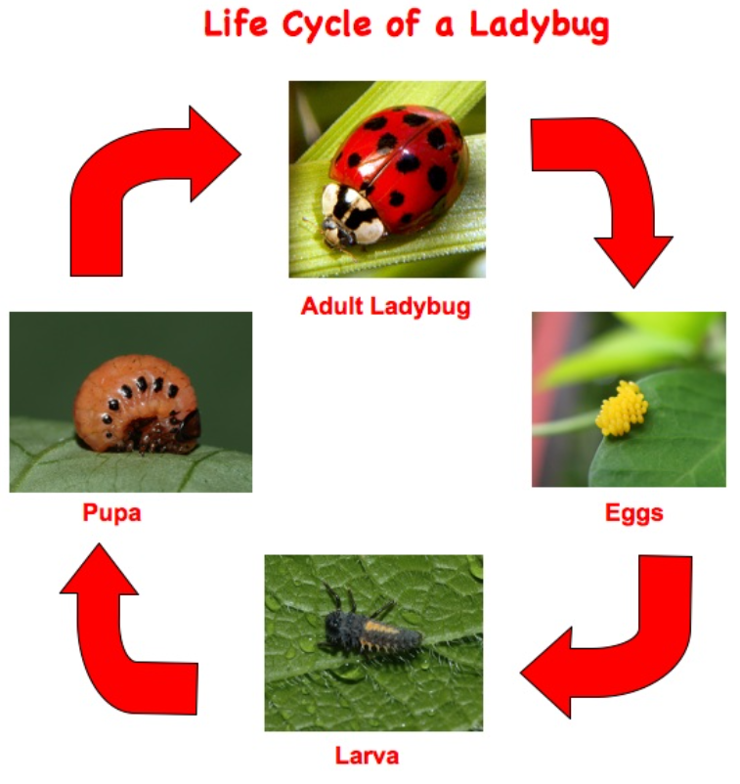

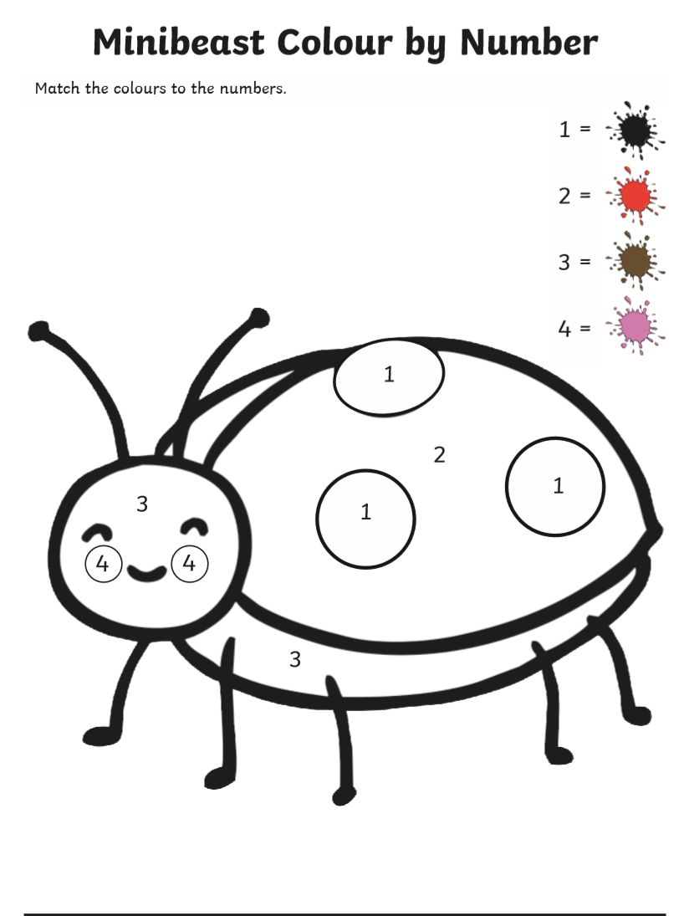

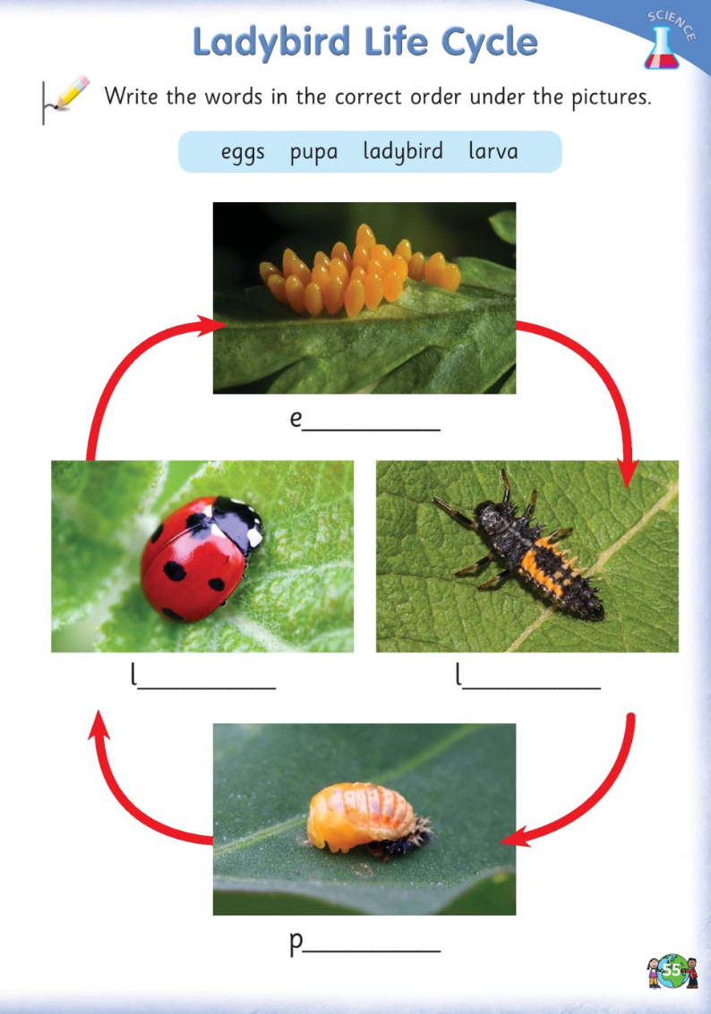

Attachment 12:

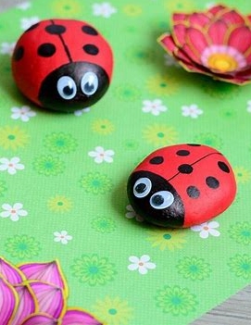You could use stones and paint.

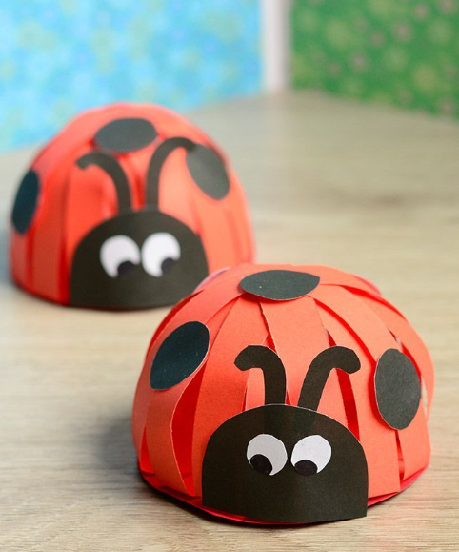You could you coloured paper.

You could use a paper plate and string. 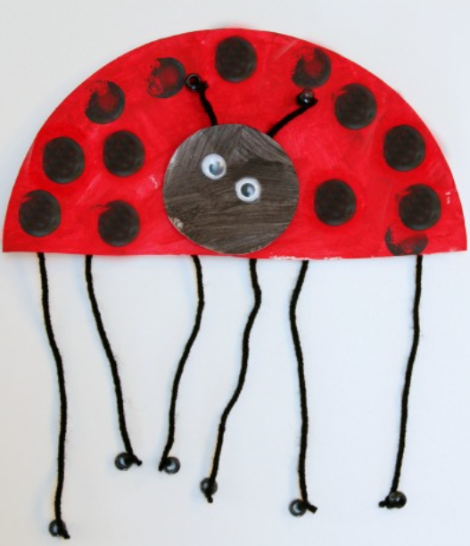

**Try your best to send me a picture of your ladybird and I will make a collage of them all for you to see.**

**Attachemt:13**

