Attachment 1- 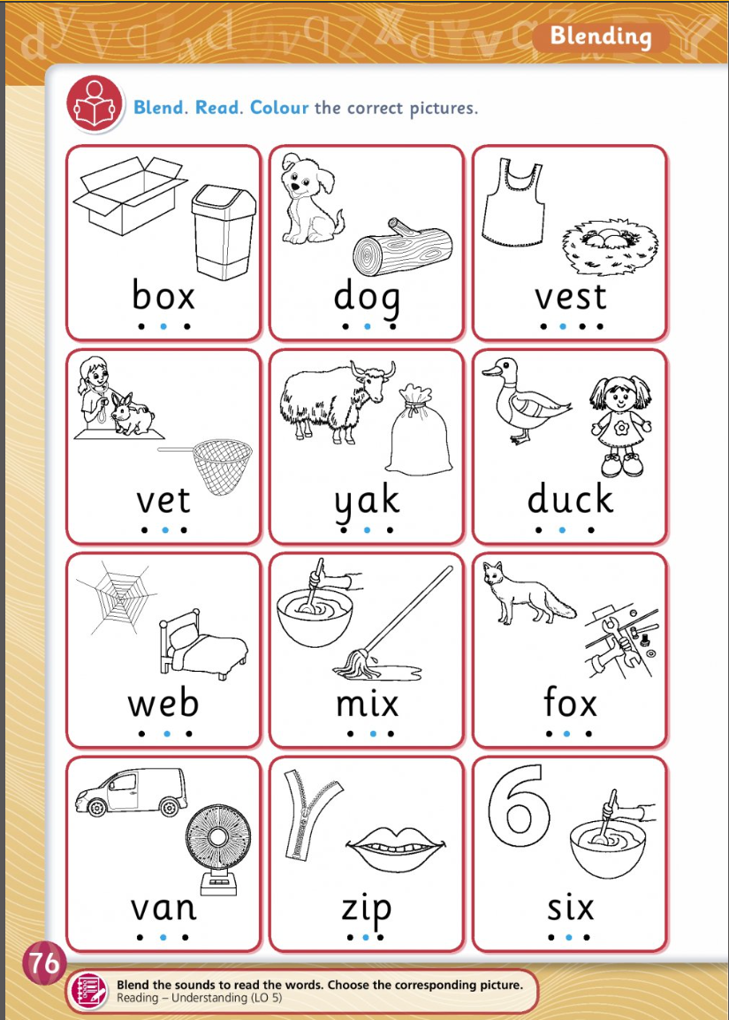

Attachment 2: 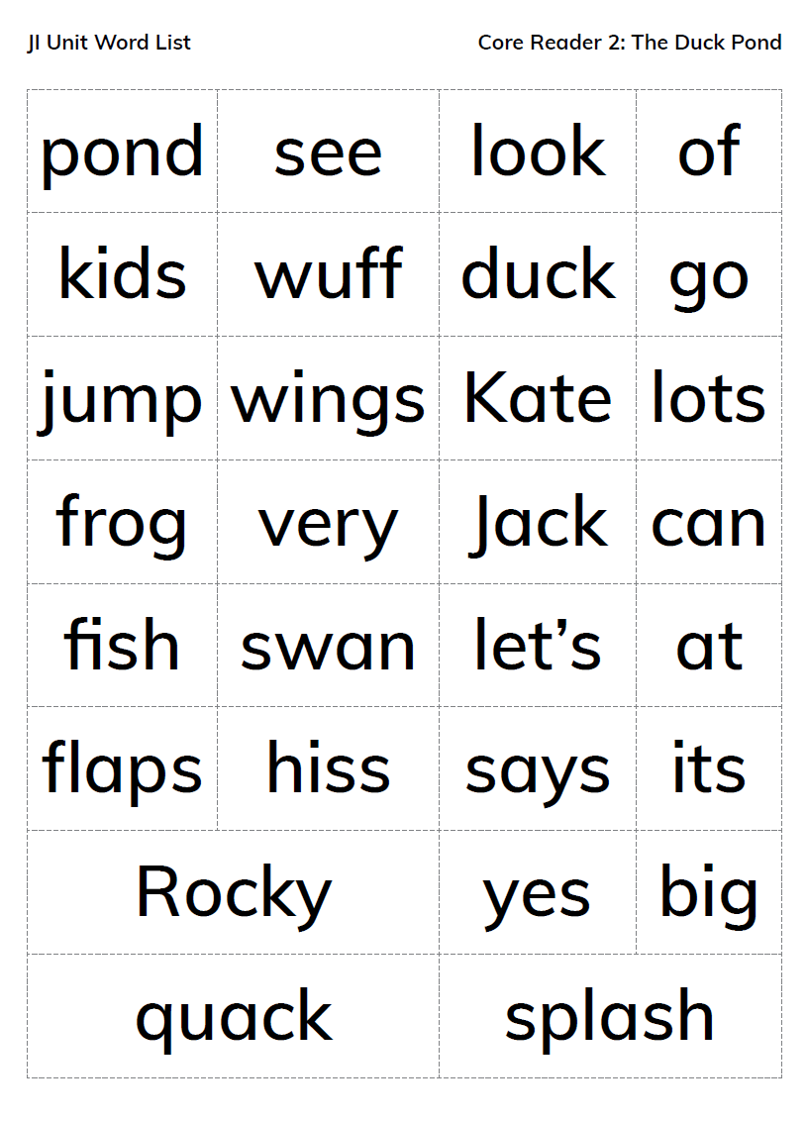

Attachment 3: Food word games LO 5, 6
- Name a food that is red (red pepper; apple; tomato; strawberry; raspberry; red onion; watermelon); yellow (cheese; banana; pineapple; yellow pepper; lemon; melon); green (peas; kiwi; cucumber; cabbage; celery; avocado); purple (grapes; cabbage; cherries; plums; aubergine); orange (oranges; orange peppers; carrots; sweet potatoes; pumpkins), etc.
- Name a food that is crunchy (cornflakes, crisps, toast); juicy (tomatoes, oranges, lemons); creamy (yoghurt, ice-cream, hummus, macaroni cheese, chocolate)
- Name a food that is cold (ice-cream, ice-pops, yoghurt, cheese) hot (pizza, pasta, soup)
- Name a food that you can peel (banana, carrot, potato, kiwi)

Pair talking tasks LO 4, 5, 6
What foods do you like?
Play the song Do you Like Lasagna Milkshakes? (https://www.youtube.com/watch?v=13mftBvRmvM) for the whole class, inviting the children to sing along.
Organise the children into pairs. Give them the following talking task instructions:
- Turn to your partner and describe for him/her the kind of pizza you like (e.g. I like a cheesy/crunchy/ fresh/hot/crispy/salty/doughy/round/small/large/yummy/tasty/delicious/scrumptious pizza).
- Ask your partner what he/she likes to eat for breakfast/lunch/dinner/dessert/supper. Ask them to explain why (e.g. I like to eat cereal for breakfast because it is crunchy and delicious; I like to eat mashed potatoes for dinner because they are scrumptious and creamy; I like to eat strawberries for dessert because they are sweet and juicy).
- Now tell your partner what foods you dislike (don’t like), (e.g. I dislike porridge/beetroot/Brussels sprouts/mangoes because…)

Nouns: red pepper; apple; tomato; strawberry; raspberry; red onion; watermelon; peas; kiwi; cucumber; cabbage; celery; avocado; banana; carrot; potato; kiwi; dough; pizza base; tomato sauce; cheese, toppings – mushrooms
Adjectives: delicious; scrumptious; tasty; juicy; creamy; crunchy; horrible; disgusting; nasty; burnt; raw
Silly sentences
Read the sentences below out loud. Ask the children to discuss each sentence with their partner, identifying what’s wrong.
- At lunchtime I ate some milk and drank a sandwich.
- Yesterday Mum made brownies for dinner and shepherd’s pie for dessert.
- Alannah’s favourite breakfast is orange juice on toast.
- If I’m hungry between meals, I eat some ketchup.
- John cut his chicken with a spoon.
- Tim eats porridge for dinner every day.
- Dad fried some lettuce for dinner.
- My baby sister eats steak for breakfast every morning.
- Sarah made toast in the microwave.
- The first meal I eat every day is supper.

Now ask each child to make up a silly sentence of their own, tell it to their partner and see if he/she can guess what is wrong.

Attachment 4: 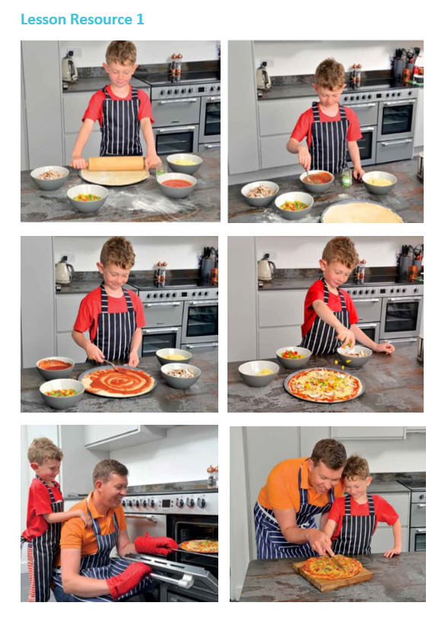

Attachment 5
Adult: “Taispeáin dom_____( Mamaí Béar, Daidí Béar, Cinnín Óir)
Child: “Seo ____Daidí Béar etc”
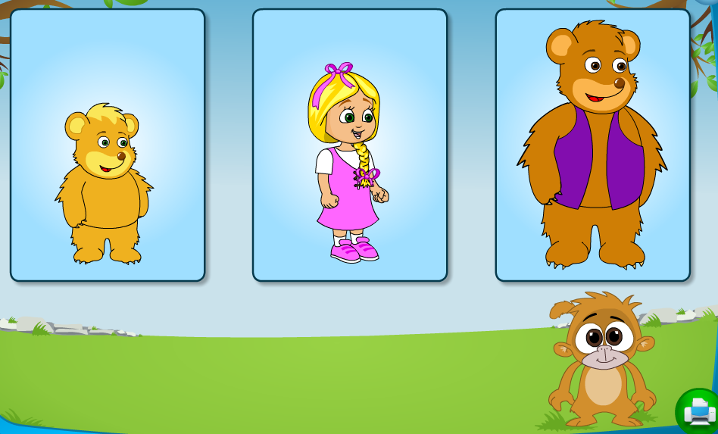
Attachment 6:
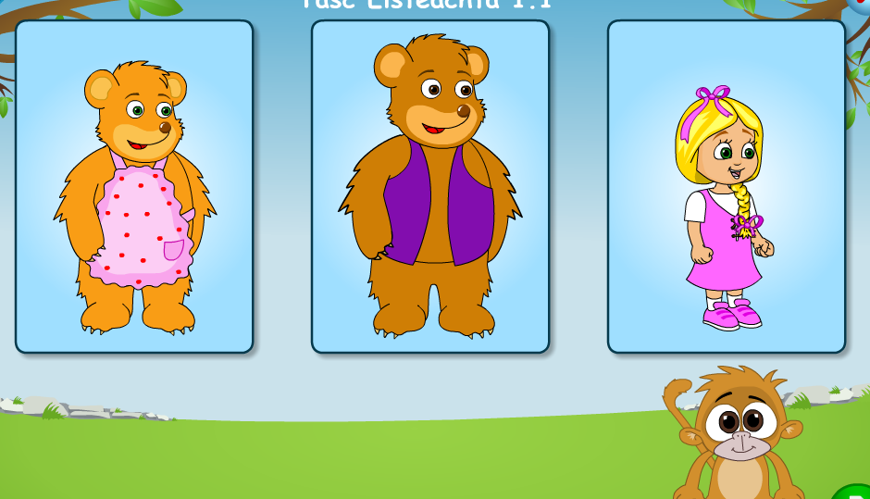
Attachment 7: 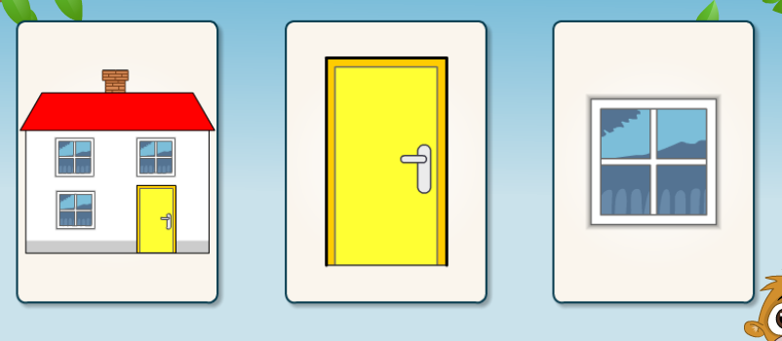

Attachment 8:
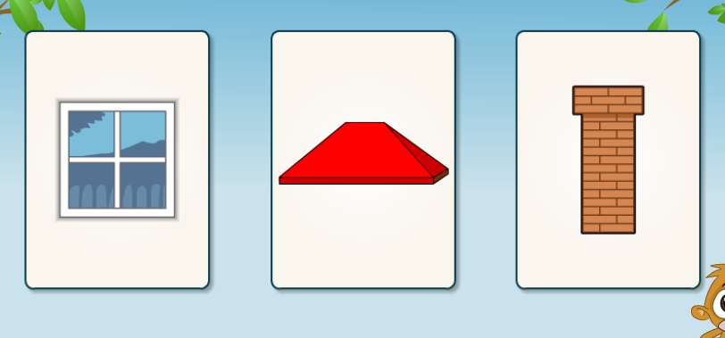

Attachment 9:
Taispéain dom uimhir a haon, a dó, a trí, a ceathar, a cúig, a sé, a seacht,a hocht, a naoi, a deich.
Practice count up and back from 10 in Irish.

Attachment 10: Match the pictures to correct numbers.
To make this task more difficult try cover the picture and just call out the number instead that the children need.
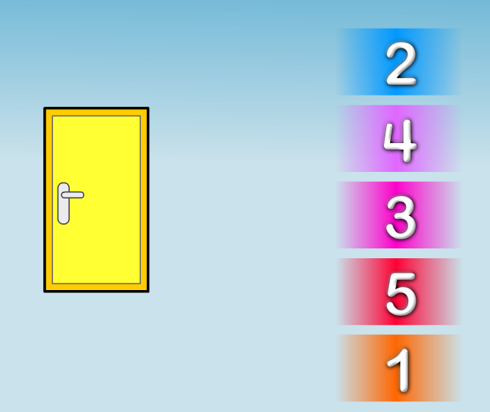
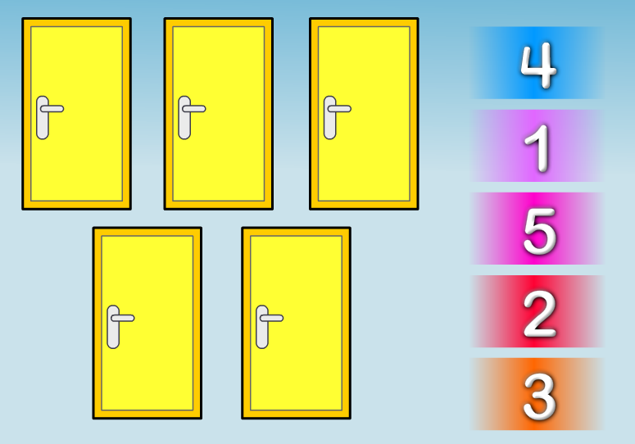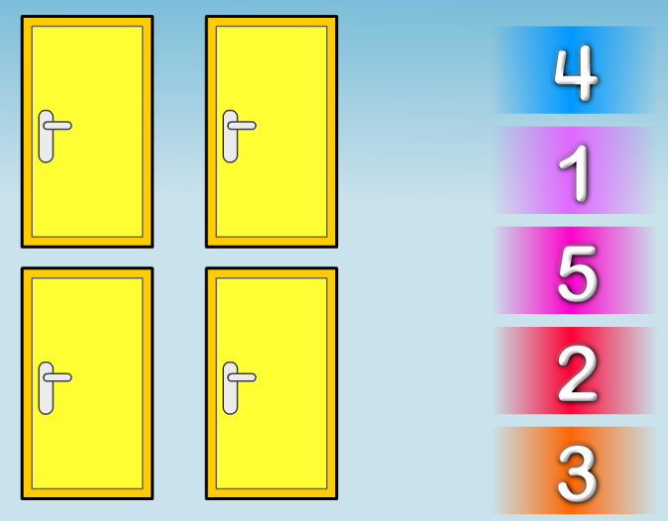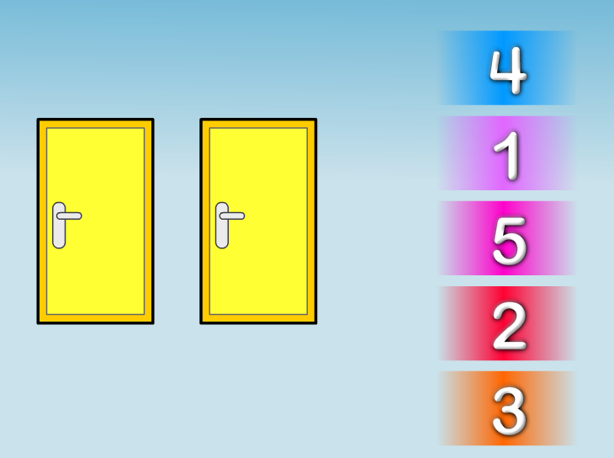

Attachment 11 : Count the pictures as gaeilge and match to the correct number.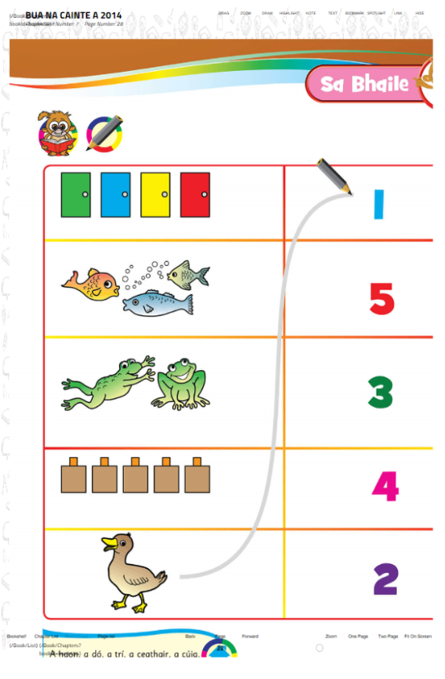

Attachment 12: “Cuir díon, doras agus simléar ar an teach. Dathaigh an doras buí.” Put a roof, door and chimney on the house. Colour the door yellow.
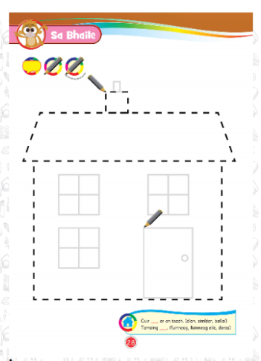
Attachment 13: SPHE
Tom’s Story
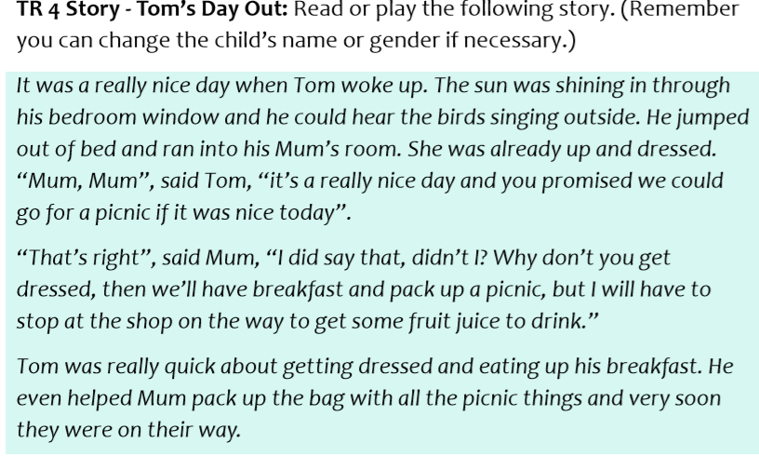
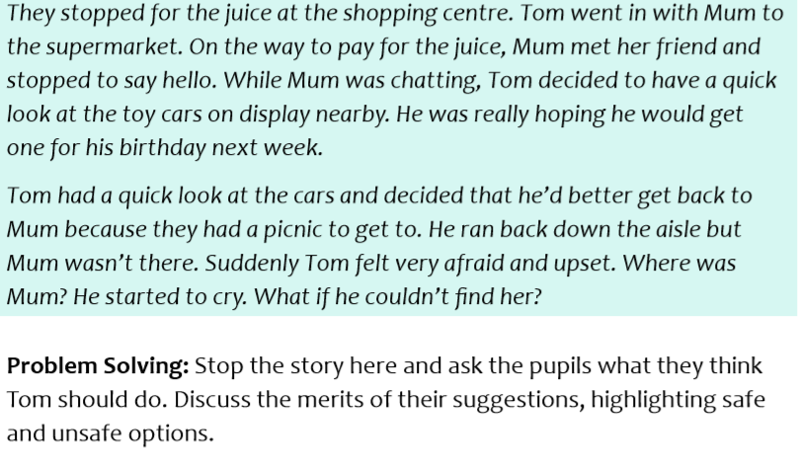

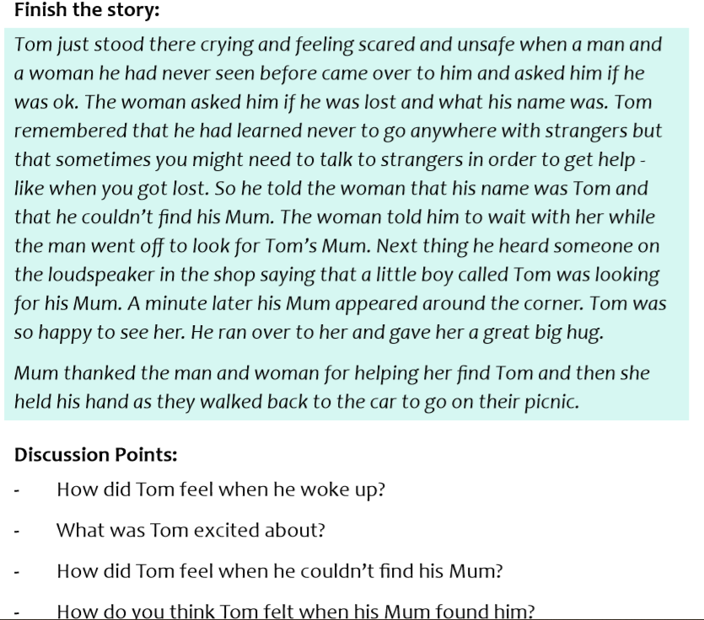
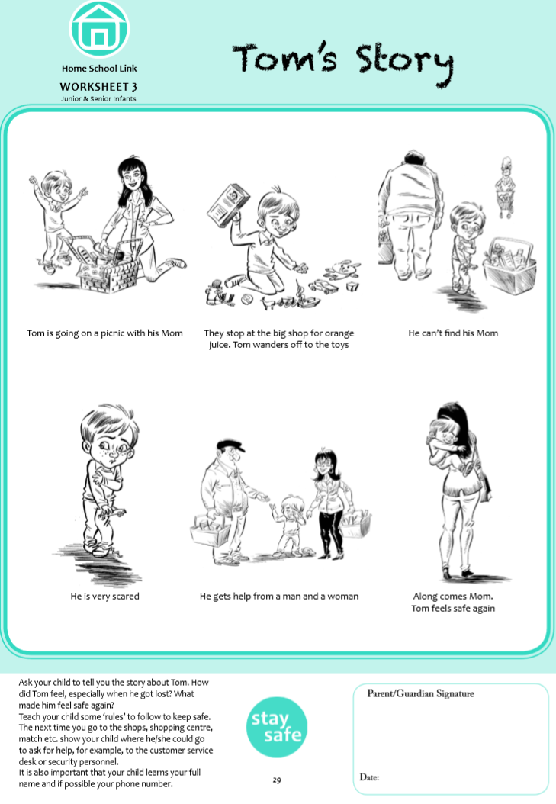
Attachment 14 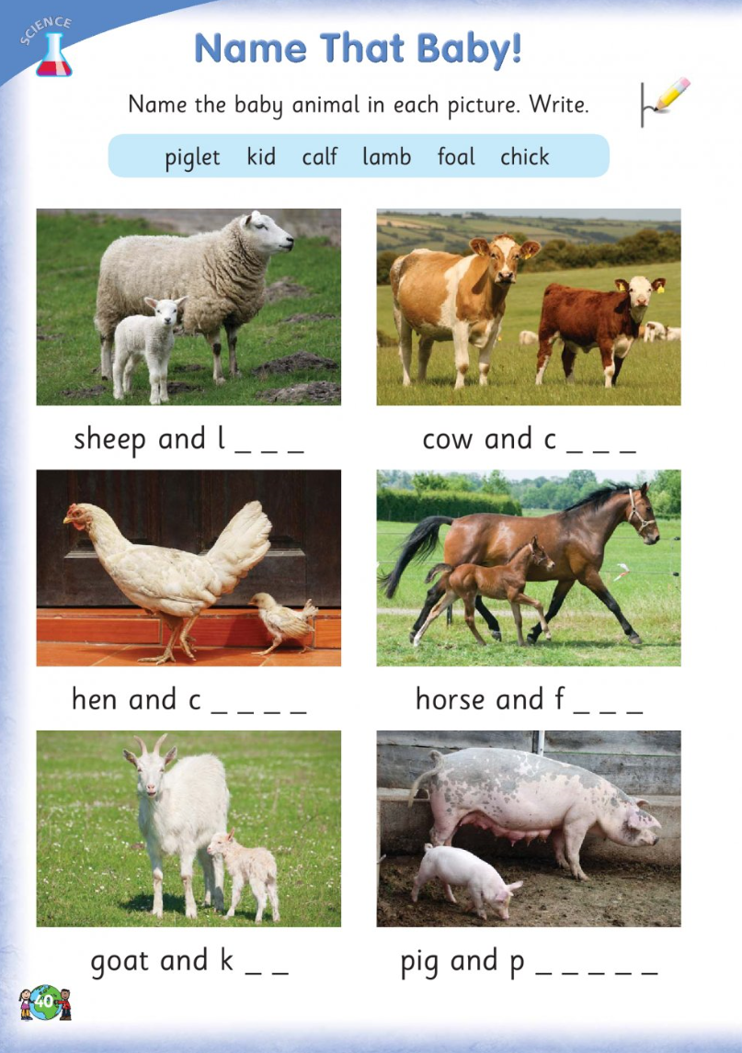

Attachment 14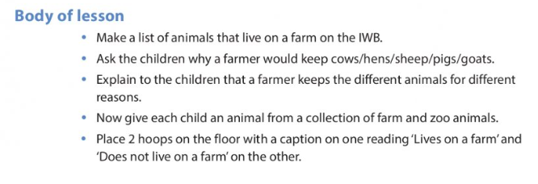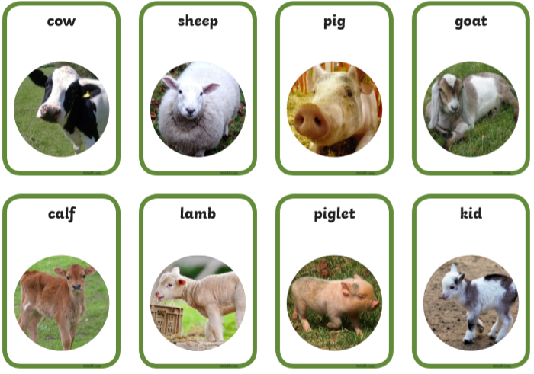
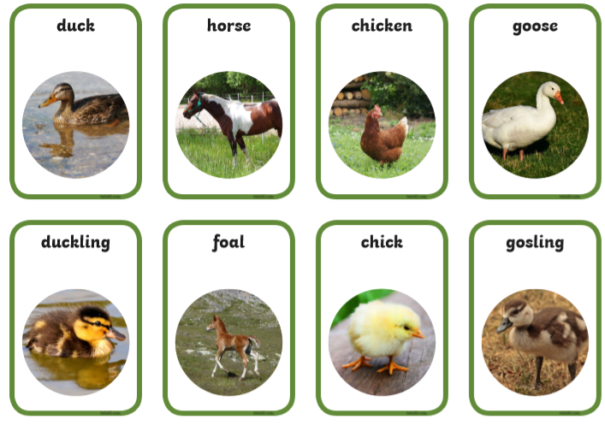

Attachment 15: Art - Print Making
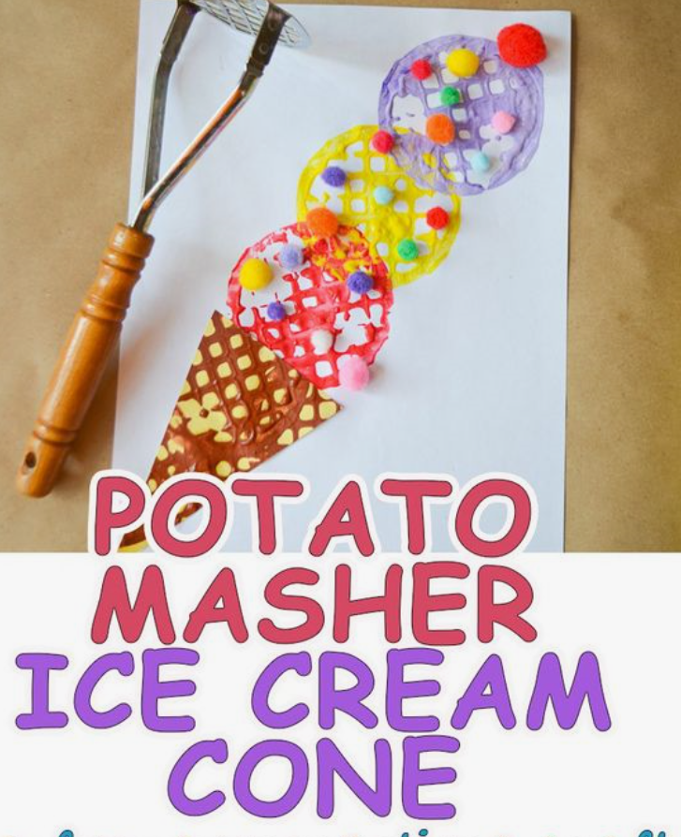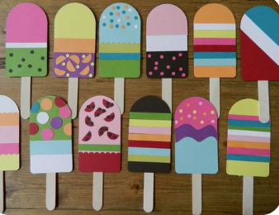
Attachment 16 Drama Game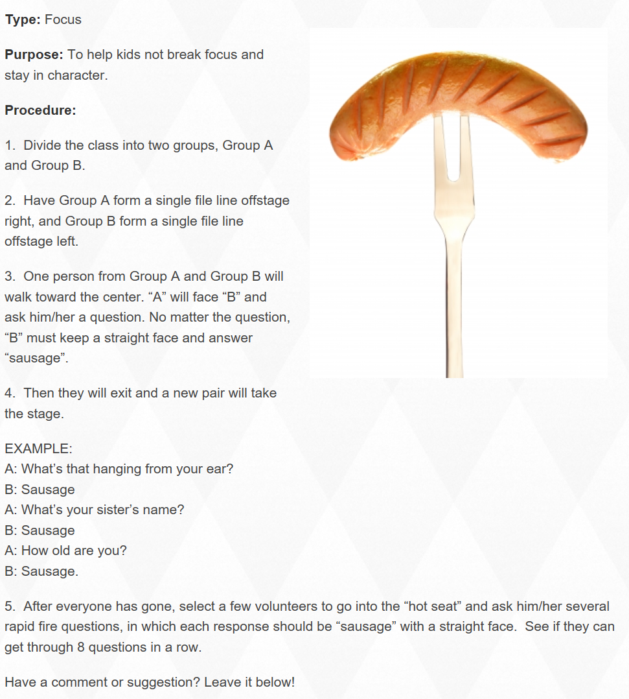

Attachment 17 PE
Home Obstacle Course Idea
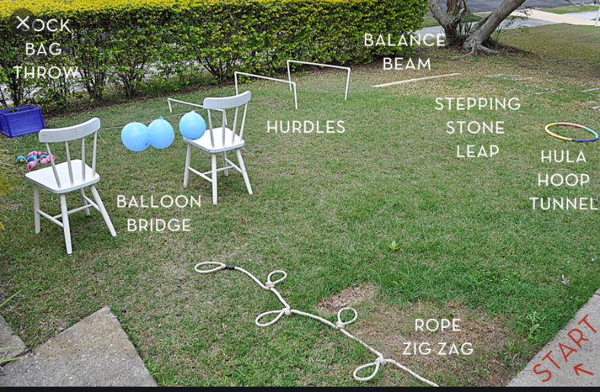
Attachment 18 Games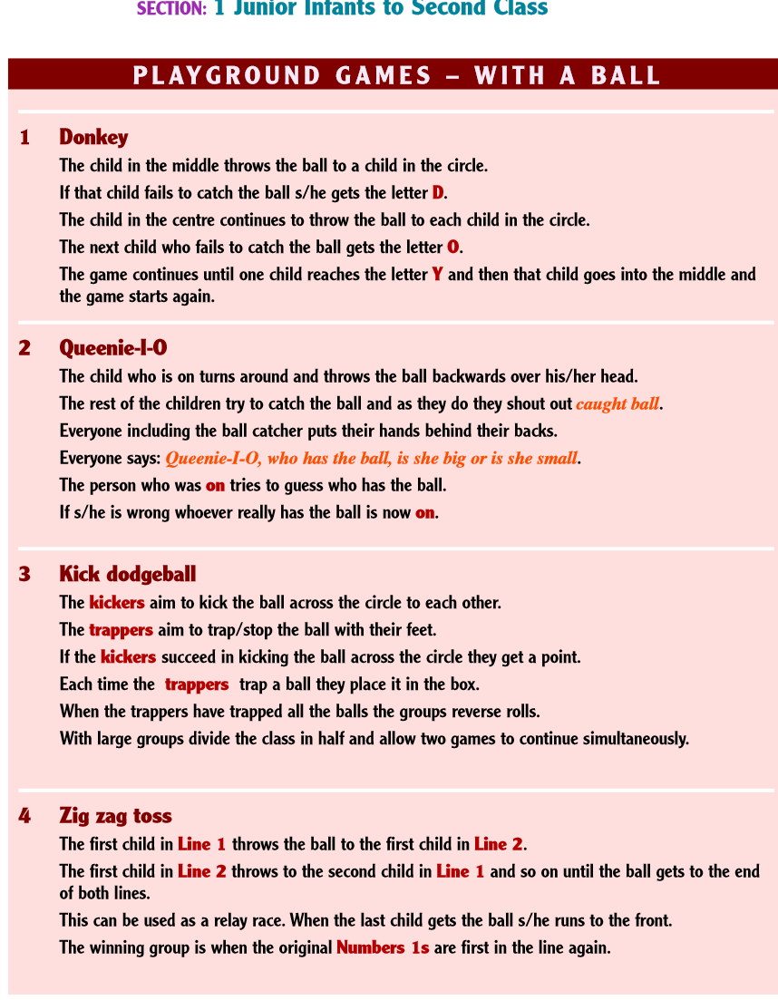
Attachment 19: Religious Education



