**Attachment 1-** 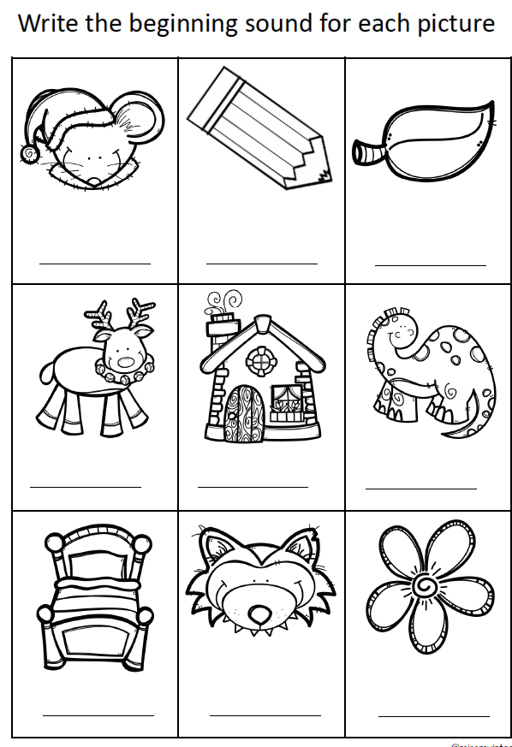

**Attachment 2:**

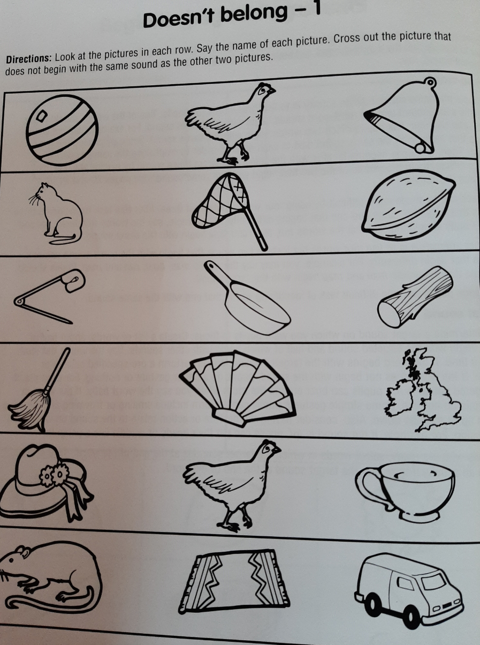

**Attachment 3:** 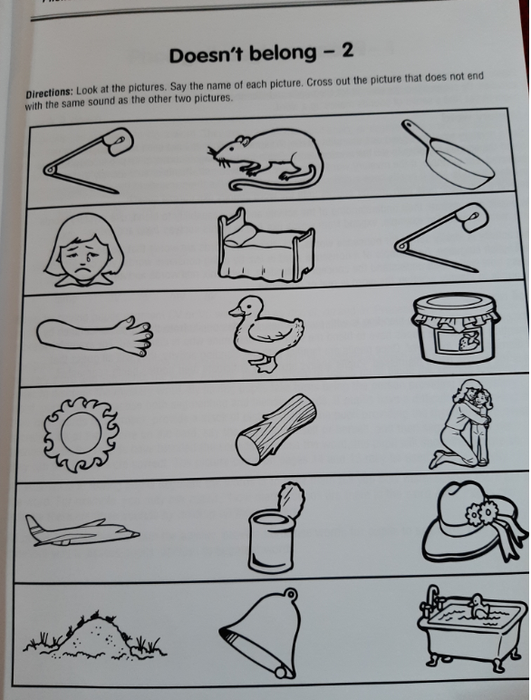

**Attachment 4: An Cháisc**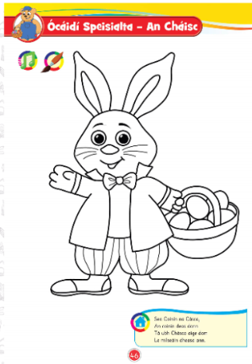

**Attachment 5**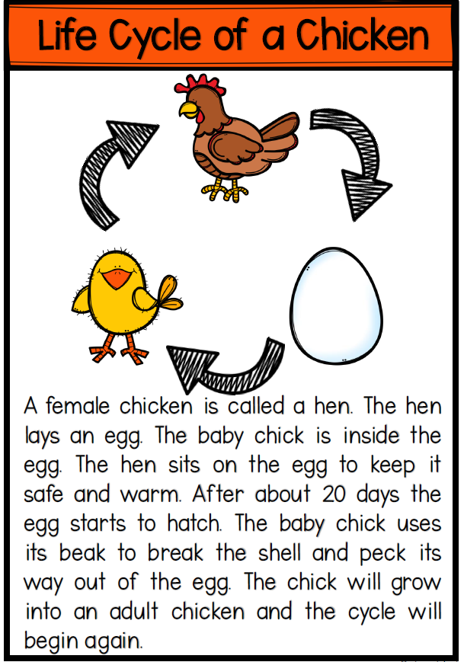

**Attachment 6:** 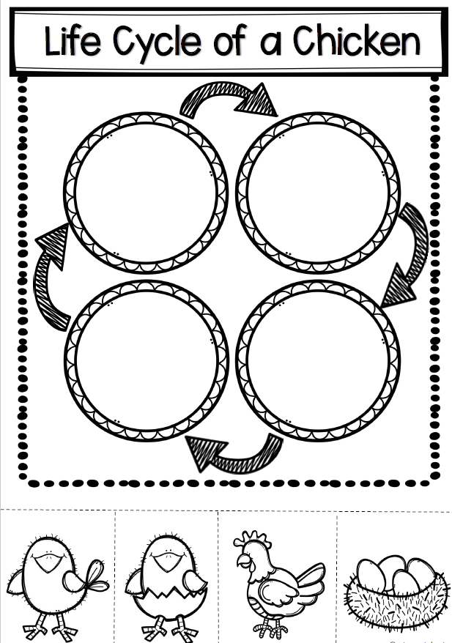

Attachment 8: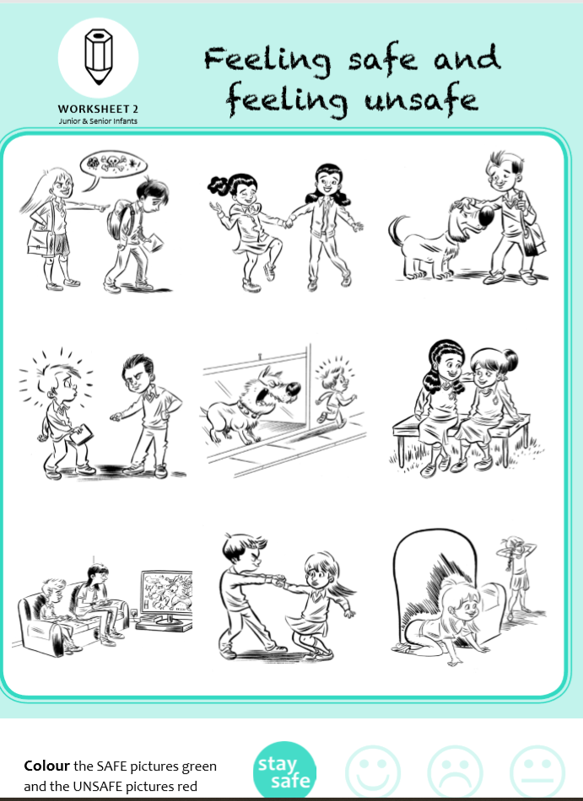

**Attachment 8:**

**Attachment 9: Easter Basket**

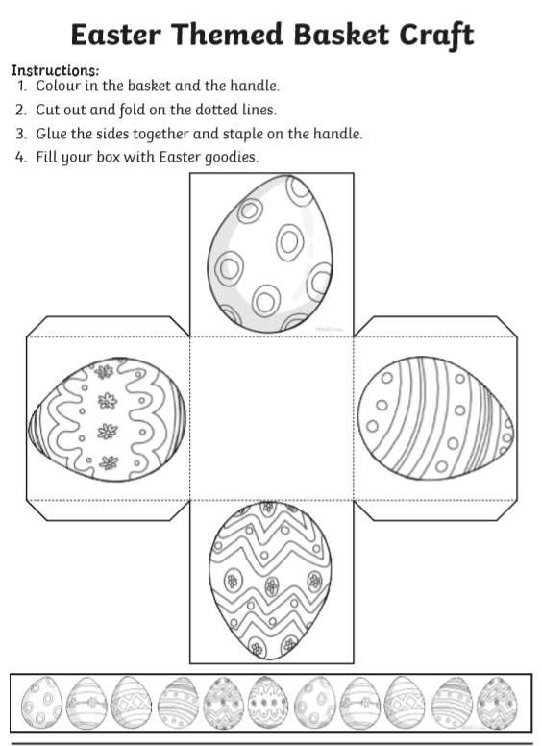

**Attachment 10:** 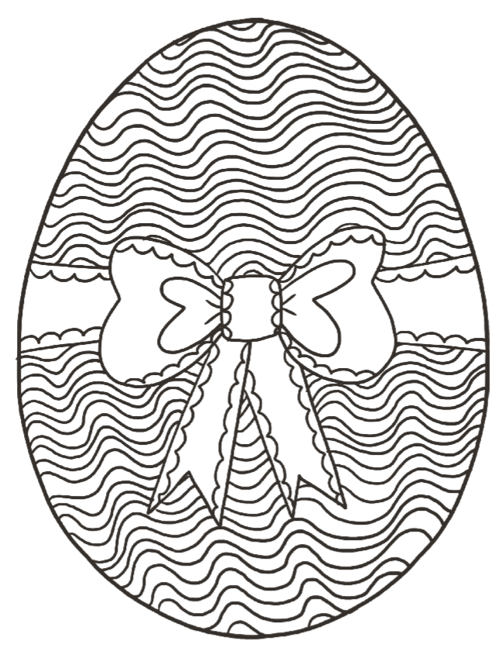

**Attachment 11**

**The Ultimate List of Tongue Twisters**

Unique New York

Three free throws

Red Leather, Yellow Leather

I thought a thought.  
But the thought I thought wasn’t the thought I thought I thought.

One-One was a racehorse.  
Two-Two was one, too.  
When One-One won one race, Two-Two won one, too.

Say this sharply, say this sweetly,  
Say this shortly, say this softly.  
Say this sixteen times very quickly.

**Attachment 11: Religious Education**

***.***