**Attachment 1- Colour by sound**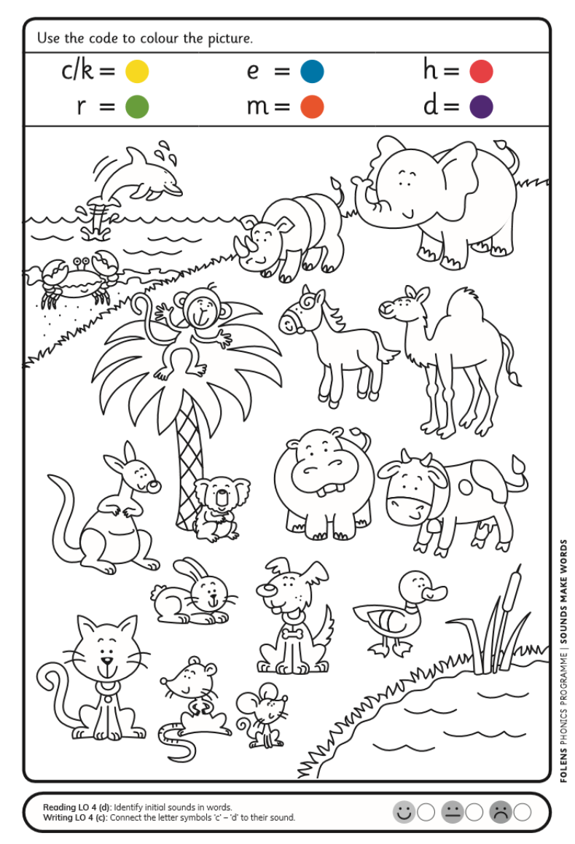

**Attachment 2: Oral Language Poster “the Duck Pond”**

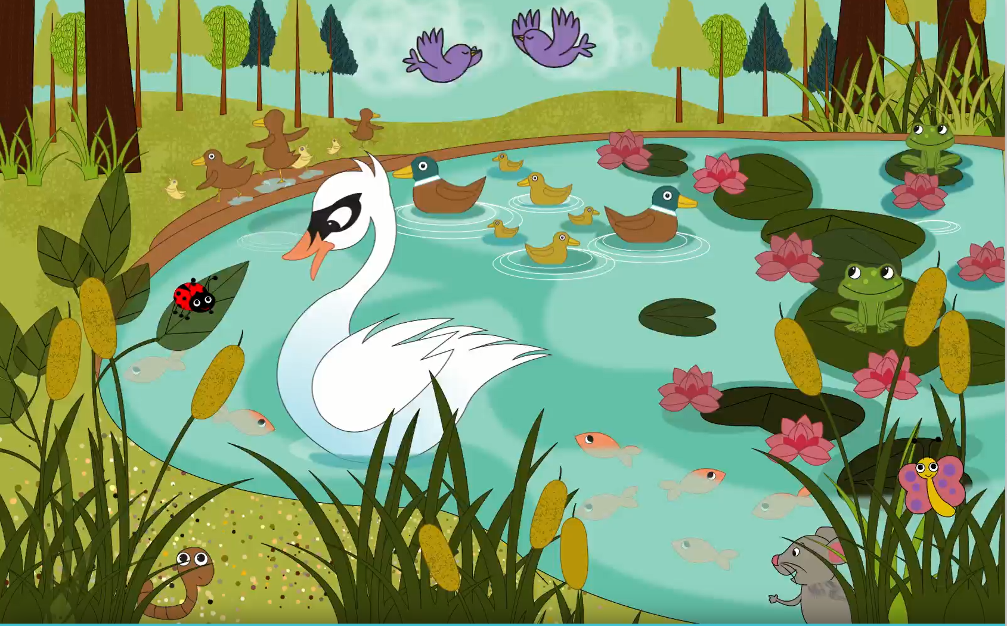

**Attachment 3: Oral Language Questions/Activities**

* How many **creatures** can you name **on** the water/**under** the water/**over** the pond/on the **bank** of the pond/**around** the pond?
* Can you describe how the animals are moving?
* What words would you use to describe the creatures?
* What sounds do they make? (e.g. *croak; chirp; quack; squeak*)
* Can you name some interesting feature about each animal(*e.g. ladybird – spots; frog – bulging eyes; hedgehog – prickly spines; swan – long neck; duck – yellow beak/bill; mouse – whiskers*)
* What baby animals can you see? What are their names? (*e.g. ducklings, hoglets, tadpoles, cygnets, pinkies, chicks)*
* ‘I spy’ – part 1
* Play a game of ‘I spy’ with the class, focusing on colour, features, movement, sound and location.
* e.g. *I spy with my little eye something that is green/has spots/waddles/tweets/lives under the water,* etc.
* Encourage correct naming and expanded descriptions, using the most interesting and varied vocabulary possible.

|  |  |
| --- | --- |
| Q1. | Where do these animals live? |
| Q2. | What is the swan doing? |
| Q3. | Where is the worm? |
| Q4. | There are baby ducks beside the pond. What is a baby duck called? |
| Q5. | The frogs are sitting on floating leaves. What are these leaves called? |
| Q6. | How are the swan and the ducks alike? How are they different? |
| Q7. | Do you think the hedgehog is afraid? How can you tell? |
| Q8. | Do you think swans are graceful? Why? |
| Q9. | What do you think the pond might look like in winter? |
| Q10. | Which of the animals at the pond is your favourite? Which is your least favourite? Why? |

**Story: *I don’t want to be a Frog*** ***LO 1, 7, 14***

Play the story *I Don’t Want to be a Frog* by Dev Petty for the class. (<https://www.youtube.com/watch?v=mqLB9pbJprU>) Ask children the following questions:

* What does Frog want to be?
* Why does he not want to be a frog? (*frogs are too wet, too slimy, eat bugs)*
* Do you think he is right? Why?
* What animal would you like to be? Why?

How are they different? Part 1

Discuss how the animals in the story are **different****from** one another. Have children complete sentences contrasting different animals in the poster, e.g:

A frog is **different from** a rabbit because … (*a frog doesn’t have long ears*)

A frog is **different from** a pig because … (*a frog doesn’t have a curly tail or eat garbage*)

A frog is **different from** an owl because … (*a frog doesn’t have wings; doesn’t look wise; can’t turn its head all the way around*

**Attachment 4- Gaeilge Eadaí (Clothes)**

|  |  |  |
| --- | --- | --- |
|  |  |  |
|  |  |  |
|  | | |
|  | | |
|  | | |

**Attachment 5: Eadaí**

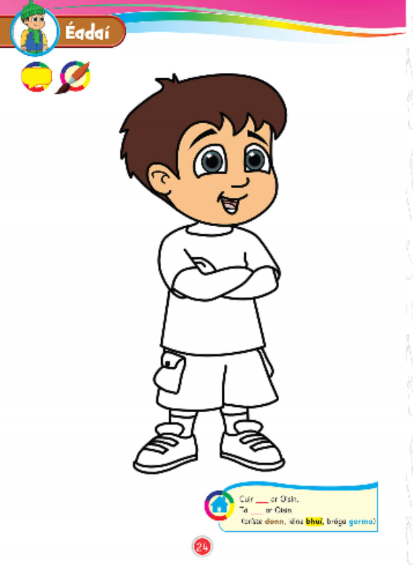

**Attachment 6**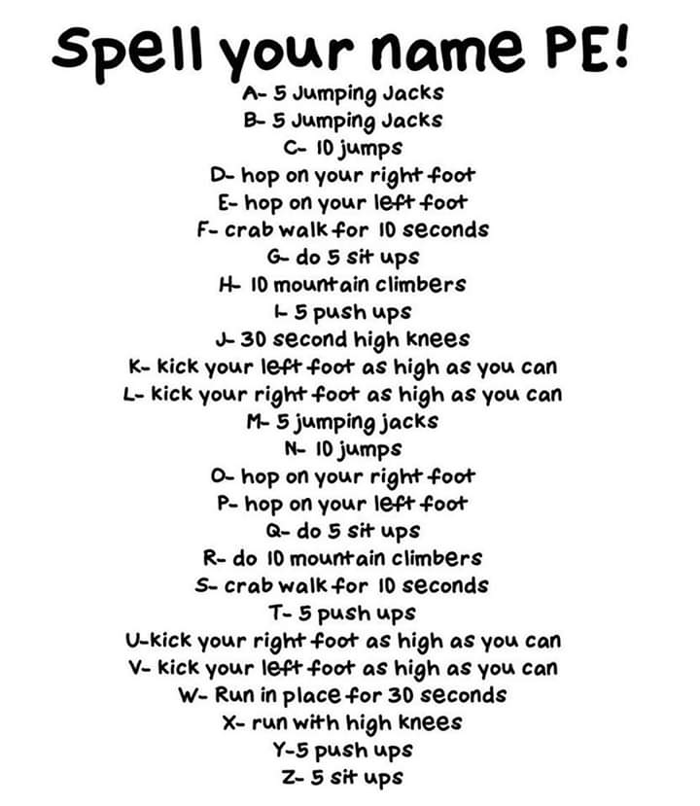

**Attachment 7**

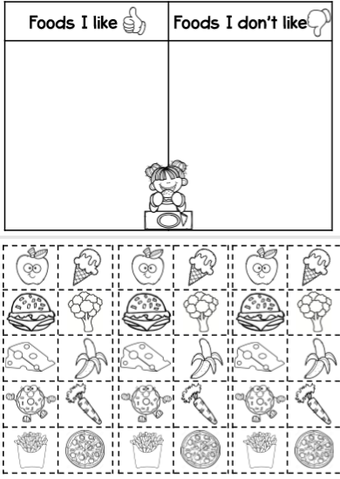

**Attachment 8:**

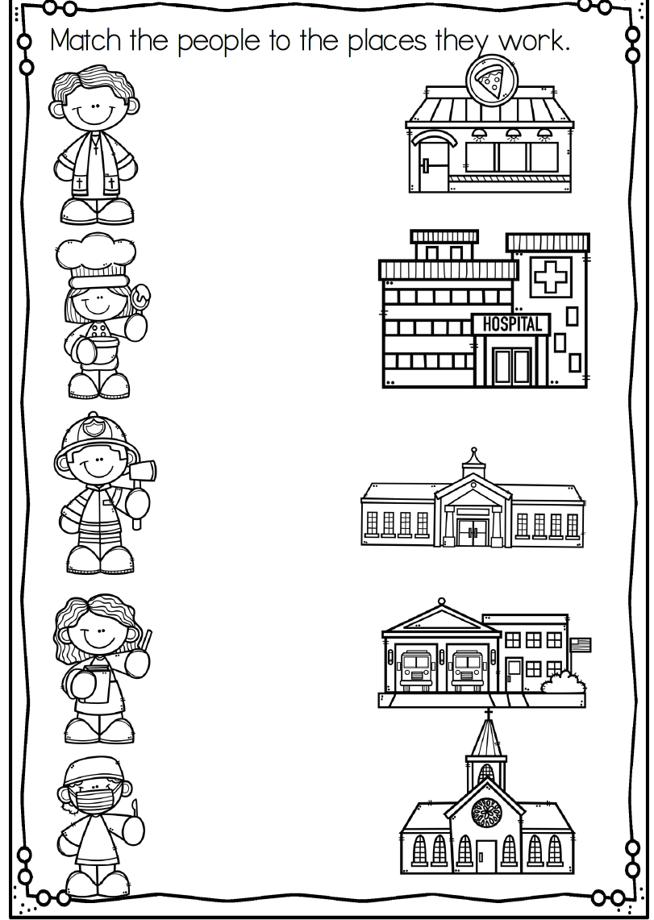

**Attachment 9: Easter Bunny**

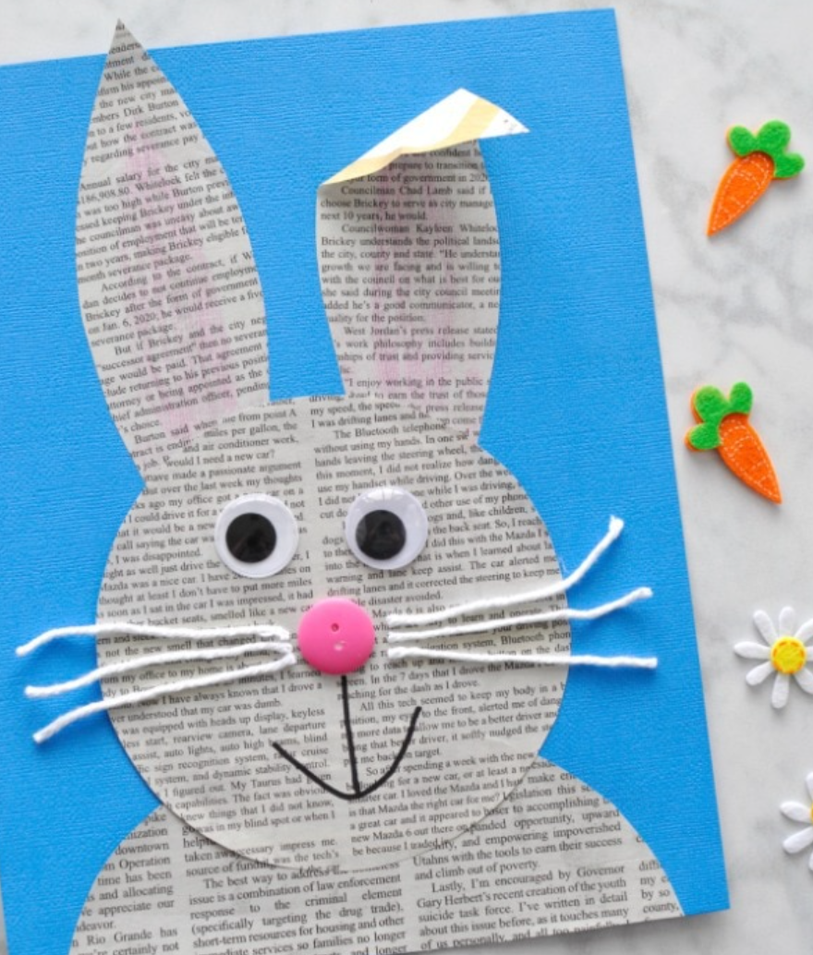 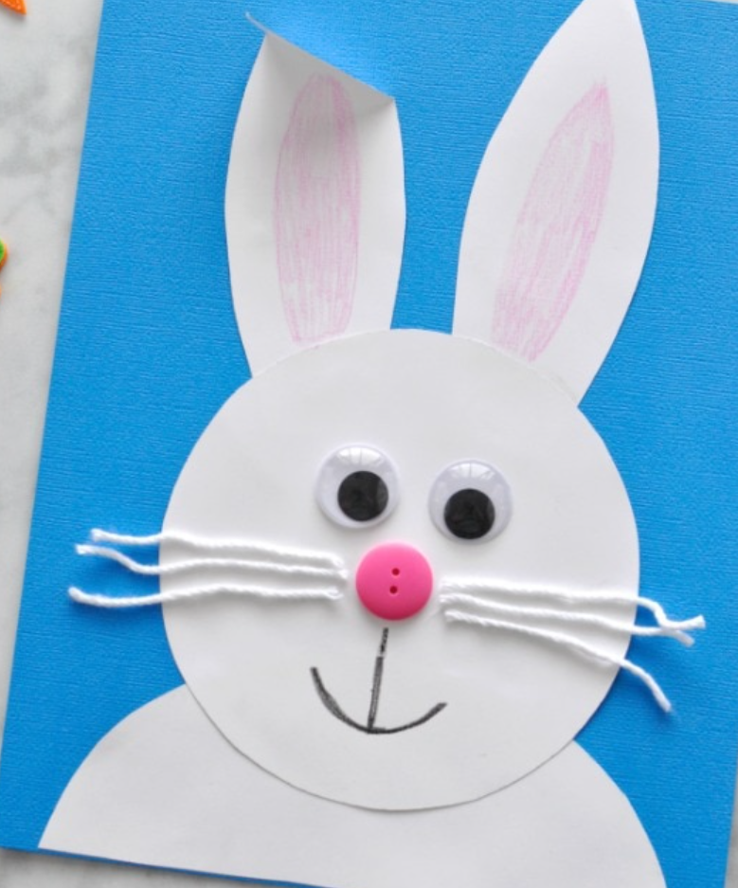

**Attachment 10: Drama mime cards.**

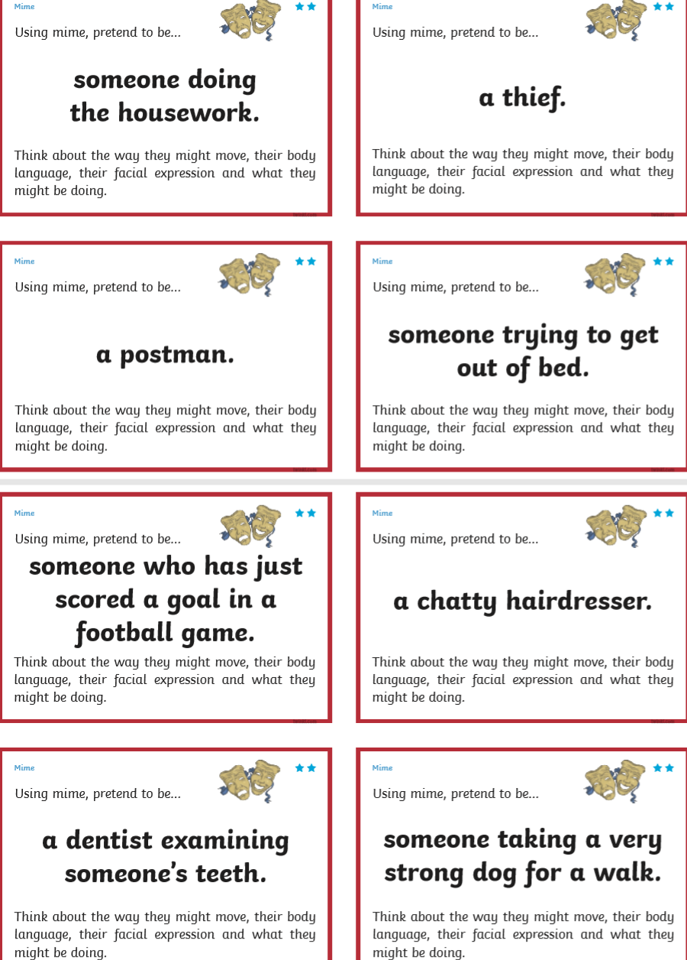

**Attachment 11: Religious Education**

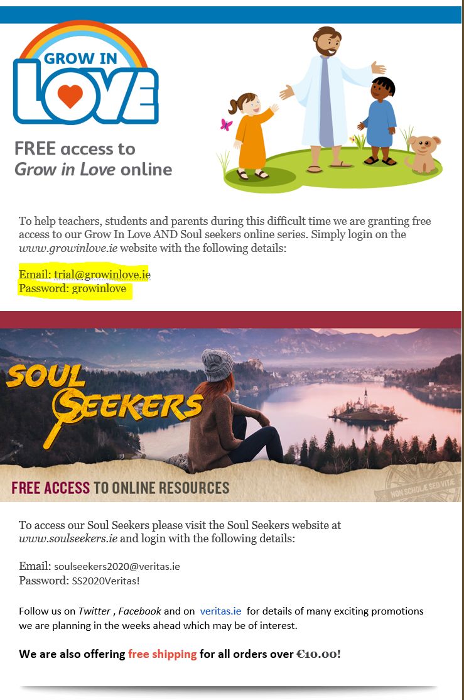

***To be attached directly to Class Dojo***

***Video clip of oral language poster***

***Healthy Eating Powerpoint.***