**Week 9 Attachments.**

Attachment 1: “Fish and Chips”

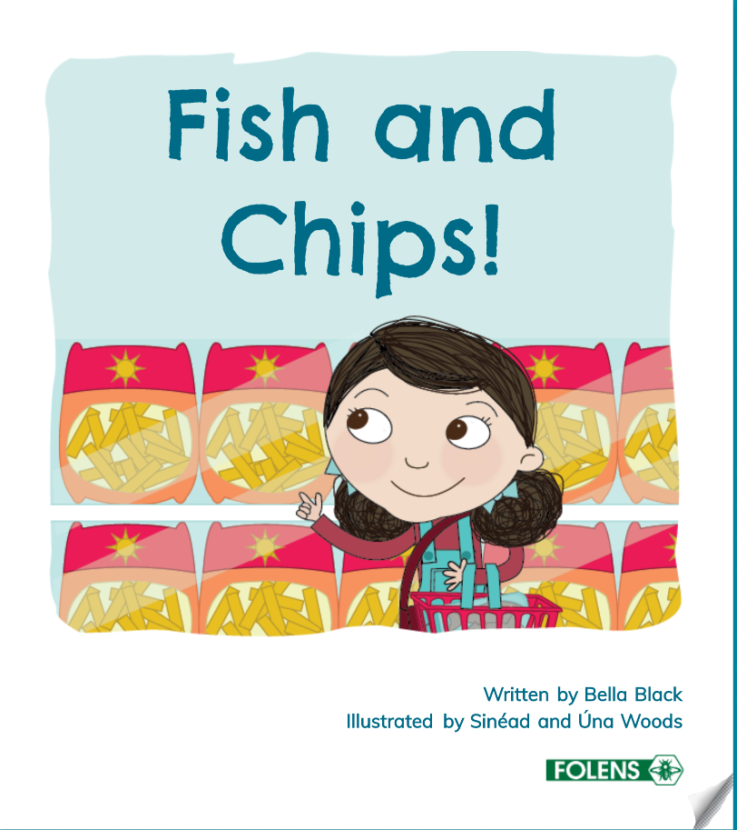 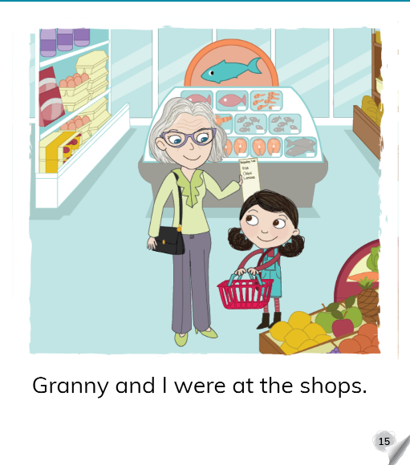 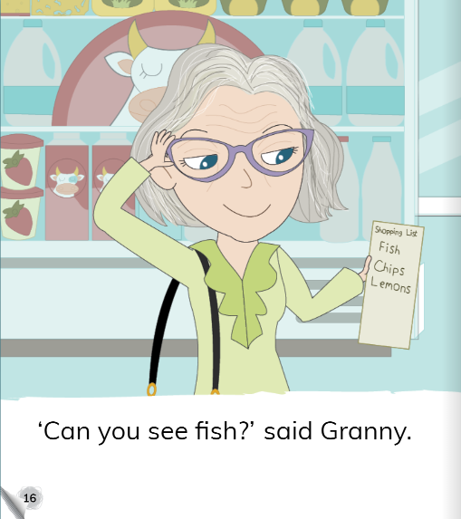 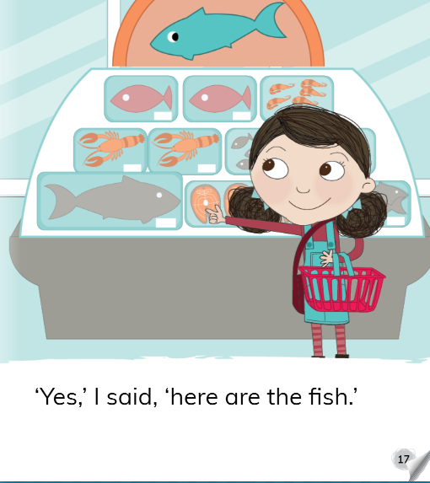 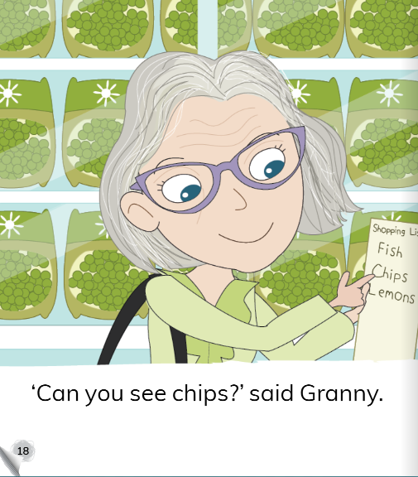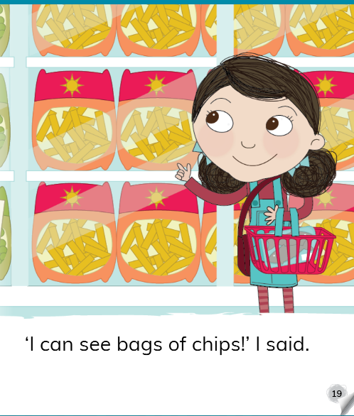 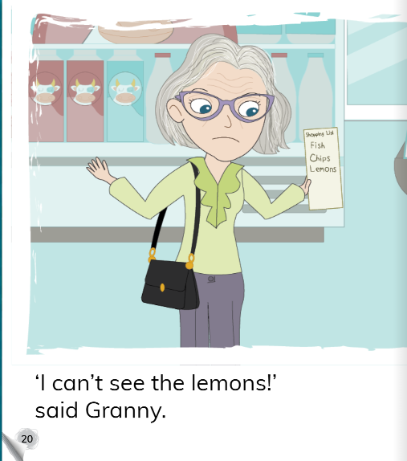 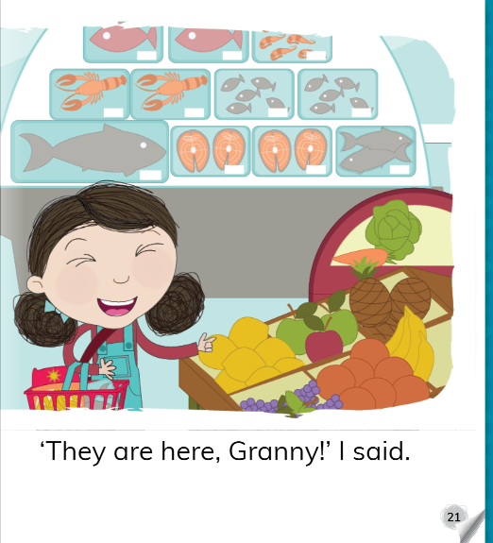 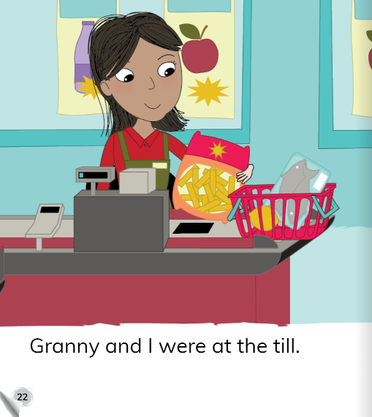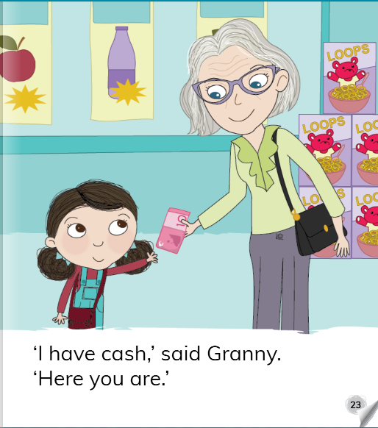 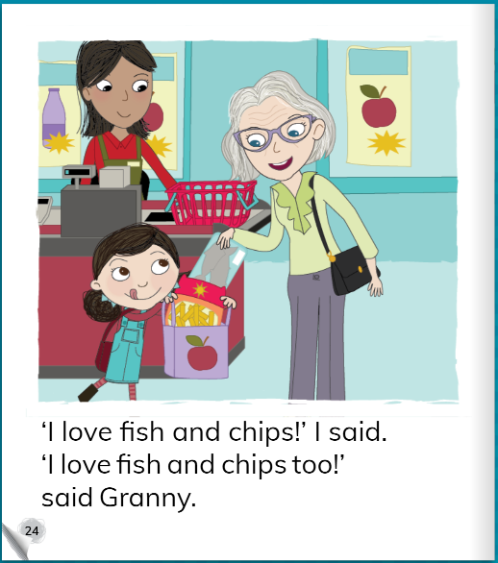

Attachment 2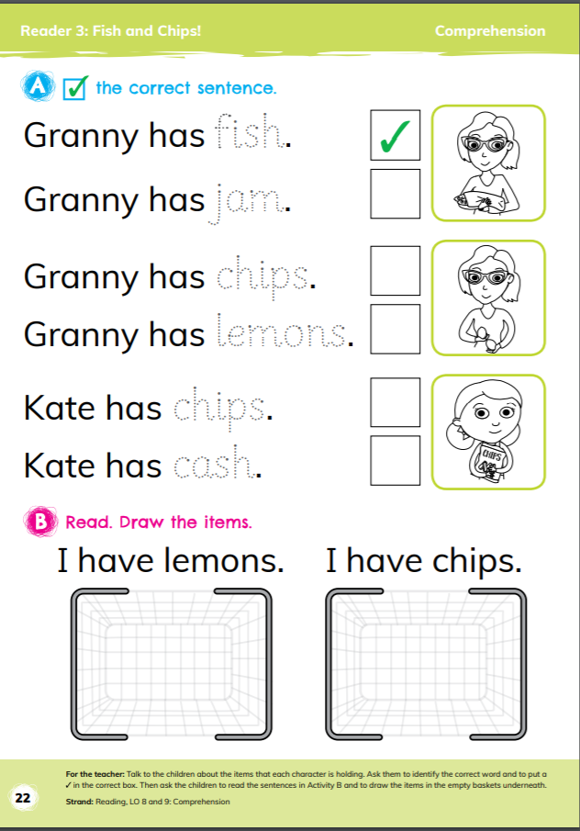

Attachment 3 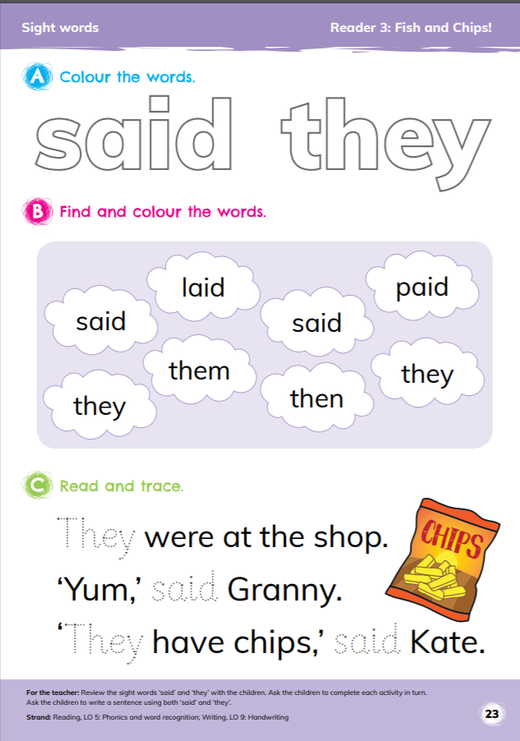

Attachment 4: “oi” Sound

oil coin soil boil point foil

Attachment 5: Phonics

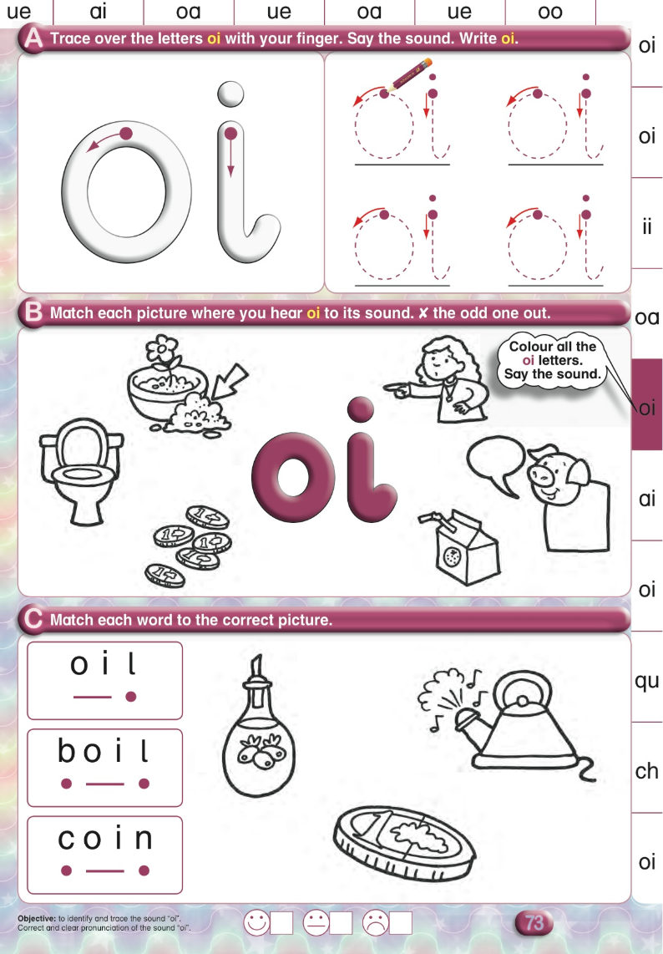

Attachment 6 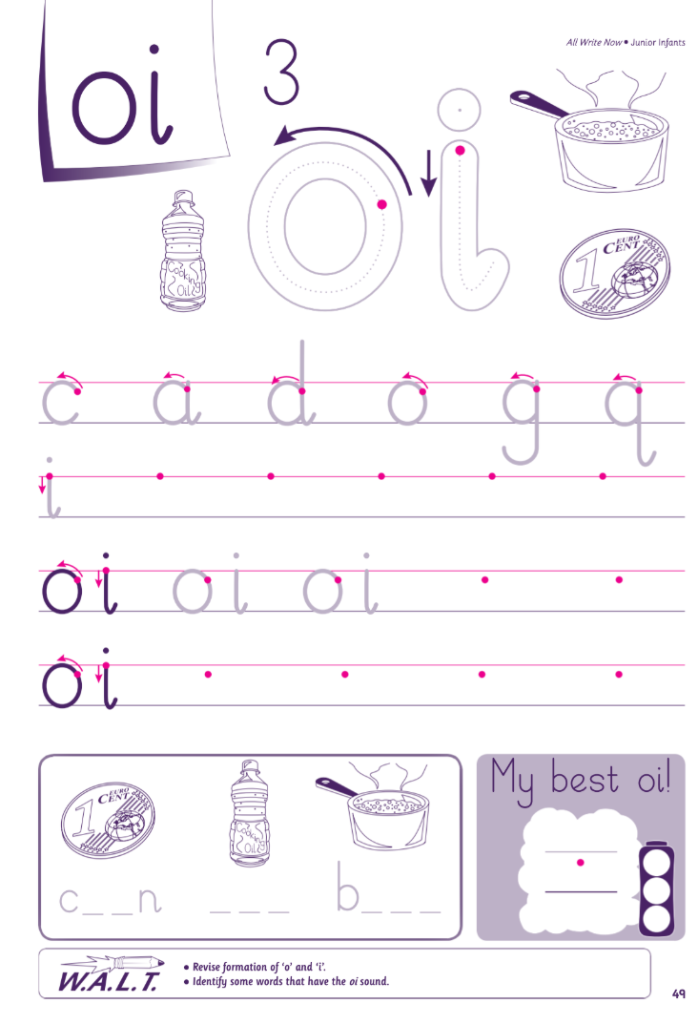

Attachment 7:

Tá tíogar ar an teilifís. Tiger is on the TV. (Draw tiger on TV)



Attachment 8:  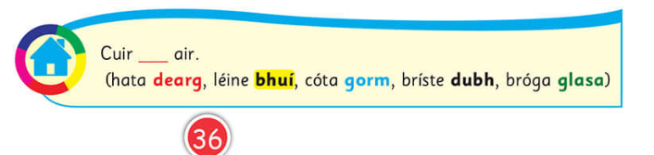

Attachment 9: Maths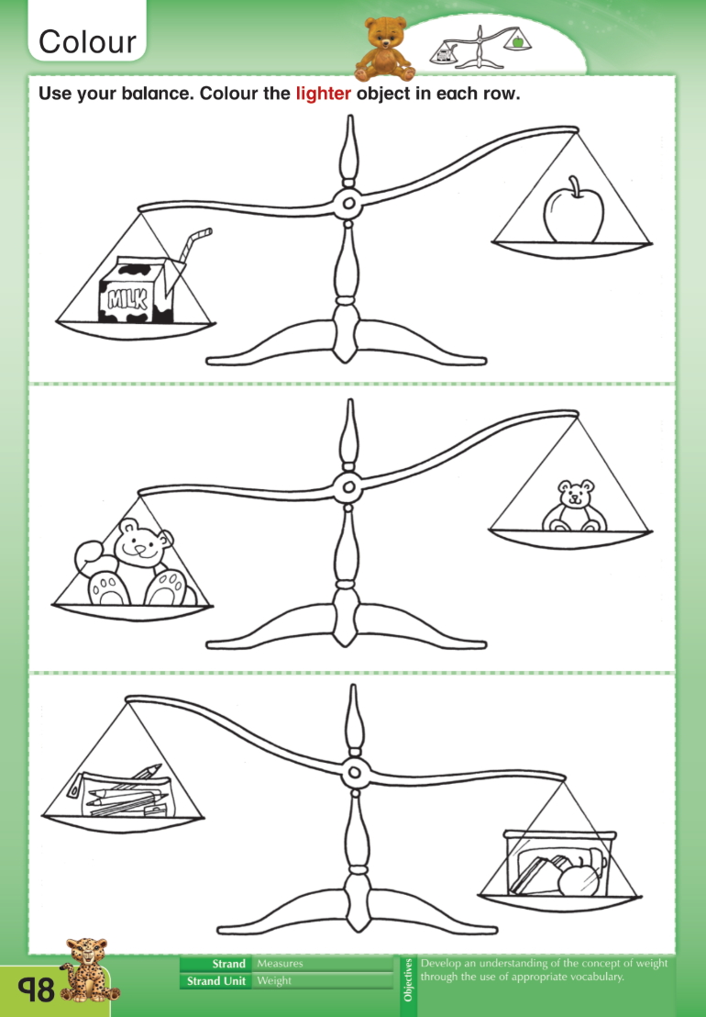

Attachment 10:

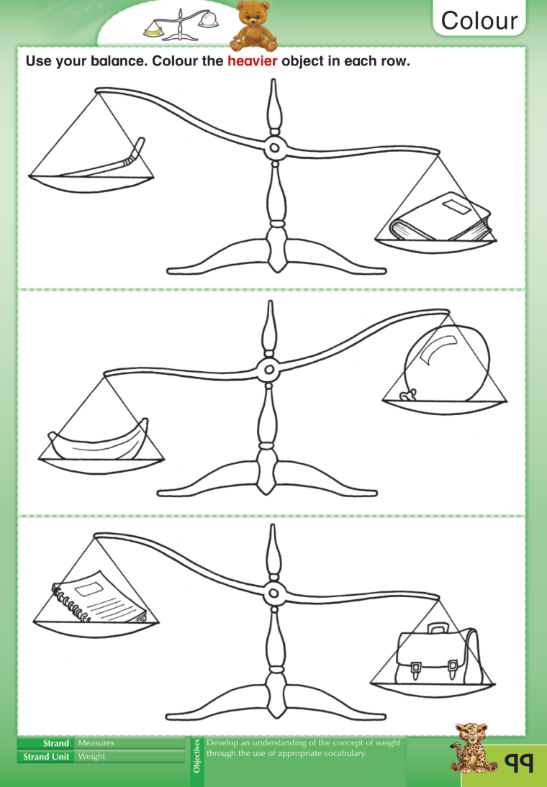

**Attachment 11:**

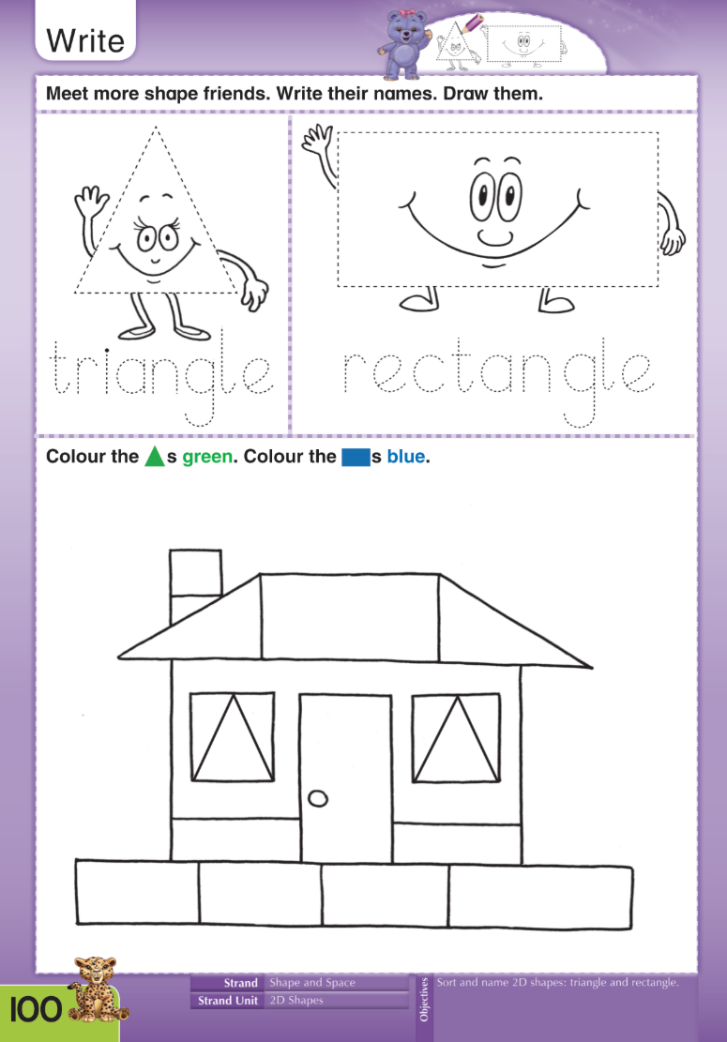

**Attachment 12**

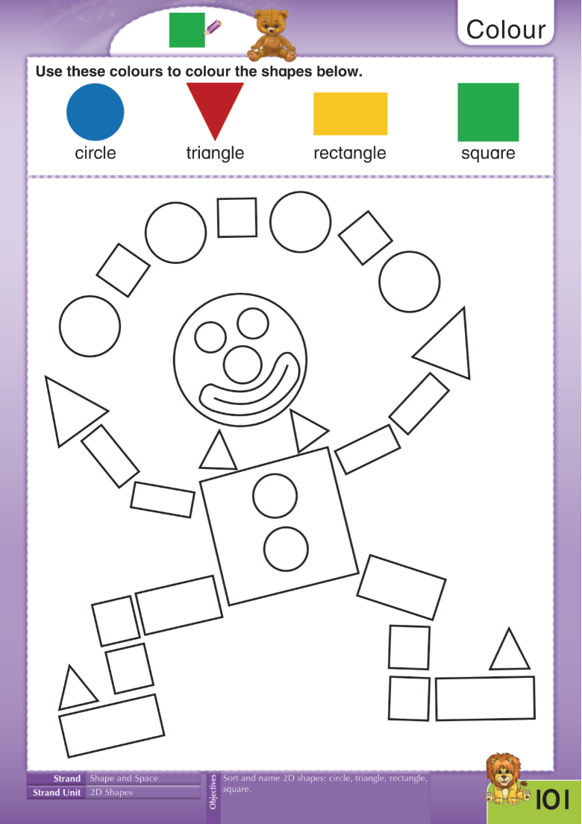

Attachment 13: Rhymes

**One, Two, Three, Four, Five**

One, two, three, four, five,

Once I caught a fish alive,

Six, seven, eight, nine, ten,

Then I let it go again.

Why did you let it go?

Because it bit my finger so.

Which finger did it bite?

This little finger on my right.

**Five Little Candles**

Five little candles in the night.

Five little candles, burning bright.

Along came the wind…Shoooooo….all is quiet,

Four little candles burning in the night.

Four little candles in the night.

Four little candles, burning bright.

Along came the wind…Shoooooo….all is quiet,

Three little candles burning in the night.

Three little candles in the night…….

Two little candles in the night …….

One little candle in the night…….

**Five Brown Cookies**

Five brown cookies in the baker’s shop,

Round and fat with chocolate on top,

Along came (your child’s name) with a euro one day,

Bought a brown cookie and took it away!

Four brown cookies in the baker’s shop,

Round and fat with chocolate on top,

Along came ______ with a euro one day,

Bought a brown cookie and took it away!

Three brown cookies in the baker’s shop…….

Two brown cookies in the baker’s shop…..

One brown cookie in the baker’s shop…..

**Five Little Monkeys**

Five little monkeys jumping on the bed,

One fell off and bumped his head,

Mammy called the doctor and the doctor said

“No more monkeys jumping on the bed!”   

Four little monkeys jumping on the bed….

Three little monkeys jumping on the bed…..

Two little monkeys jumping on the bed…..

One little monkey jumping on the bed…..

Attachment 14: Science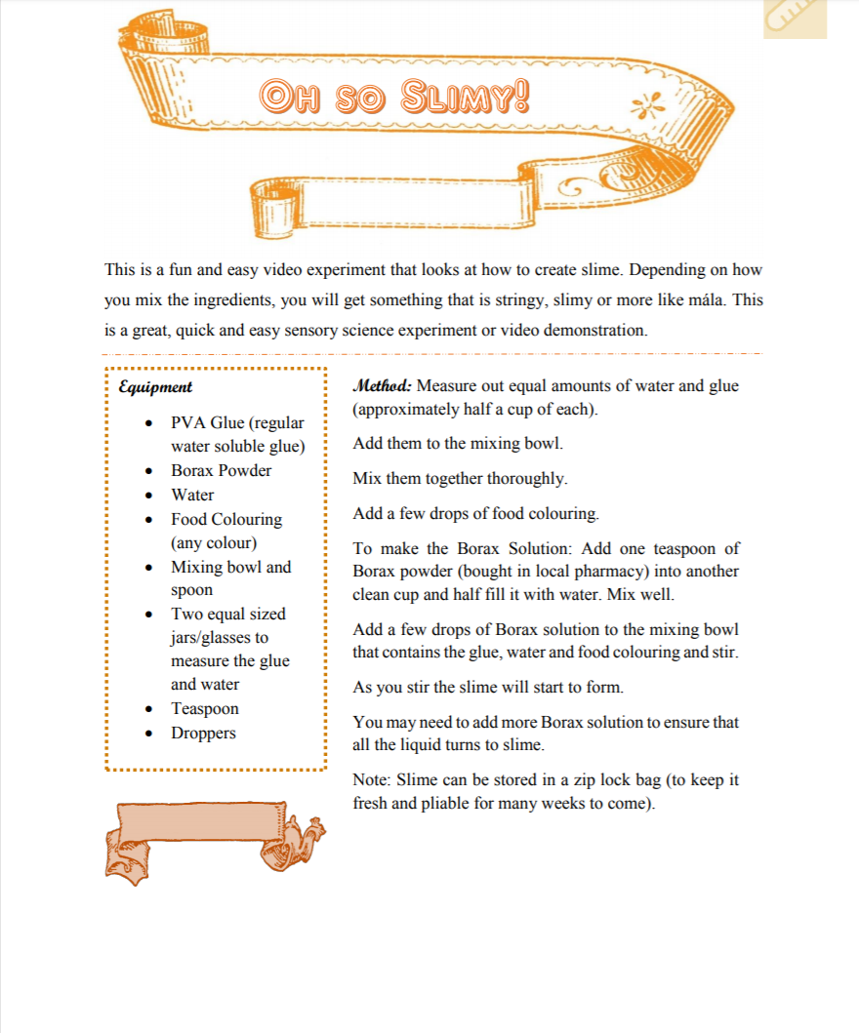

Attachment 15: Art

