Hello everybody!

I hope you are all well.

I have planned some work to be completed this week by the children. They can do as much as they are able for each day. It is very important that each child continues to revise their phonics, tricky words and reading.

Educational packs and books have been sent home with your child on Thursday. I am going to recommend a few pieces of work each day for the children to do to stay busy and to help revise what they have learned.

**Class Dojo:**

Class Dojo is a great way to stay in contact so feel free to message with any questions you may have over the coming days/weeks. I will send you all a class code to allow each child add work to their portfolio. If your child would like to show me some work he/she has done or record some reading etc. I would love to see it. The individual portfolio would be a great way to do this.

**Apps:**

* Jolly phonics - this is the programme used in school. Some of you may have this downloaded already. It includes letter sounds, correct formation, songs and activities. There is no need to buy if you don’t already have it. Some sections are free to use.
* Teach Your Monster to Read- a very good phonics based app. The children have to clear levels beginning with individual sounds and moving on to CVC words and reading. (This is 99c at the moment)

**Website:**

* Nessy-Reading & Spelling Games
* Oxford Owl- some very nice ebooks for the children to read from this site.
* Twinkl- free at the moment for parents to sign up.
* GoNoodle- to keep active!
* Topmarks.co.uk
* Scoilnet

**Wednesday 18th March:**

1. Phonics: Revision of Set 1 phonics (s,a,t,i,p,n)

Practice how to form each letter, sing the song and blend some words using these letters.

Jolly Phonics App have set 1 available for free to download.

Alternatively click on this link for all phase 1 letters.

<https://www.youtube.com/watch?v=_TsCrRdFu7k&list=PLth2Z62NSFRGp8rBwEkxC_hCpX3STh_JN>

1. Complete page 13 of literacy pack which was sent home last week. Take a look at each sound and colour the picture that begins with this sound.

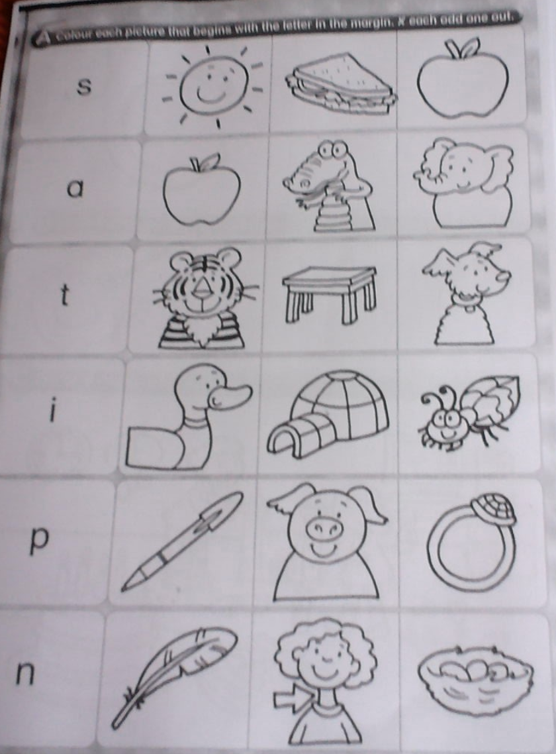

3. Revise the tricky word cards in your child’s zip folder.

**Maths:**

4. Planet Maths Junior Infants practice book pg 30. Write the numeral 0. Colour the picture.

**Fine Motor:**

5. Practice cutting along straight, wavy and zigzag lines.

<https://www.twinkl.ie/search?term=school+closure>

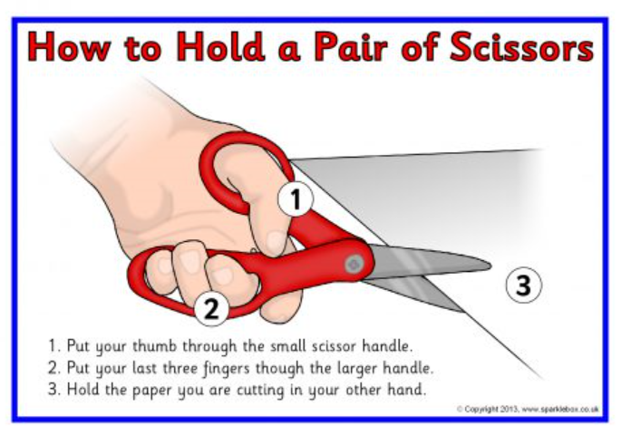

**Gross Motor Tasks:**

6. Stand on one foot for 5 sec then swap and stand on other foot for 5 seconds.

Walk along the “tightrope” (straight line on the floor). Hold hands out for balance if required.

**Thursday 19th March:**

Literacy:

1. Phonics: Revision of Set 1 phonics (s,a,t,i,p,n)

Practice how to form each letter, sing the song and blend some words using these letters.

Teach Your Monster to Read would also help the children to revise these letters.

Alternatively click on this link for all phase 1 letters.

<https://www.youtube.com/watch?v=_TsCrRdFu7k&list=PLth2Z62NSFRGp8rBwEkxC_hCpX3STh_JN>

1. Call out the words cat, sat, tap, tip and pit for the children. Break each word into its 3 sounds c-a-t and allow your child time to write each letter correctly by themselves.

Maths:

1. Match the items that are the same and colour them the same. (page 173 located in Maths pack)

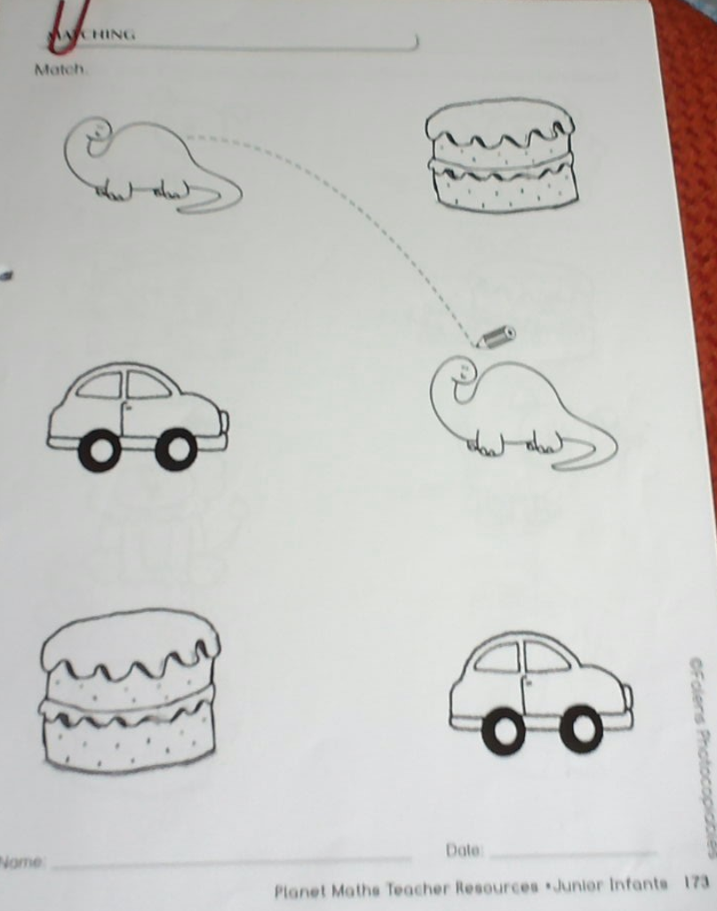

Art:

1. Here are some suggestions that could be completed for Mother’s Day. I would love to see some artwork on Class Dojo!

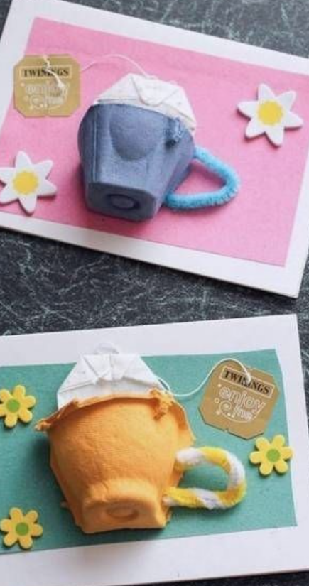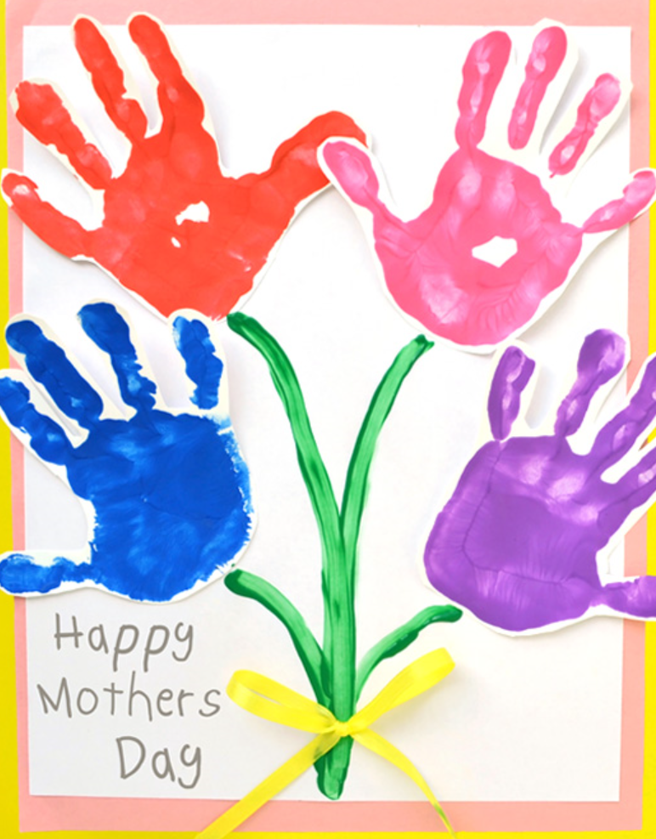

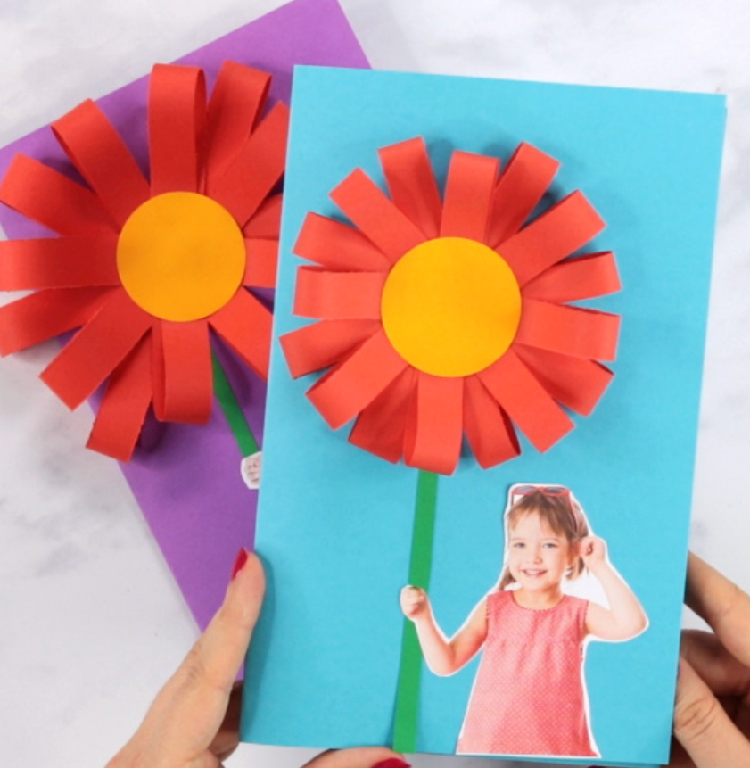

1. PE Activities:

GoNoodle – Lets keep active by dancing along to some great routines on gonoodle.

Suggestions: Boom Chicka Boom

Yes I Wanna Build a Snowman

Purple Stew

Maxarena

Football Skills: If you can, try to get outside and practice the following; throwing and catching a soft ball, bouncing and catching, soloing and hand passing.

**Friday 20th March:**

Literacy:

1. Each child should read their dandelion book located in their zip folder. Please ensure they attempt to sound out each unknown word and if they come across a tricky word like the/I/here you can prompt them and remind them that it is not a word they can sound it. To ensure the children do not memorise the book, try calling out a word yourself and asking them to point to it or vice versa. It can also be a good idea at times to cover the picture as they read.

If your child is finding this book particularly easy you can log onto oxford owl, set up an account and begin reading the coloured oxford readers online. Age 4-5 ebooks.

Maths:

1. Page 174 & 176 of booklet to complete.

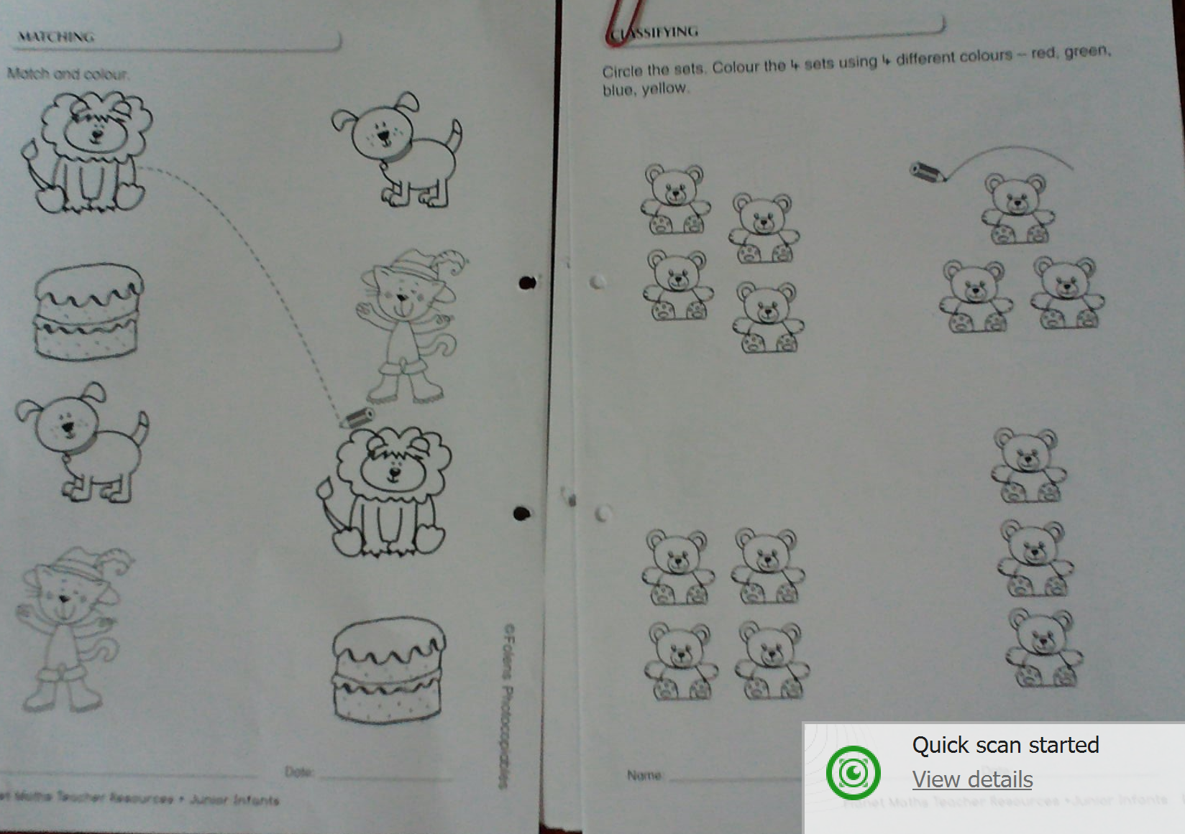

Geailge:

1. Revision of colours.

foclóir.ie can help with pronunciation if required.

Dearg- red

Gorm-blue

Glas-green

Buí- yellow

Donn-brown

Dubh-black

The children have learned the colours mentioned above. It would be a good idea to draw a very simple picture and call out some colours as Gaeilge and allow them to colour the picture accordingly. If you say “dearg” they colour something red.

Alternatively, you could lay out the colours on a table and say “Taispeáin dom dath glas” your child should show you the colour green.

Another idea would be to lay some colours out, ask your child to close their eyes as you hide 1 colour and they need to guess what you hid. Make sure they say the Irish word each time.

**Geography**

1. Go on a spring nature walk and see if you can spot some flowers and wildlife. 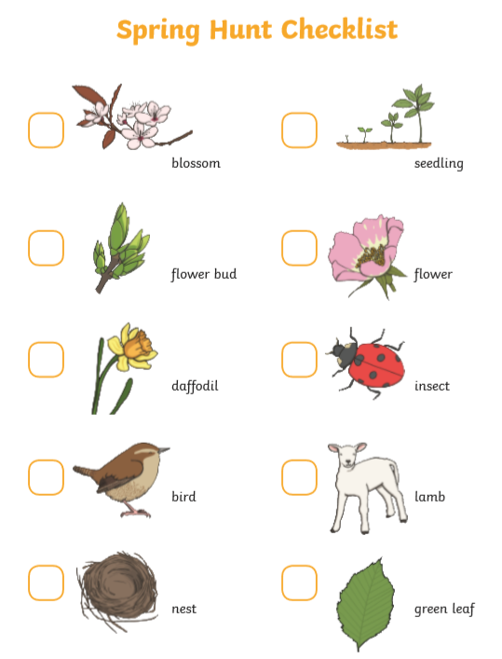
2. Take a look at the Signs of Spring powerpoint and draw your favourite sign of spring.