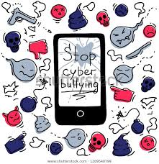
Stop Cyberbullying

Always tell an adult if you are being bullied.
- Never share your password with anyone.
- Never arrange to meet somebody online.
- Always screenshot messages before BLOCKING.
#STAYSAFE #SAYNO #STANDUPTOBULLIES

