|  |
| --- |
|  |
| Green School News at Geashill N.S |
|  |

BottleBusters

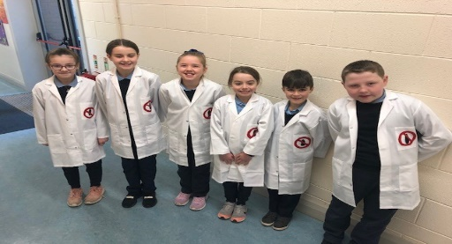

# Upcoming Events

## January 31

Competition Deadline (Video and Presentation)

## February 25

Regional Final at Omniplex Limerick

|  |
| --- |
|  |
| Students Involved Ava- 5th Class  Sasha- 5th Class  Grace- 3rd Class  Samuel- 3rd Class  Oisín-4th Class  Ciara- 4th Class |

SEAI One Good Idea Competition

|  |
| --- |
|  |
| We are third, fourth and fifth class students at Geashill N.S and we have entered a competition called “One Good Idea”. We came up with an idea related to climate change and submit a proposal. Our good idea is to try eliminate the use of single-use plastic water bottles in our school. We have decided to provide all present and future pupils with aluminum re-usable bottles to fill with water with the help of Offaly County Council.  We have been successful in stage one of the competition and now need to create a 60 second video and a PowerPoint presentation that will be shown at the regional finals in Limerick to lots of schools in Ireland. We call ourselves the “BottleBusters” and we will explain why reducing plastic is so important. |
|  |

## Why We Chose This Topic

* Research shows that single-use plastic waste makes up 40% of all plastic waste.
* Around the world, one million single-use plastic bottles are purchased every minute.
* Most plastic items never fully disappear, they just get smaller and smaller.
* Experts believe that by 2050 there will be more plastic in the ocean than fish.

We couldn’t believe these facts when we saw them at first. We decided to take a look at each class and count how many plastic bottles were used by the children. Just under 50% of our students brought single-use plastic bottles with them, particularly at the junior end of the school. We know that these bottles are very convenient and easy to manage, particularly for small children but they are damaging our environment and contributing to climate change. If we continue this we will have used over 20,000 plastic bottles in one school year. This small change will make a big difference. Could you help us by reducing your plastic waste?

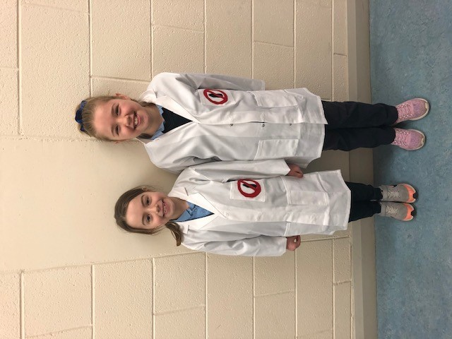

|  |
| --- |
|  |
| Keeping In Touch[www.geashillns.ie](http://www.geashillns.ie) @geashillns  Tune in to our school website and twitter page for regular school updates. |

# Link with Climate Change

## Our climate is changing each day. Our planet is heating up and big changes are happening to our weather and wildlife.

## The burning of fossil fuels is a big cause of climate change. Carbon dioxide is released into our atmosphere and an invisible blanket is formed which traps heat from the sun and causes Earth to warm up.

During the manufacturing of plastic bottles, fossils fuels are used and carbon dioxide is released into the atmosphere adding to the blanket and adding to climate change. These bottles are used once by some people, thrown away and the process of making and buying continues.

We believe that by using one bottle, refilling and reusing it for a much longer timeframe we can make a difference. We will be saving energy, reducing the amount of gases released and helping to reduce climate change.

**How can you help?**

There are many ways that each house can help reduce plastic use. We would be really happy if each family made even one small change.

1. Make a plastic free lunch for your children.
2. Bring your own coffee cup/flask instead of buying disposable ones at your nearest shop.
3. Buy loose fruit and vegetables when shopping.
4. Shop in bulk.
5. Say no to straws.

*Thank you for taking the time to read our newsletter. We are looking forward to presenting our idea to the panel of judges in Limerick. We hope they like it too.*