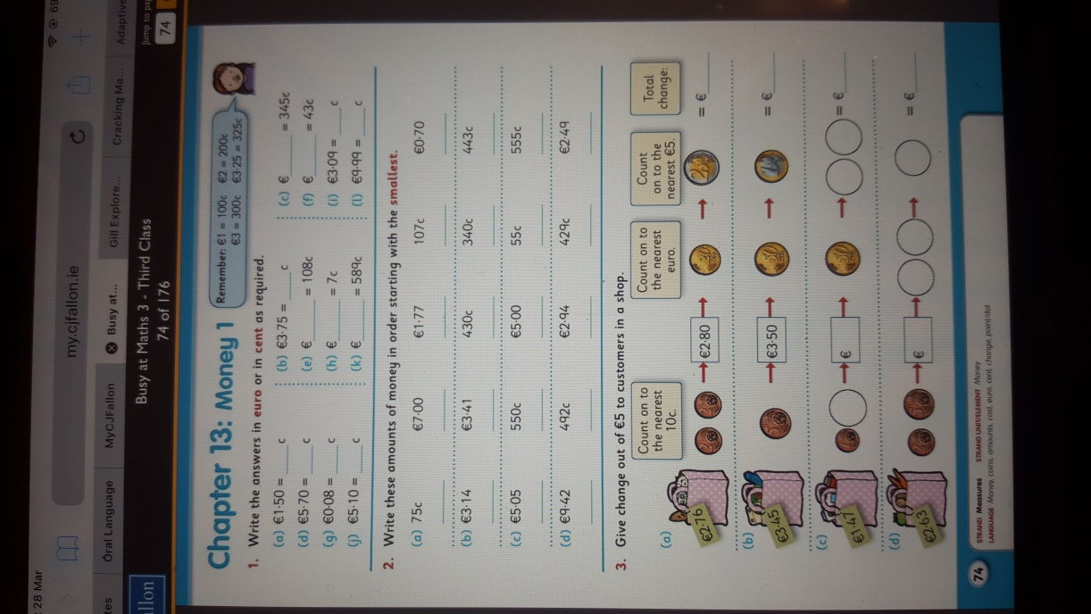 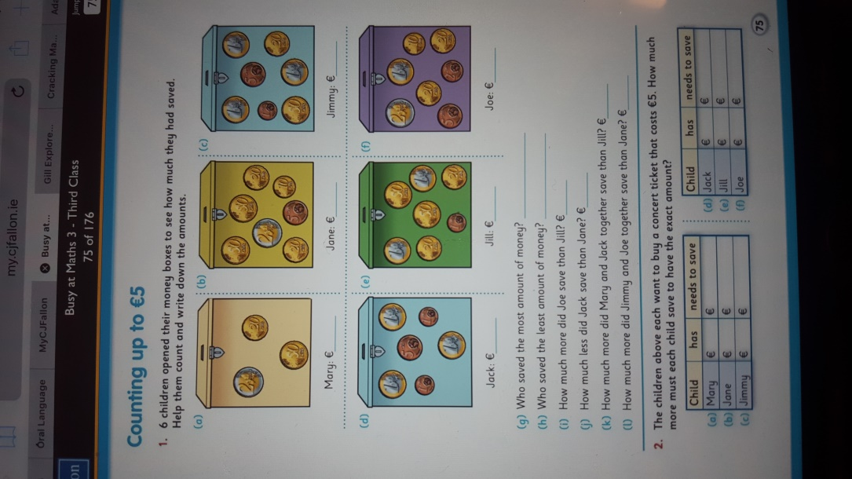

**Oisín- Maths work week 30th Mar-3rd April 2020**

|  |  |  |  |
| --- | --- | --- | --- |
| **Monday** | **Tuesday** | **Wednesday** | **Thursday** |
| 1,2 p.74 | 3 p.74 | 1 p.75 | 2p. 75 |