Happiness Jar (or cup)
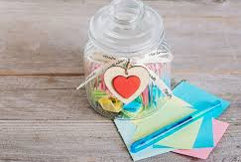
- Find a cup or jar.
- Get some paper and cut into small squares.
- Write down one thing you love to do on each note (sing songs, skip, paint, eat ice-cream).
- Try coming up with 20 ideas.
- Fold the notes and put them into your jar/cup.
- Decorate your jar/cup with stickers or ribbon.
- When you feel sad, worried or lonely, take a note and do it!

