Welcome to

Scoil na Croise Naofa

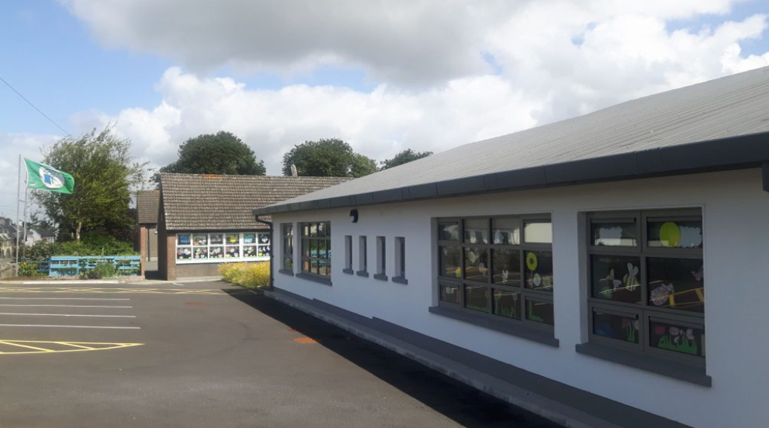

Geashill

Junior Infant Room

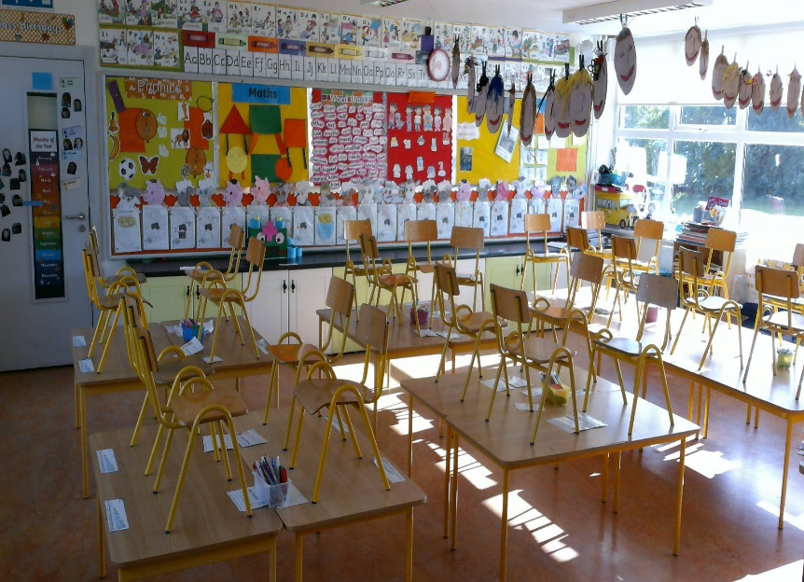

This is where you will have fun every day and learn lots.

Ms. Galvin

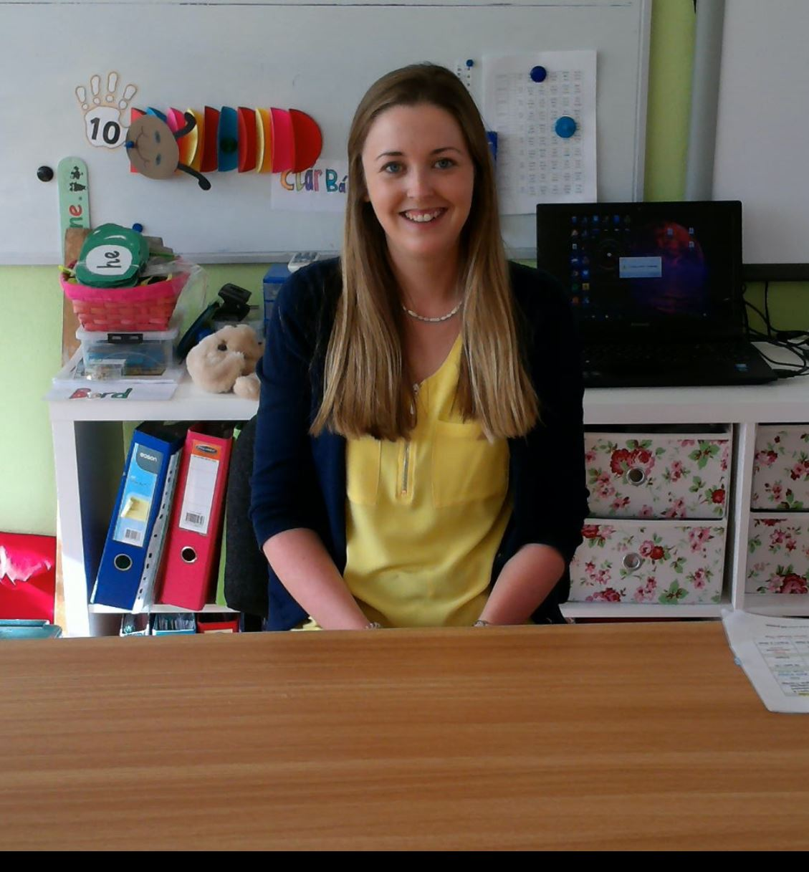

Ms. Galvin will be your teacher when you start school. She cannot wait to meet you.

Mr. Hyland

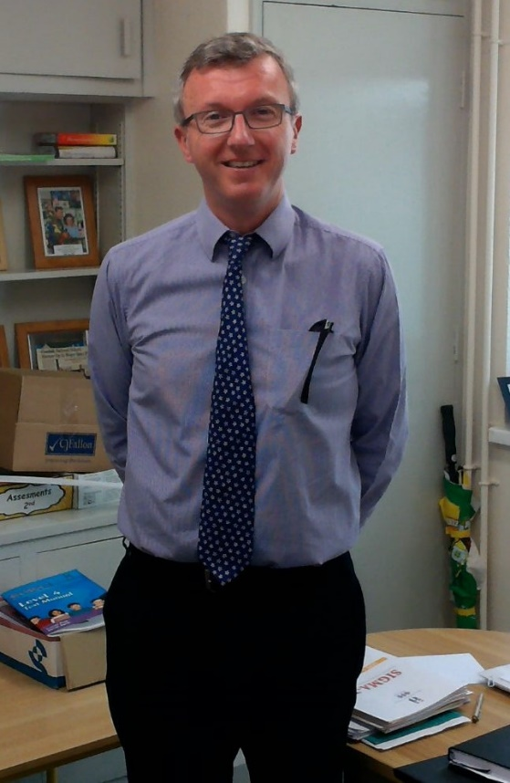

Mr. Hyland is the principal of our school. He also teaches 5th and 6th class.

Mrs. Kearns

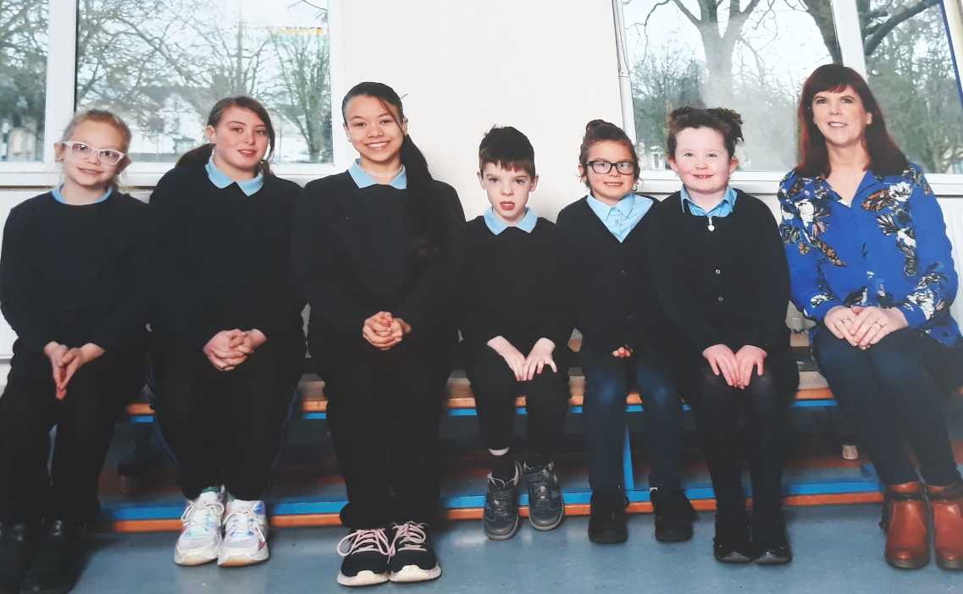

This is Mrs. Kearns. She is our deputy principal. She helps Mr. Hyland and teaches children who have hearing impairments.

Mrs. Coughlan

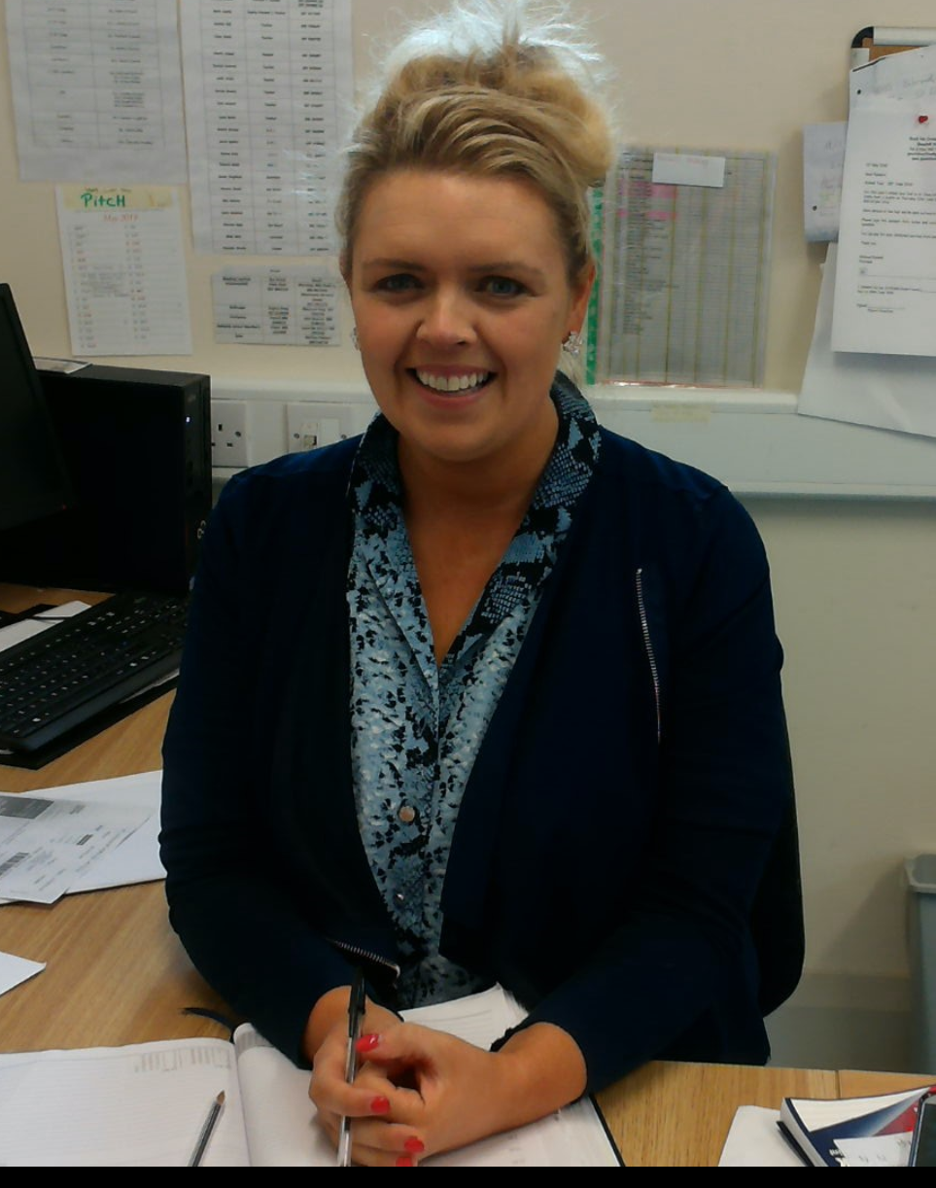

Mrs. Coughlan is our school secretary. She works in the office and greets everyone that comes to our school.

Eddie

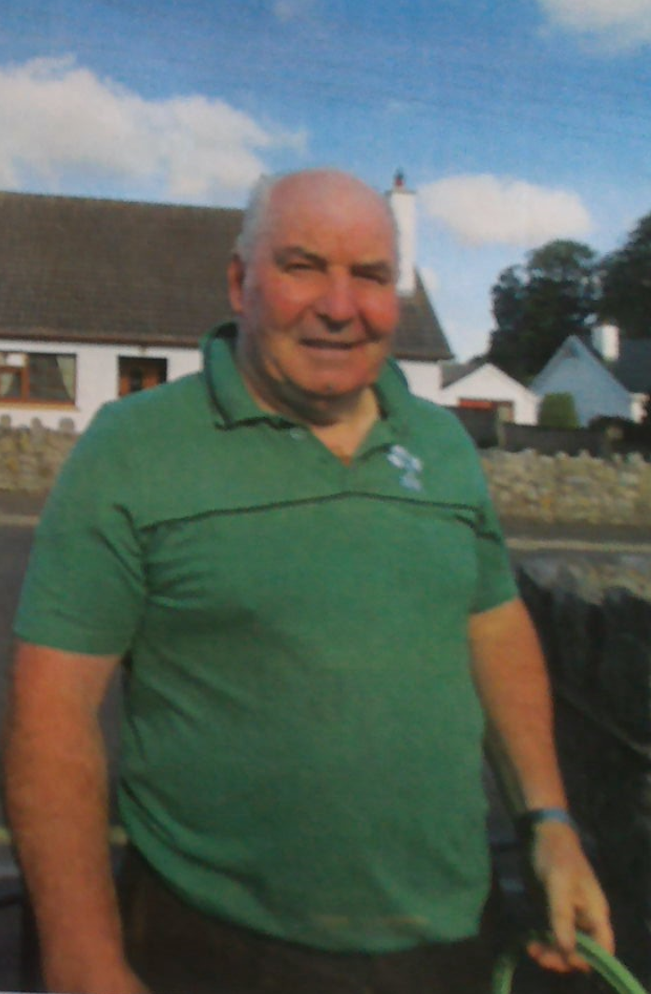

Eddie is our caretaker. He looks after our school very well. Eddie helps to fix things and takes care of our school grounds.

Playground

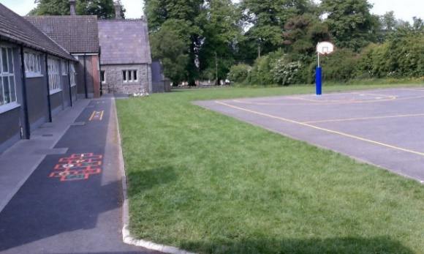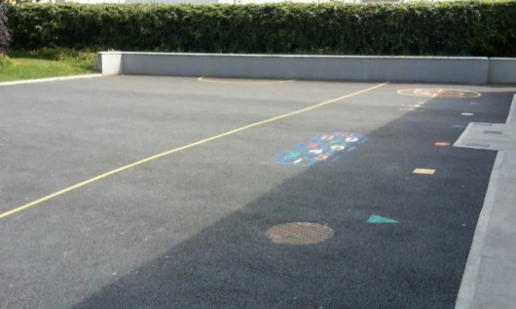

This is where everyone plays outside. You will have lots of fun here. When you hear the bell ring you will line up behind the green triangle.

Junior Infant Fun

We hope you are looking forward to starting in your new school. It will be a fun and exciting time. The staff and teachers at Geashill NS are really looking forward to meeting you all very soon.

We are looking forward to seeing you on Tuesday September 1st.

**Name**: Scoil na Croise Naofa

**Address:** Geashill, Co. Offaly.

**Phone no. :** (057) 9343754

**Email:** [geashillnsoffice@gmail.com](mailto:geashillnsoffice@gmail.com)