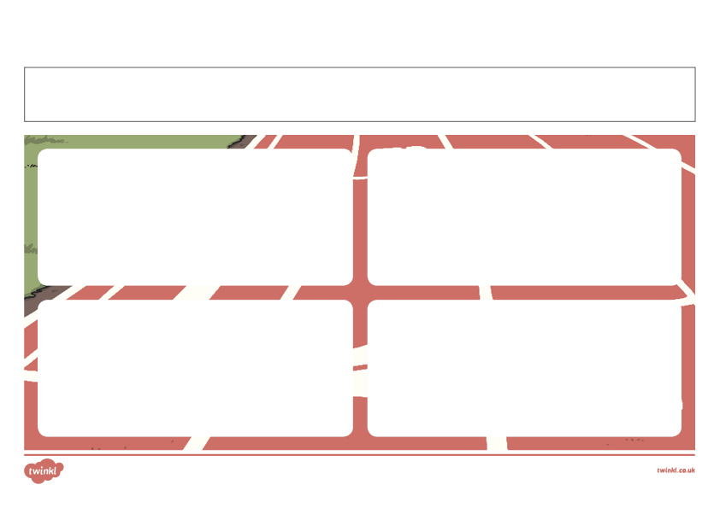
Active Week Homework Challenge
Day 1 - Tuesday
Day 2 - Wednesday
Day 3 - Thursday
Day 4 - Friday
Go outside on your bike/rollerblades/skateboard for 20 minutes or go for a little jog in the park.

Go for a walk around the block after dinner with your family.

Name: ____________________________________________________________

Do star jumps for 1 minute 5 times throughout the day. Ask an adult to time you.

In your garden play with your siblings, family or pet for 30 minutes.

Signed _________________________________

Signed _________________________________

Signed _________________________________

Signed _________________________________

